

**TESTING UNIT ON NAIL ART STUDIO SYSTEM**

Written by:

1. Leann Nataly Kenan Pakpahan (2320010227)
2. Techi Kariska Sari (2320010287)

Class:

3SE3

Faculty:

Susi Maulidah, S.T., M.Kom.

**CEP CCIT**

**FAKULTAS TEKNIK UNIVERSITAS INDONESIA**

**2024**

**Developed by**

1. **Leann Nataly Kenan Pakpahan**
2. **Techi Kariska Sari**



**PROJECT ON**

**TESTING UNIT ON NAIL ART STUDIO SYSTEM**

**TESTING UNIT ON NAIL ART STUDIO SYSTEM**

Batch Code : 3SE3

Start Date : October $9^{th}$,2024   
End Date : October ${23}^{th}$, 2024

Name of Faculty : Susi Maulidah, S.T., M.Kom.

Names of Developer :

1. Leann Nataly Kenan Pakpahan
2. Techi Kariska Sari

Date of Submission: 24 October 2024

**CERTIFICATE**

This is to certify that this report titled “Testing Unit on Nail Art Studio System” embodies the original work done Leann Nataly Kenan Pakpahan and Techi Kariska Sari. Project in partial fulfillment of their course requirement at NIIT.

Coordinator:

Susi Maulidah, S.T., M.Kom.



**ACKNOWLEDGEMENT**

We are grateful to Allah, the Almighty God, for giving us the abilities to fulfill our work without incident. Blessings and greetings are also sent to Muhammad SAW, our final and greatest prophet. Not to mention, we are grateful for our parents who have continued to support us both morally and financially till this point. We would like to thank Susi Maulidah, S.T., M.Kom. as our supervisor who always helps us to finish this paper. Also acknowledged are our friends who have assisted us up until quite recently.

This paper was prepared to fulfill our project assignment as CEP CCIT FTUI students. The topic that will be discussed in this paper mechanism Testing Unit on Nail Art Studio System. We hope this paper will be beneficial to all those who read, especially in education of information technology.

The author realizes that this paper is far from perfect, so it will be very helpful if colleagues and supervisors are willing to provide suggestions and criticism for the perfection of this paper.

Depok, September 2024

Authors

y 2024

Authors

**SYSTEM ANALYSIS**

**System Summary :**

The "Testing Unit on Nail Art Studio System" is a web-based application designed to streamline the management of customer bookings and operations for a nail art studio. To ensure the quality and functionality of the application, unit testing is conducted using JUnit to test each component of the system, such as managing customer data, booking appointments, and tracking nail service orders. Additionally, JaCoCo is utilized to analyze code coverage, enabling developers to verify that all parts of the code have been rigorously tested. By performing thorough unit testing, the system can identify and resolve potential issues before the application is deployed, thus enhancing the reliability and efficiency of managing appointments and operations for the nail art studio.

**CONFIGURATION**

**Hardware :** VivoBook_ASUSLaptop X509FJ_A509FJ   
**Processor :** Intel(R) Core(TM) i7-8565U CPU

**Installed RAM :** 8,00 GB  
**System type :** 64-bit operating system, x64-based processor  
**Operating System :** Windows 11 Home Single Language  
**Software :** Apache Netbeans IDE 8.2, MySQL, Apache JMeter, Microsoft Word

\

sssssssssss

**TYPE OF TESTING TOOLS**

**JUnit**

- **Purpose**: JUnit is a widely used unit testing framework in Java that allows you to write repeatable tests. It is primarily used for writing tests for individual methods and classes.

- **Usage in the Project**: In this project, JUnit was used to write tests on DAO (CategoryDAOTest, LocationDAOTest, LoginDAOTest, ReservationDAOTest, ScheduleDAOTest) and POJO (CategoryTest, LocationTest, LoginTest, NailArtTest, NailartUtilTest, ReservationTest, ScheduleTest) classes. These tests ensure that core functionality such as CRUD operations on category, location, login, reservation, and schedule data work correctly.

**Mockito**

- **Purpose**: Mockito is a powerful mocking framework for Java that allows you to create mock objects and define their behavior for testing purposes. It helps in isolating the code under test by mocking dependencies such as repositories and services.

- **Usage in the Project**: Mockito is used in testing DAO classes in this project (e.g., CategoryDAOTest, LocationDAOTest, LoginDAOTest, ReservationDAOTest, ScheduleDAOTest) to mock the DAO layer. This allows you to test the behavior of various DAO components without actually interacting directly with the database, ensuring that application functionality and logic are effectively tested in an isolated environment.

**TYPE OF TESTING TOOLS**

**Jacoco**

- **Purpose**: JaCoCo is a code coverage tool for Java that generates reports on how much of your code is covered by tests. It is often used to ensure that tests are adequately covering the codebase and that critical sections of the code are not left untested.

- **Usage in the Project**: JaCoCo can be used in this project to measure the coverage of unit tests contained in the DAO (CategoryDAOTest, LocationDAOTest, LoginDAOTest, ReservationDAOTest, ScheduleDAOTest) and POJO (CategoryTest, LocationTest, LoginTest, NailArtTest, NailartUtilTest, ReservationTest, ScheduleTest) classes. This will help you identify which parts of the code have been tested and which have not, allowing you to increase test coverage in areas that need attention.

**JMeter**

- **Purpose**: Apache JMeter is a popular performance testing tool that is used to test the performance and scalability of web applications. It allows you to simulate multiple users accessing your application simultaneously and measure how your system performs under load.

- **Usage in the Project**: JMeter can be used to test the performance of various components of your system, such as the reservation and schedule management pages in this nail art studio app. By simulating multiple user requests on operations such as reservation creation and management and service scheduling, you can evaluate how the app handles a high volume of requests, and whether there are any performance bottlenecks that need to be addressed.

**TESTING IMPLEMENTATION**

**DAO**

**1. CategoryDAOTest.java**

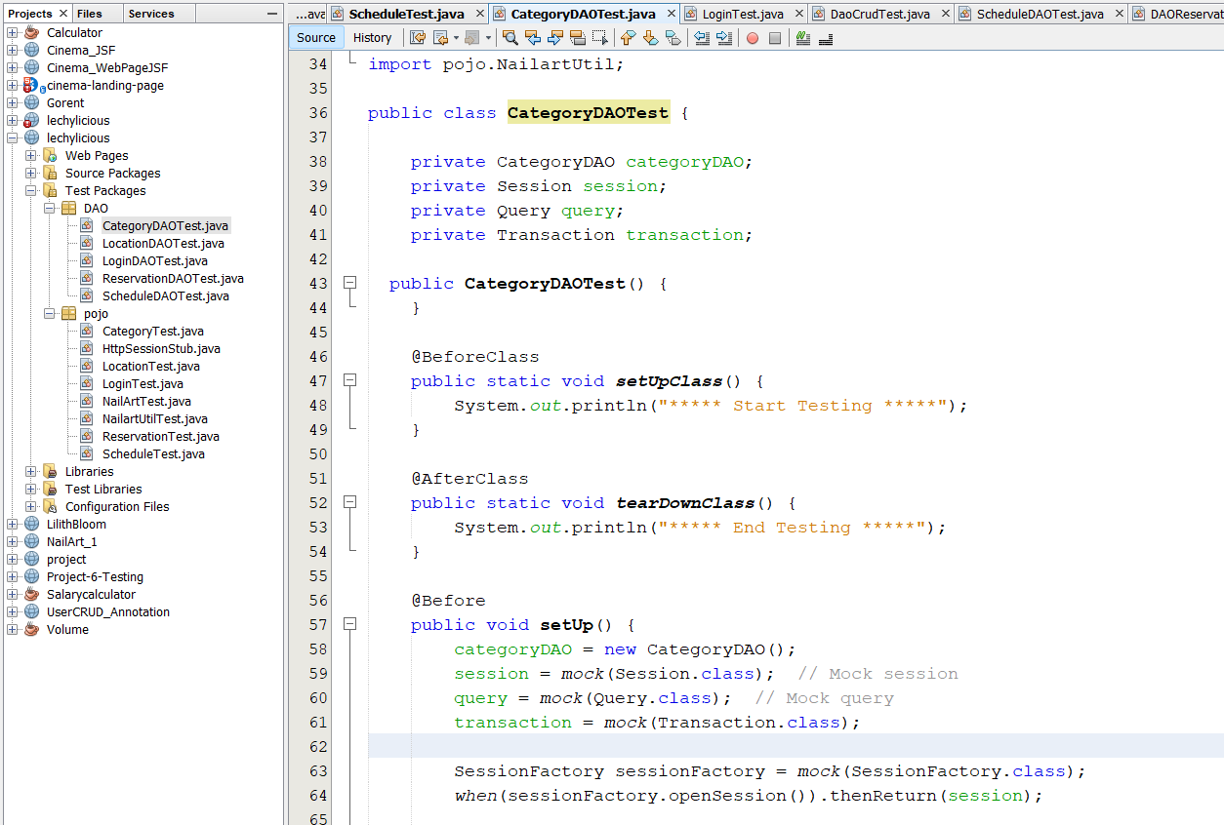

**TESTING IMPLEMENTATION**

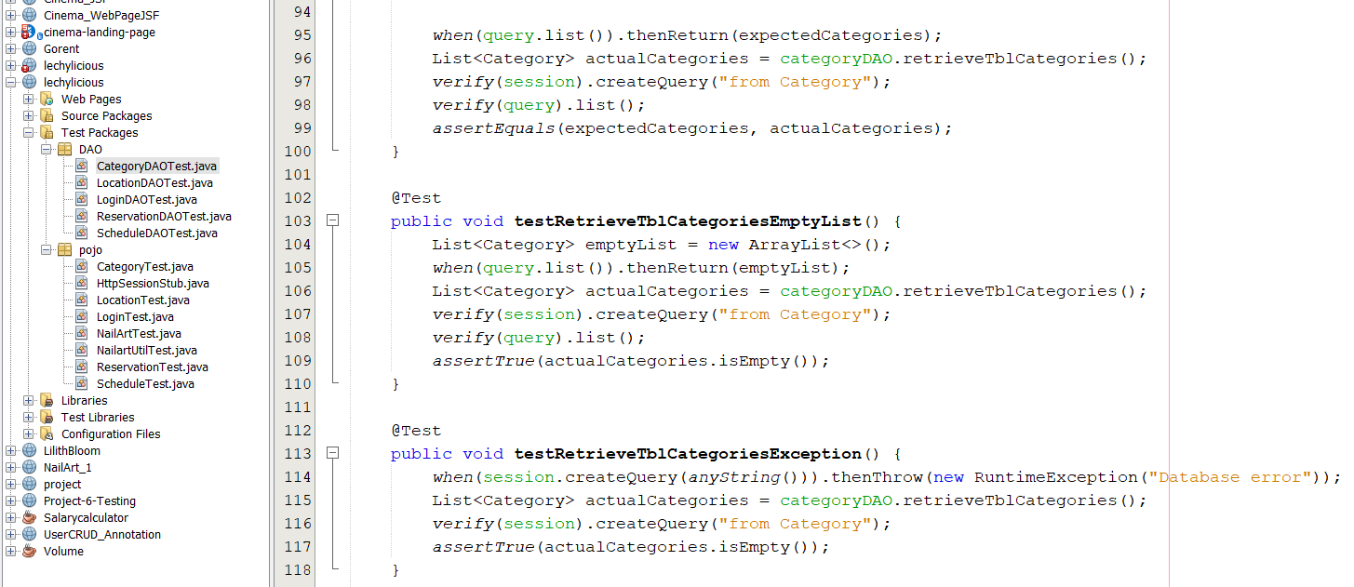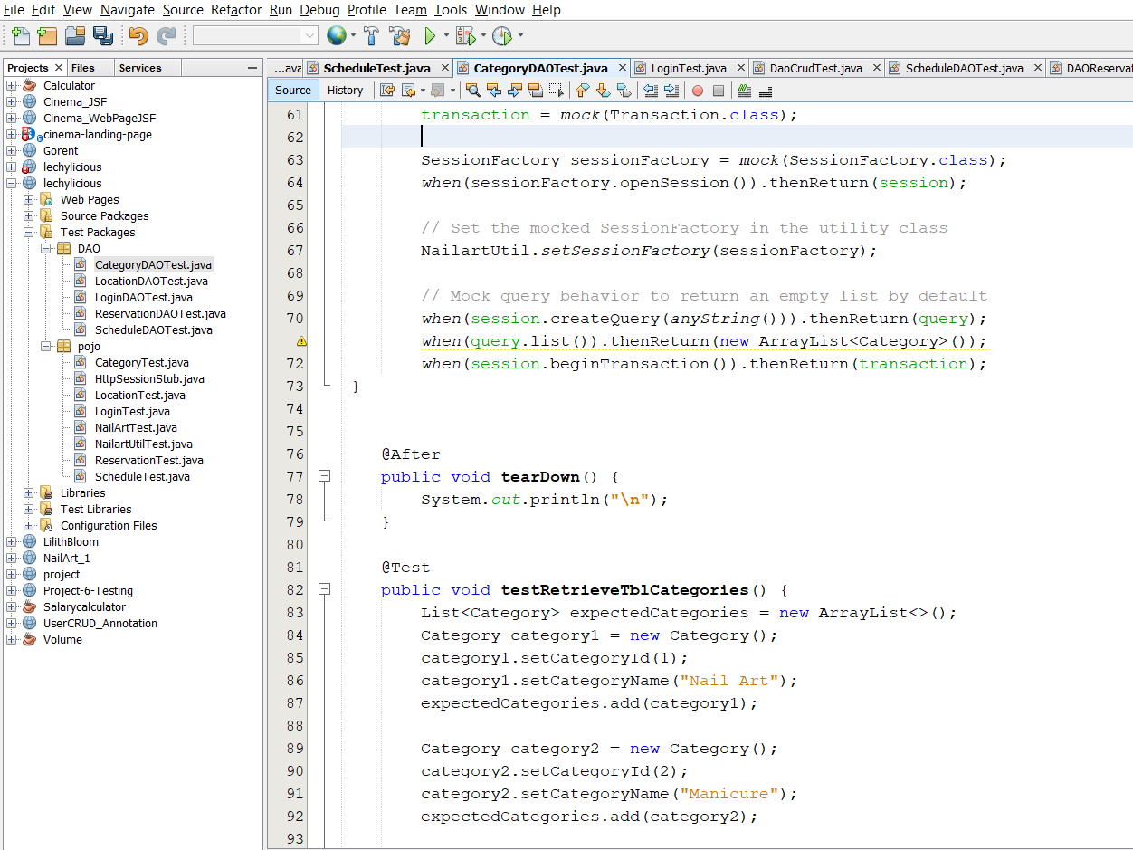

**TESTING IMPLEMENTATION**

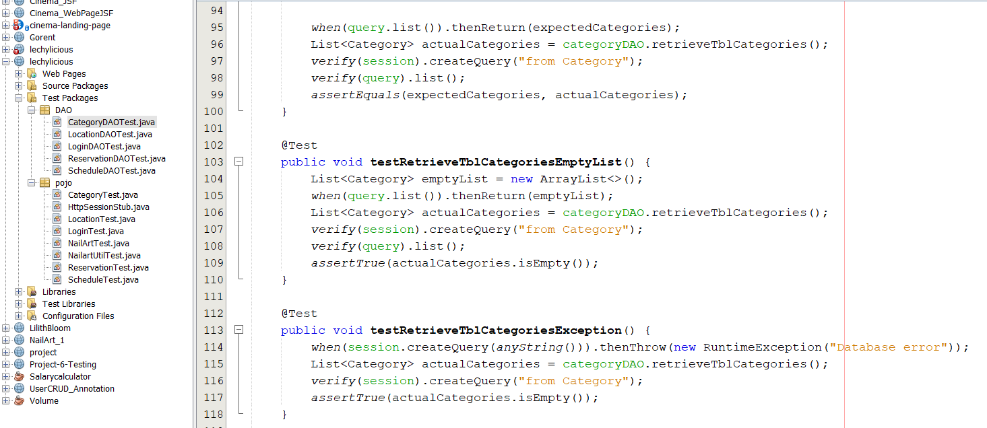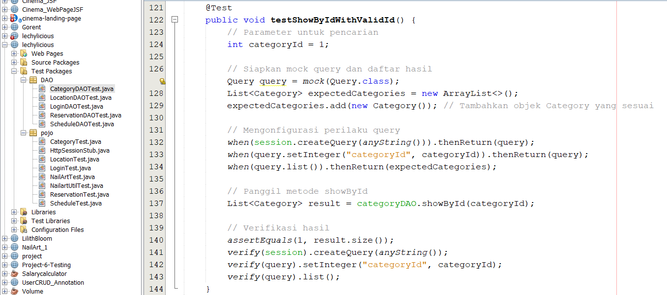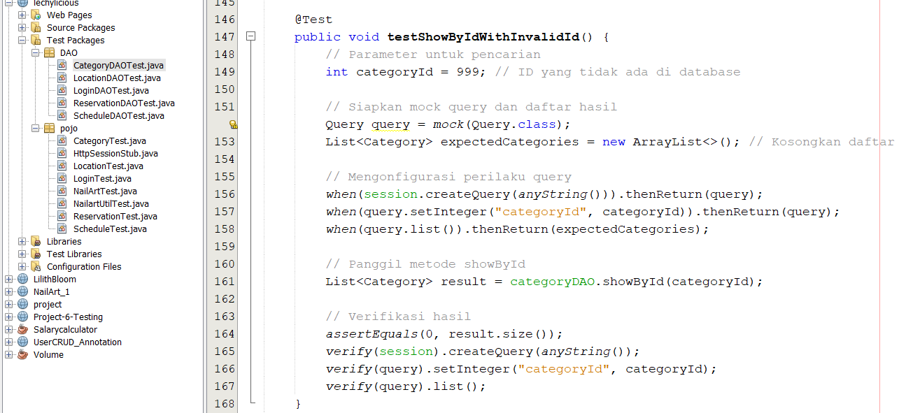

**TESTING IMPLEMENTATION**

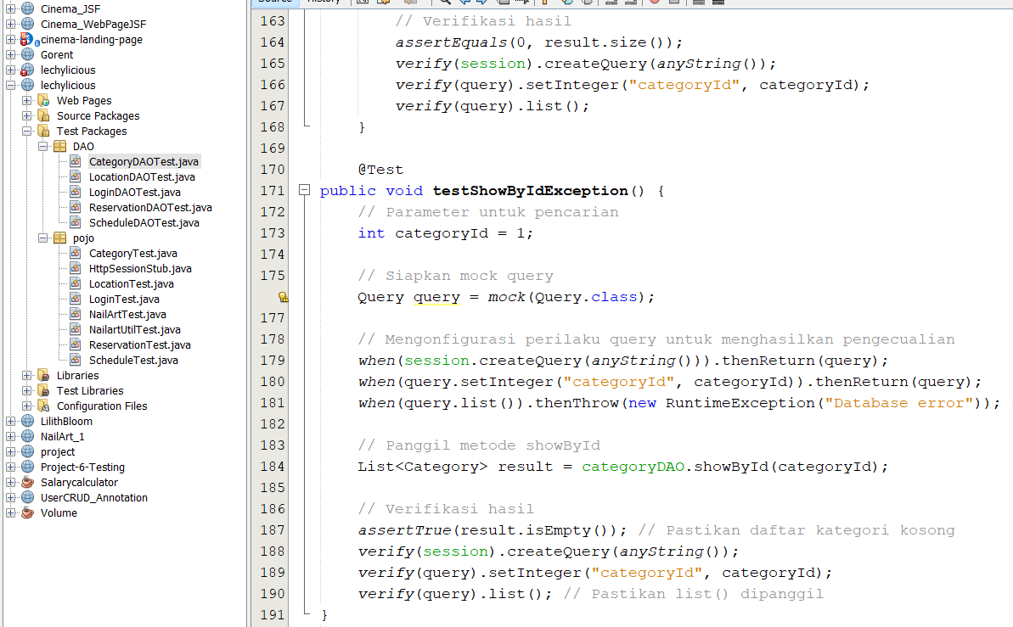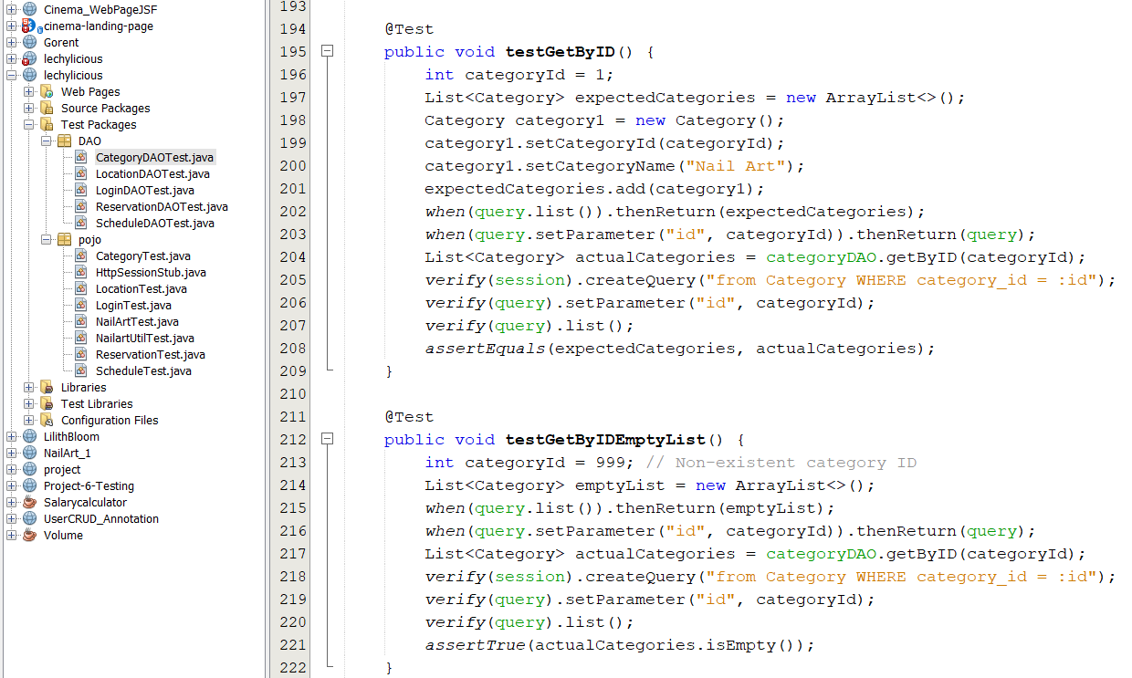

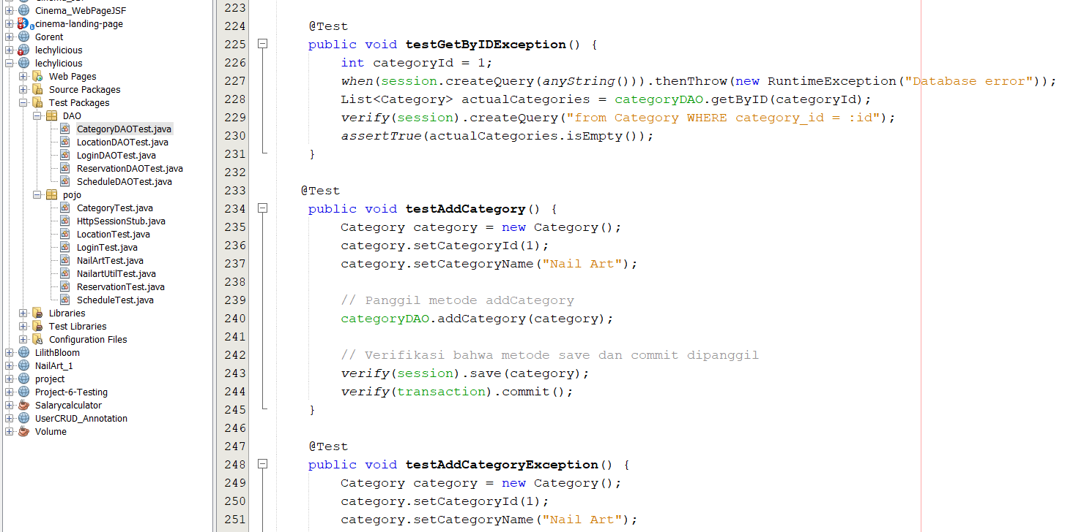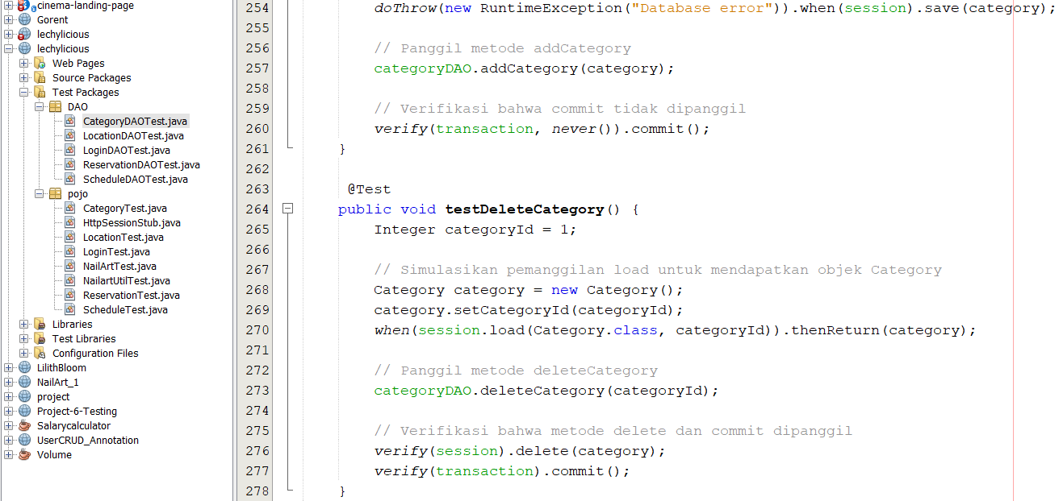

**TESTING IMPLEMENTATION**

**TESTING IMPLEMENTATION**

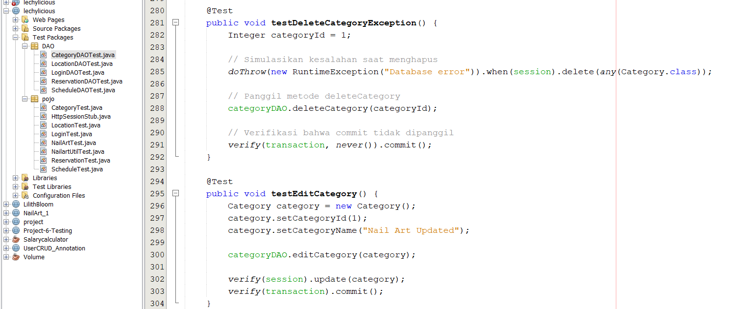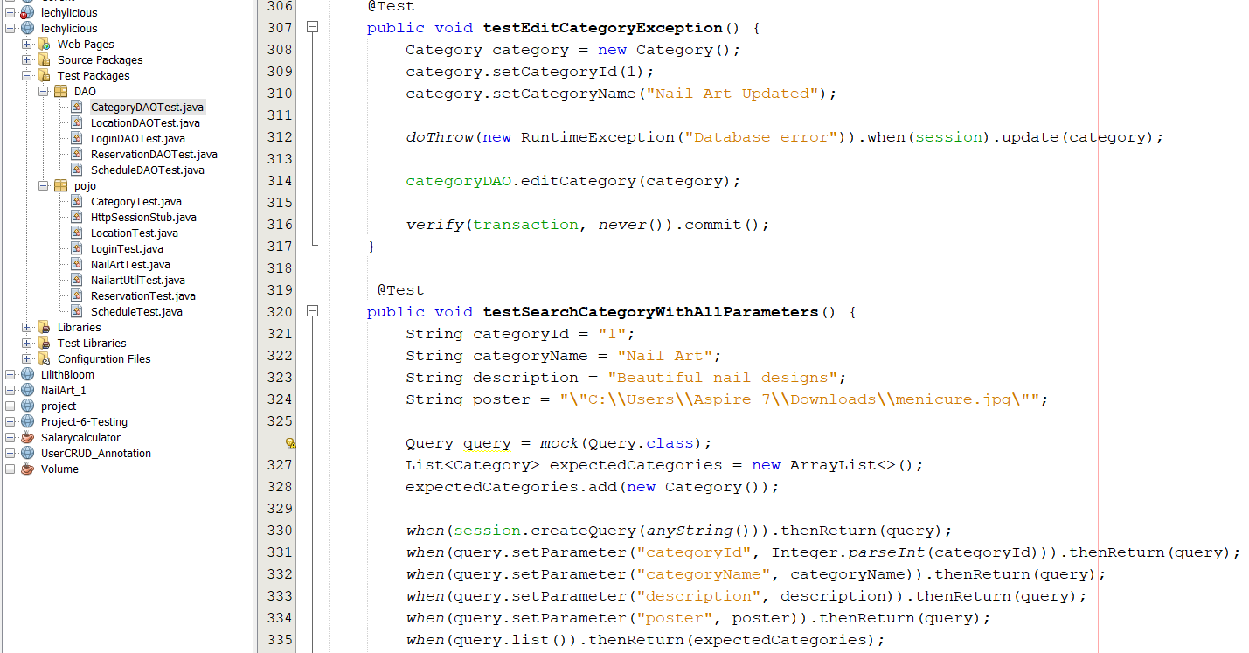

**TESTING IMPLEMENTATION**

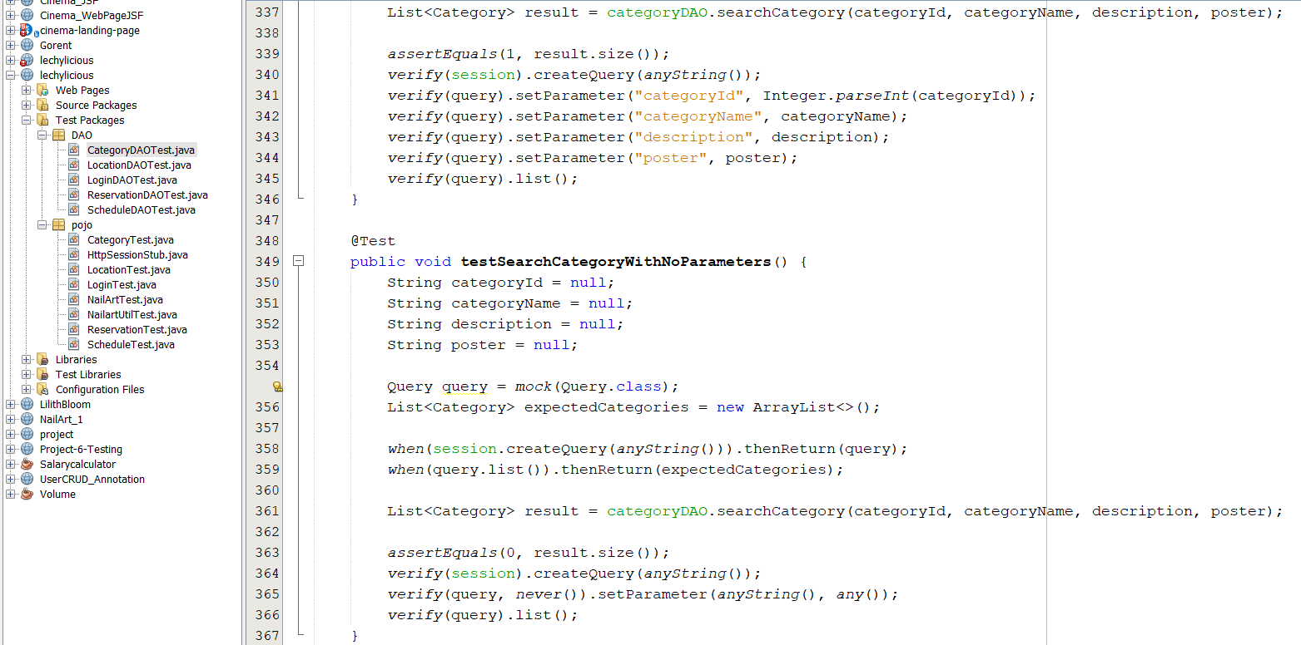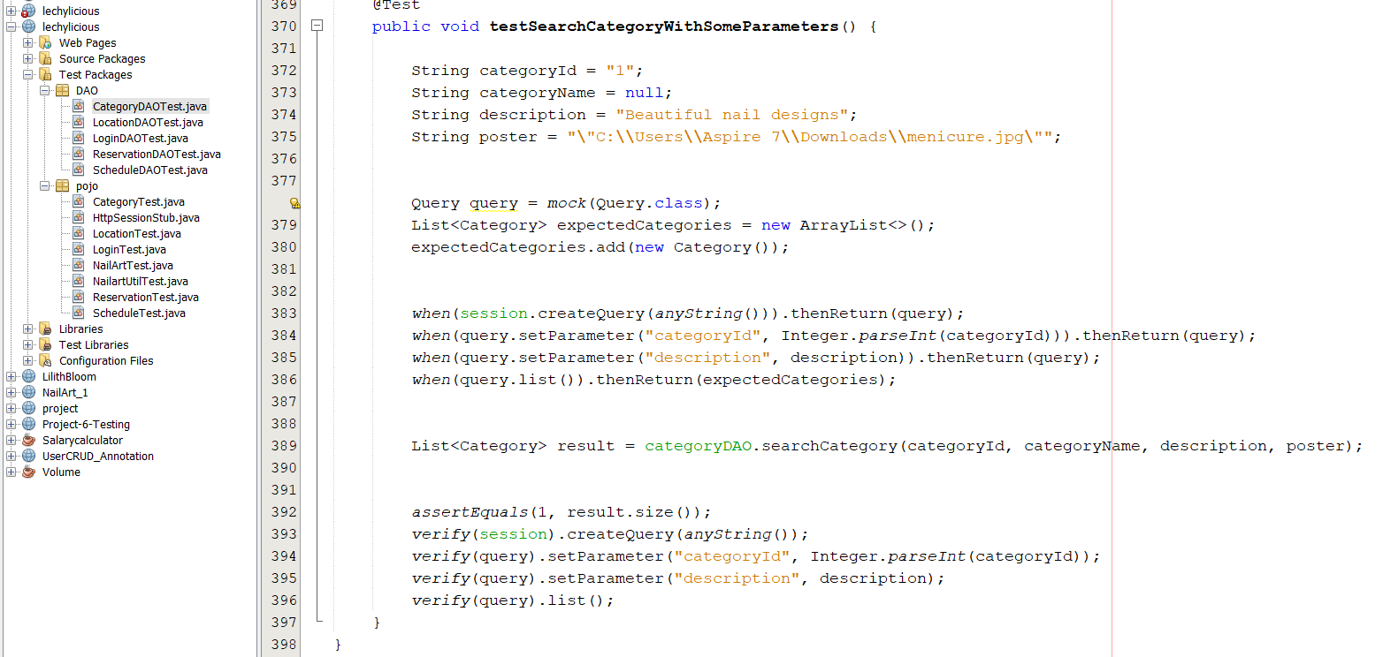

**TESTING IMPLEMENTATION**

**2. LocationDAOTest.java**

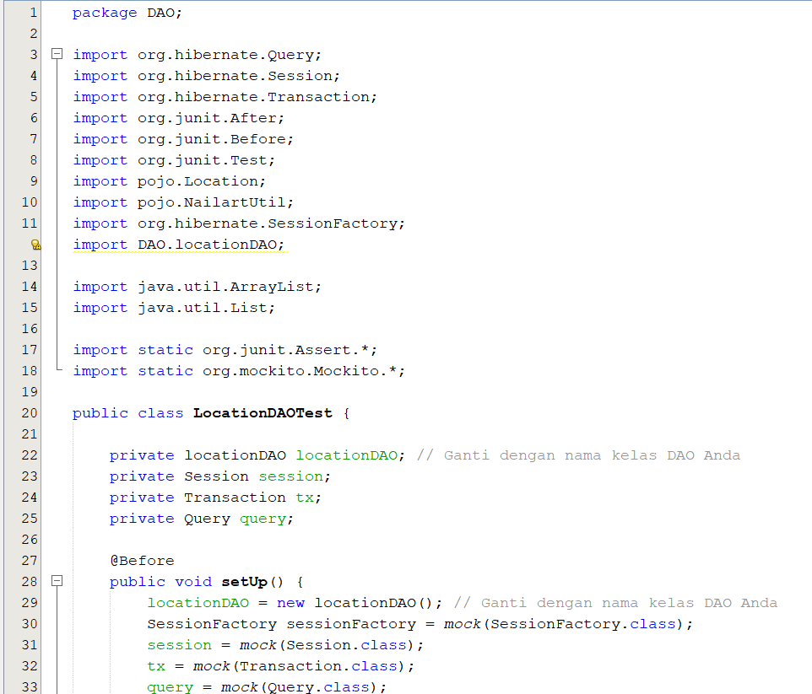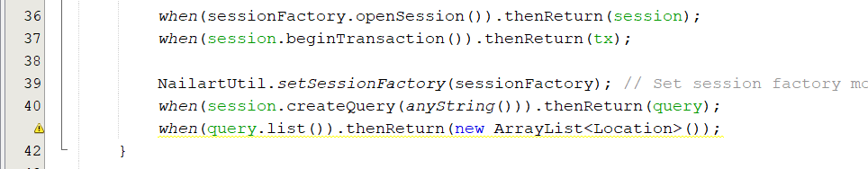

**TESTING IMPLEMENTATION**

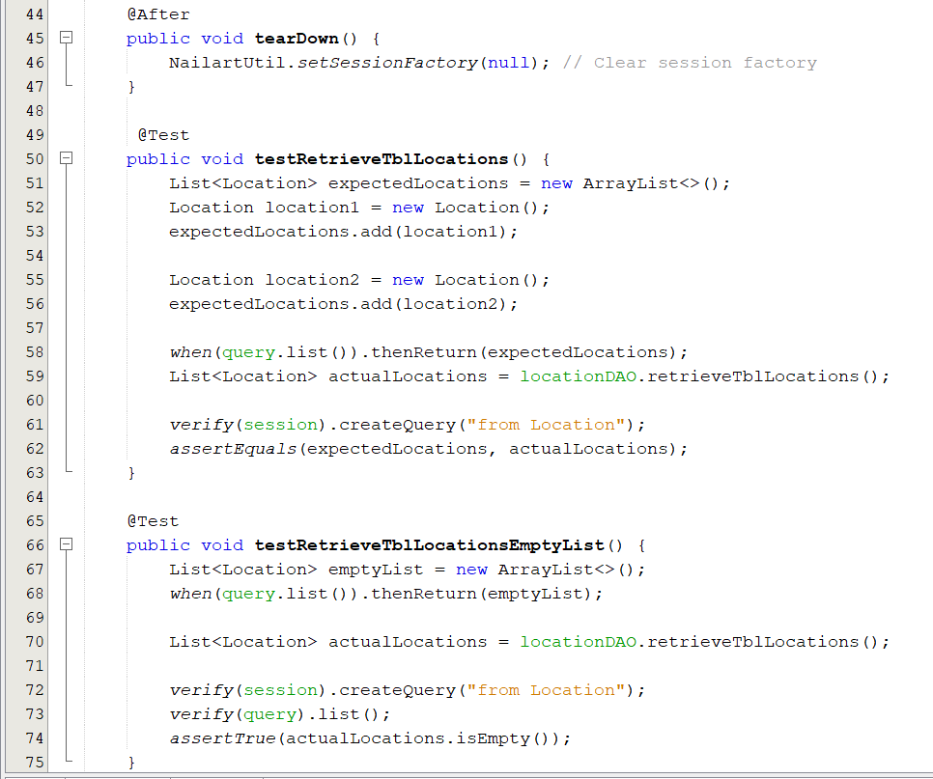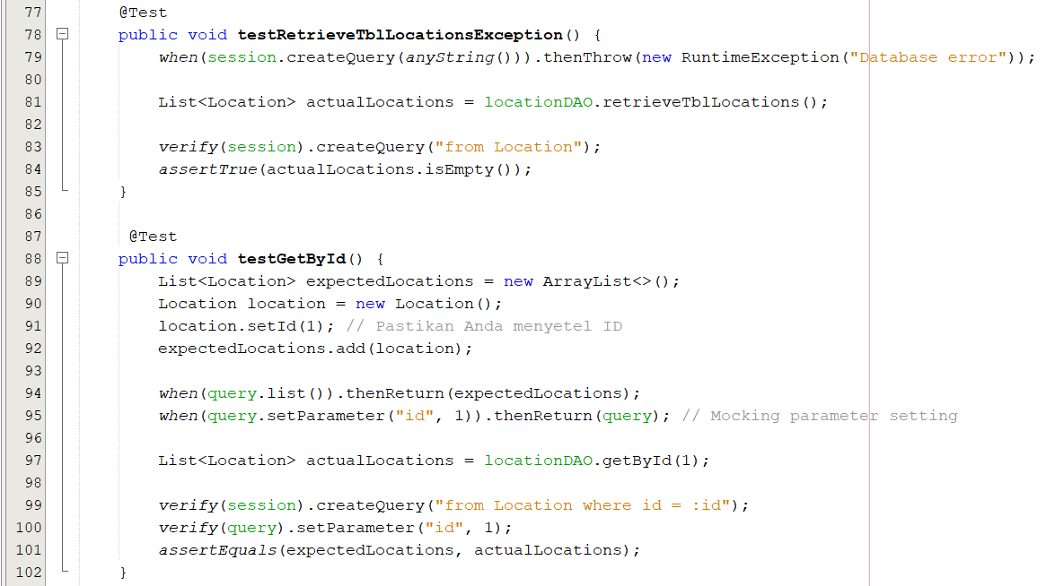

**TESTING IMPLEMENTATION**

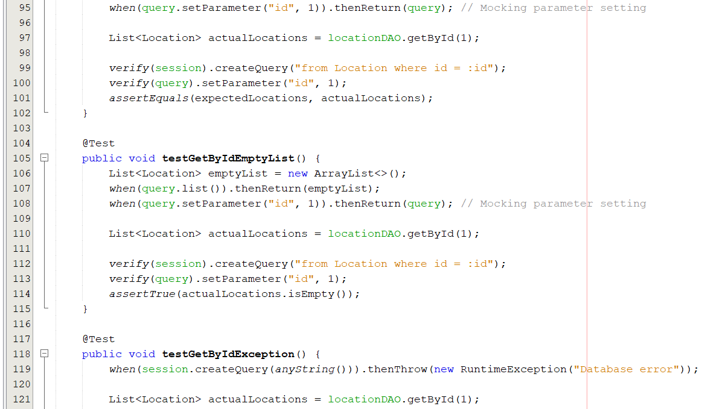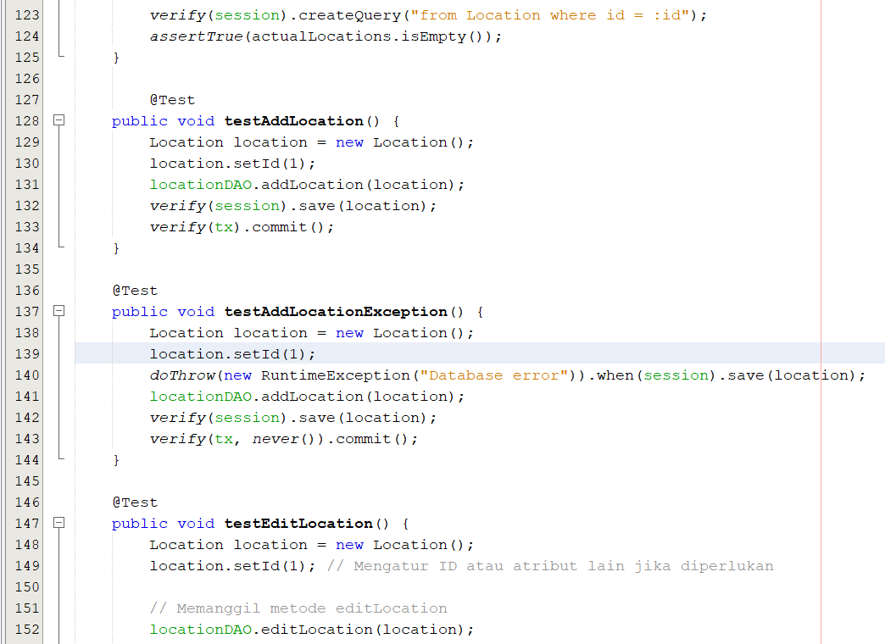

**TESTING IMPLEMENTATION**

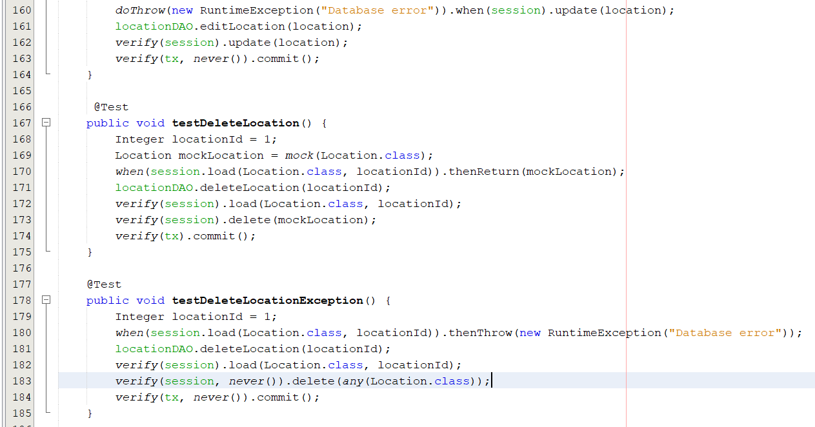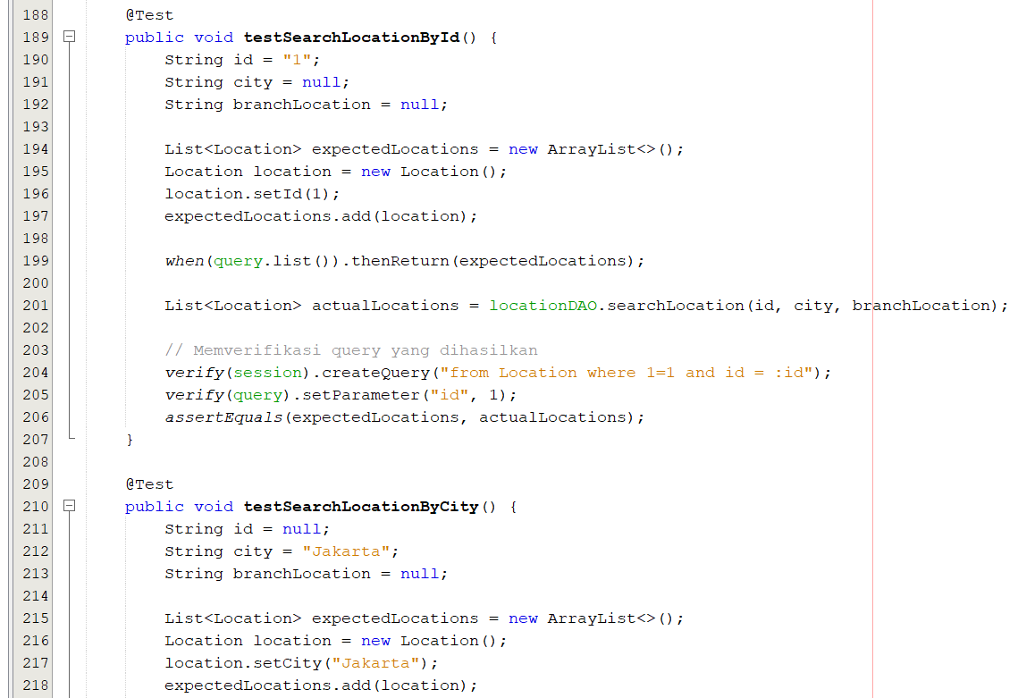

**TESTING IMPLEMENTATION**

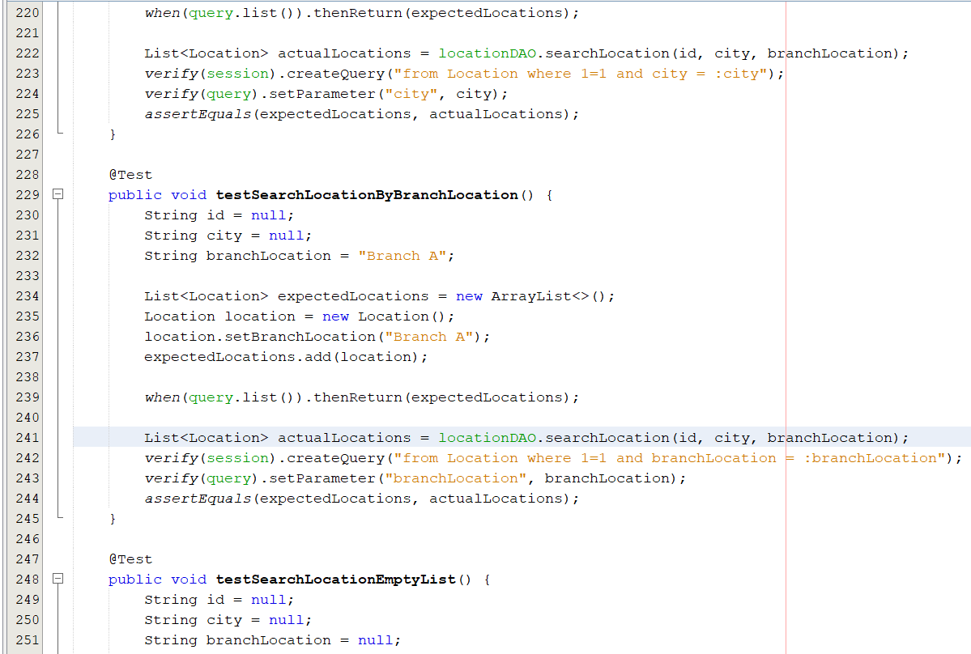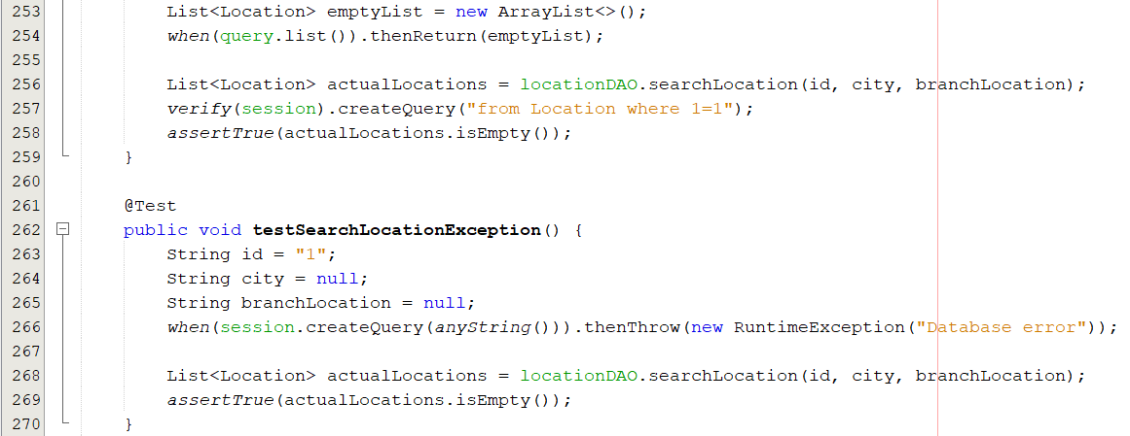

**TESTING IMPLEMENTATION**

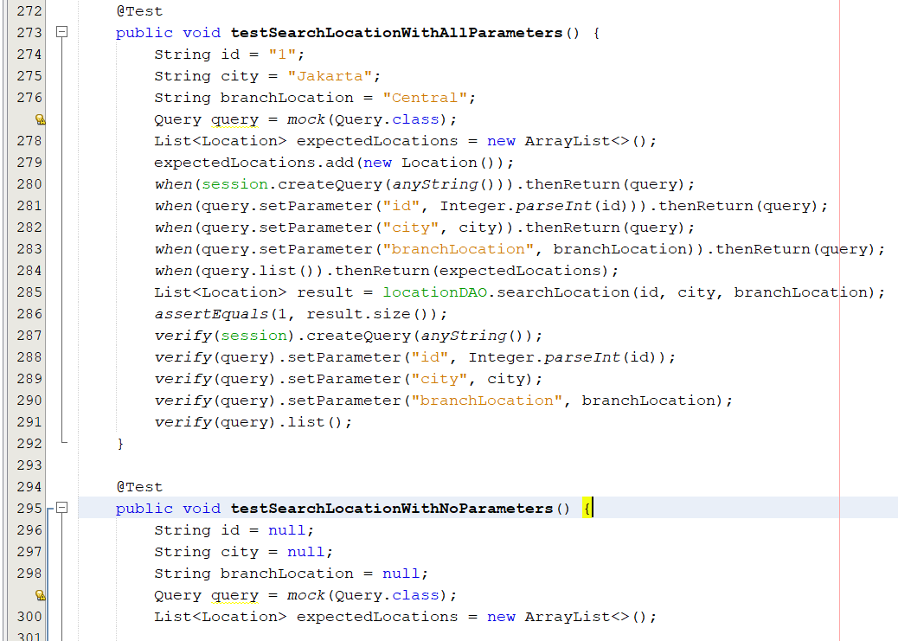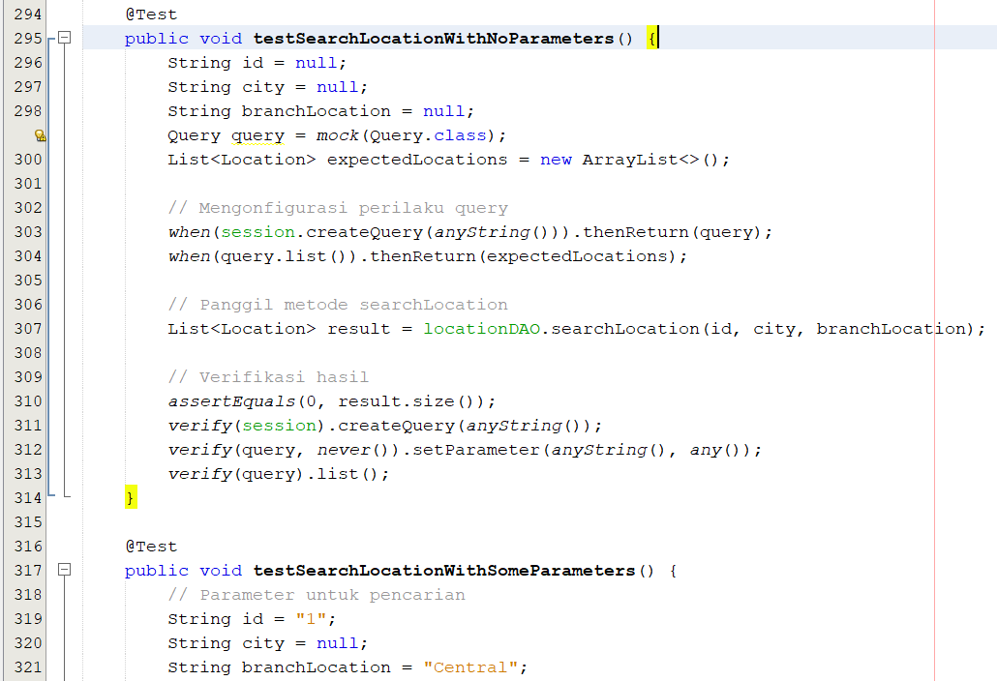

**TESTING IMPLEMENTATION**

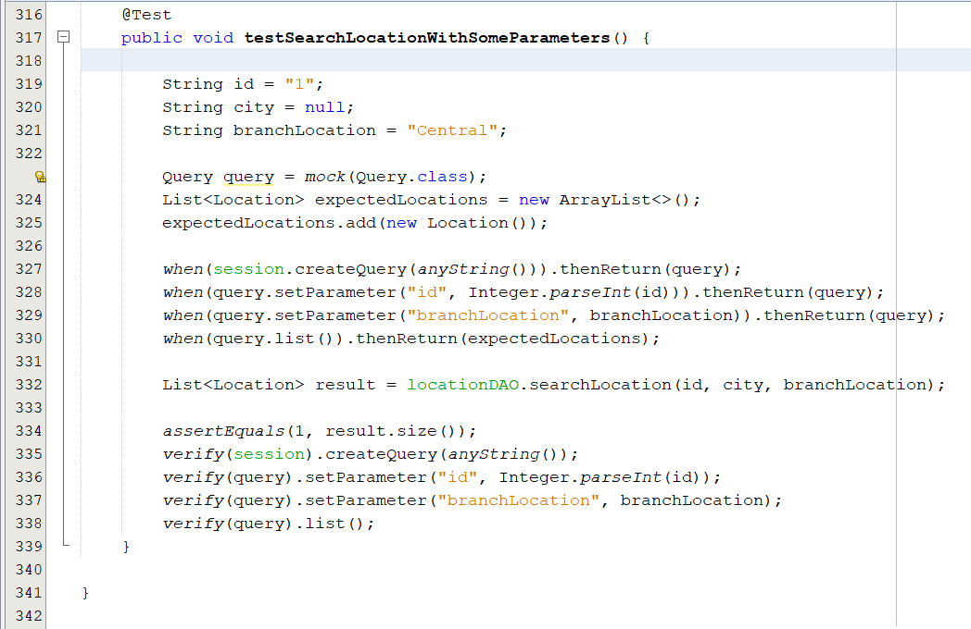

**TESTING IMPLEMENTATION**

3. LoginDAOTest.java

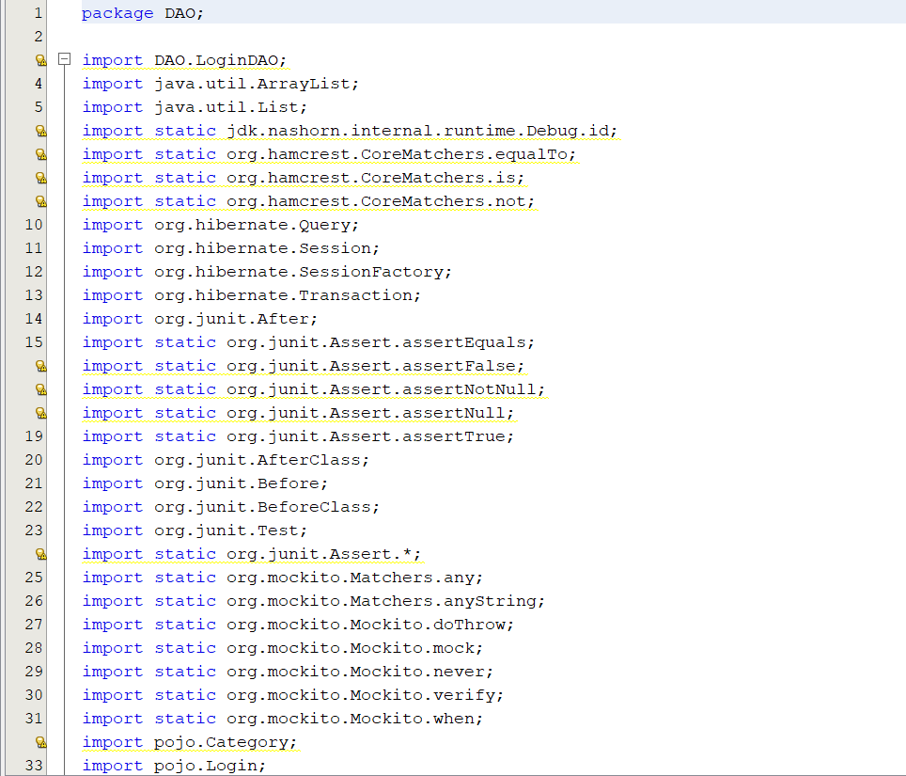

**TESTING IMPLEMENTATION**

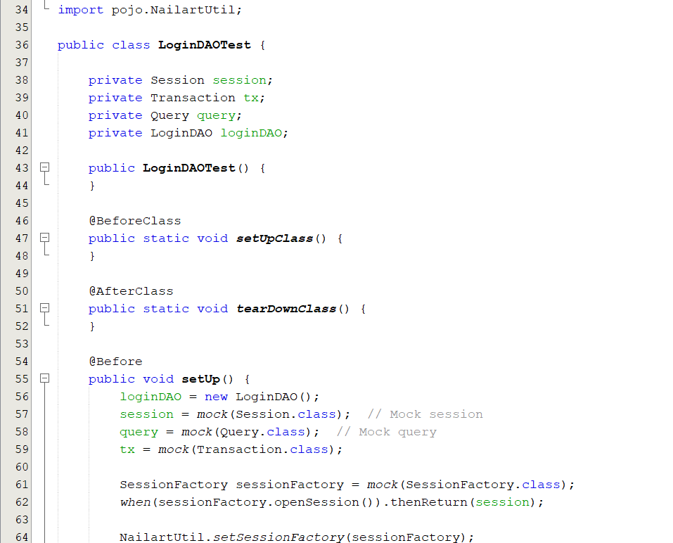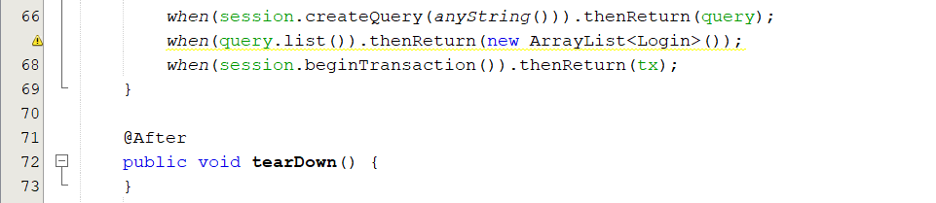

**TESTING IMPLEMENTATION**

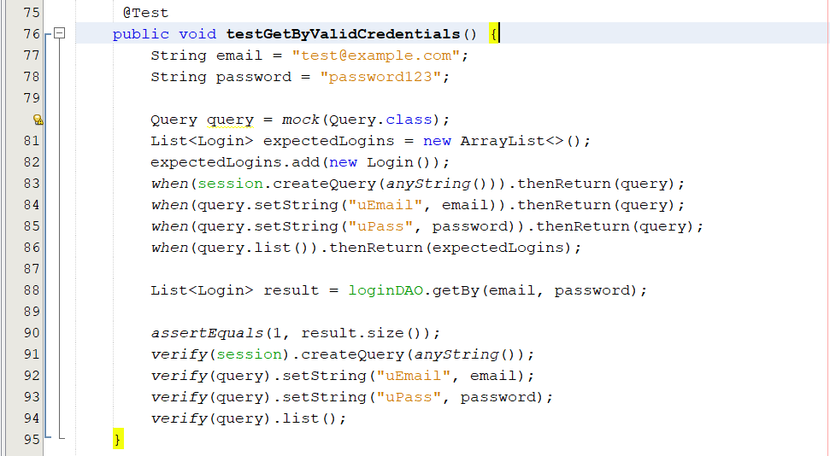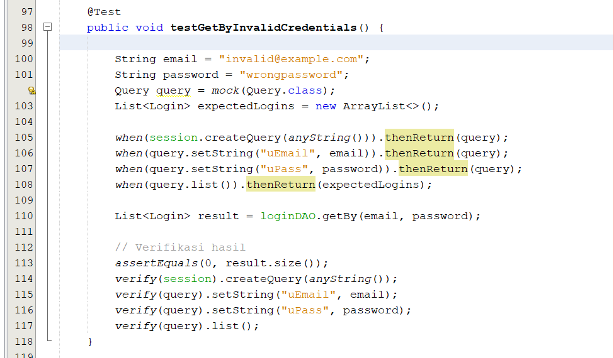

**TESTING IMPLEMENTATION**

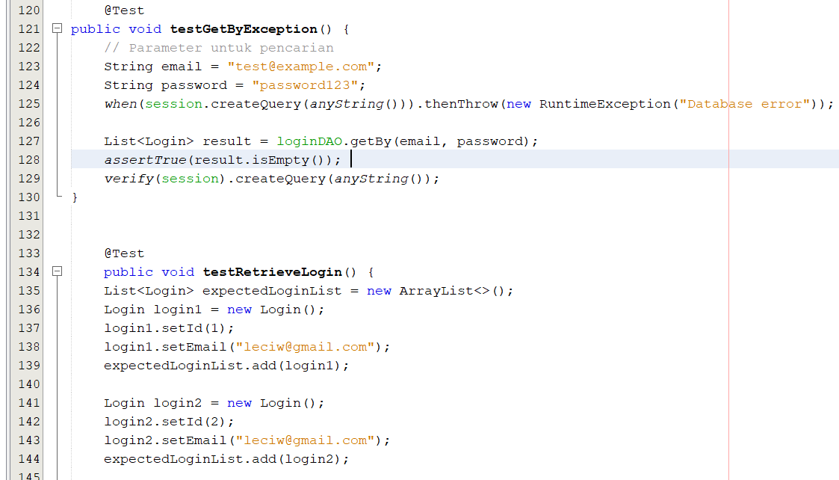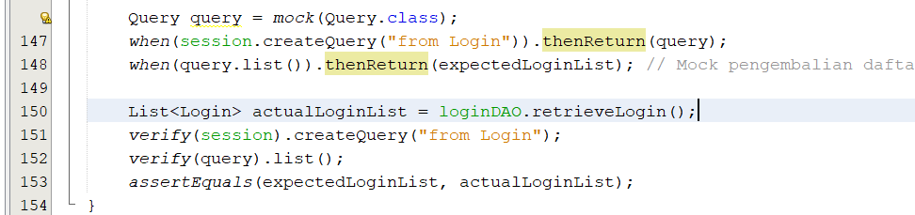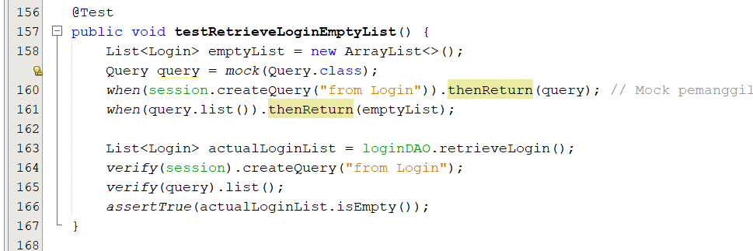

**TESTING IMPLEMENTATION**

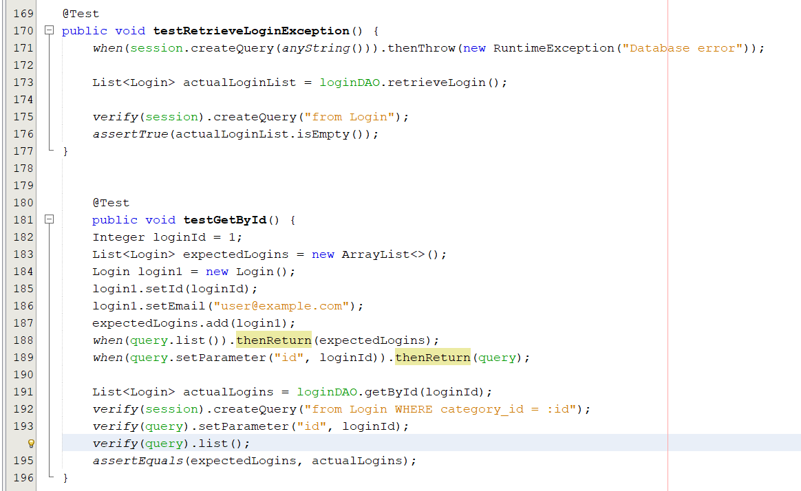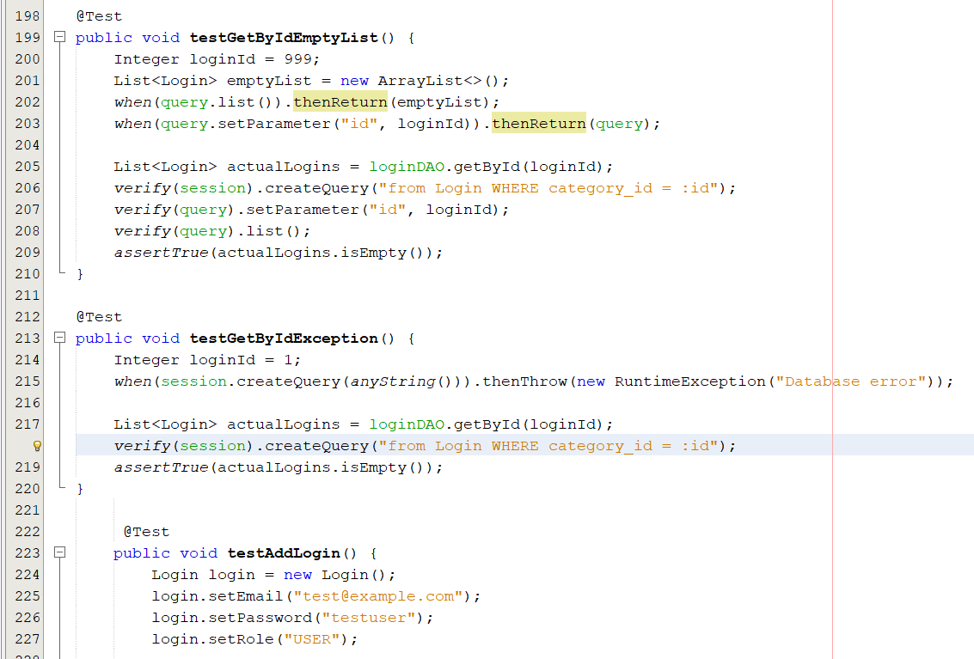

**TESTING IMPLEMENTATION**

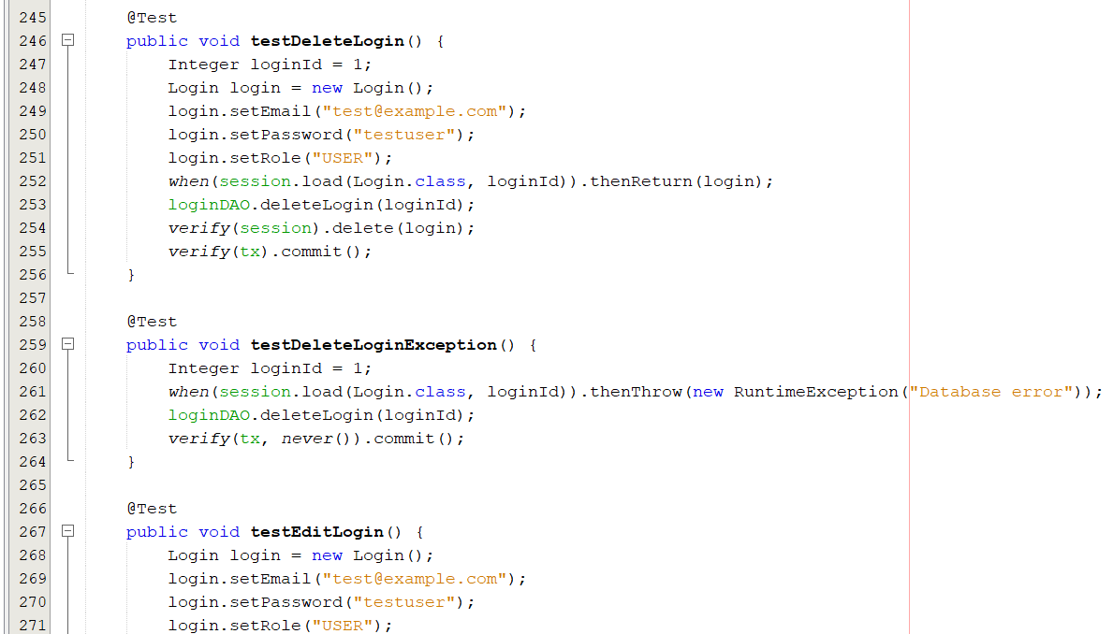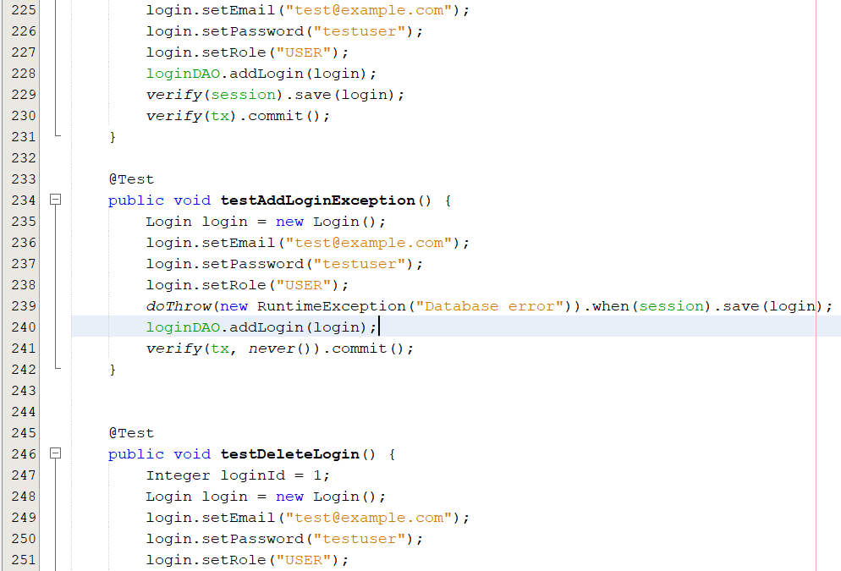

**TESTING IMPLEMENTATION**

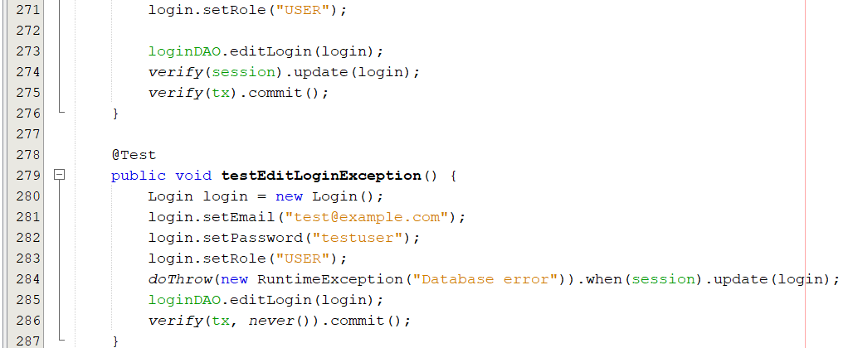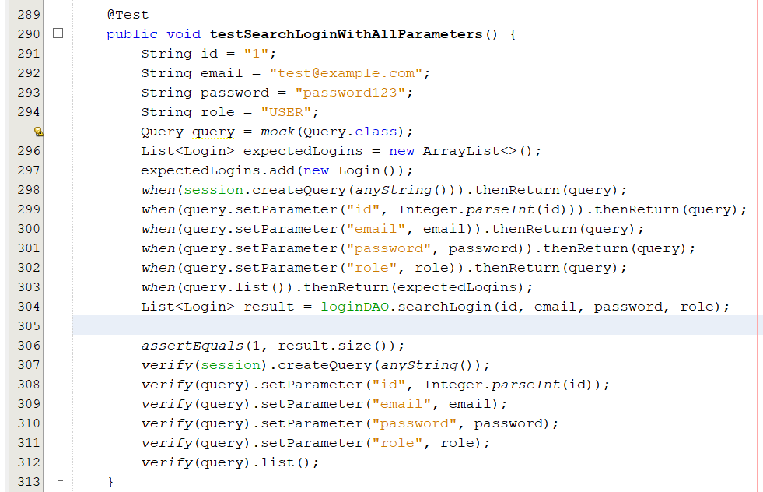

**TESTING IMPLEMENTATION**

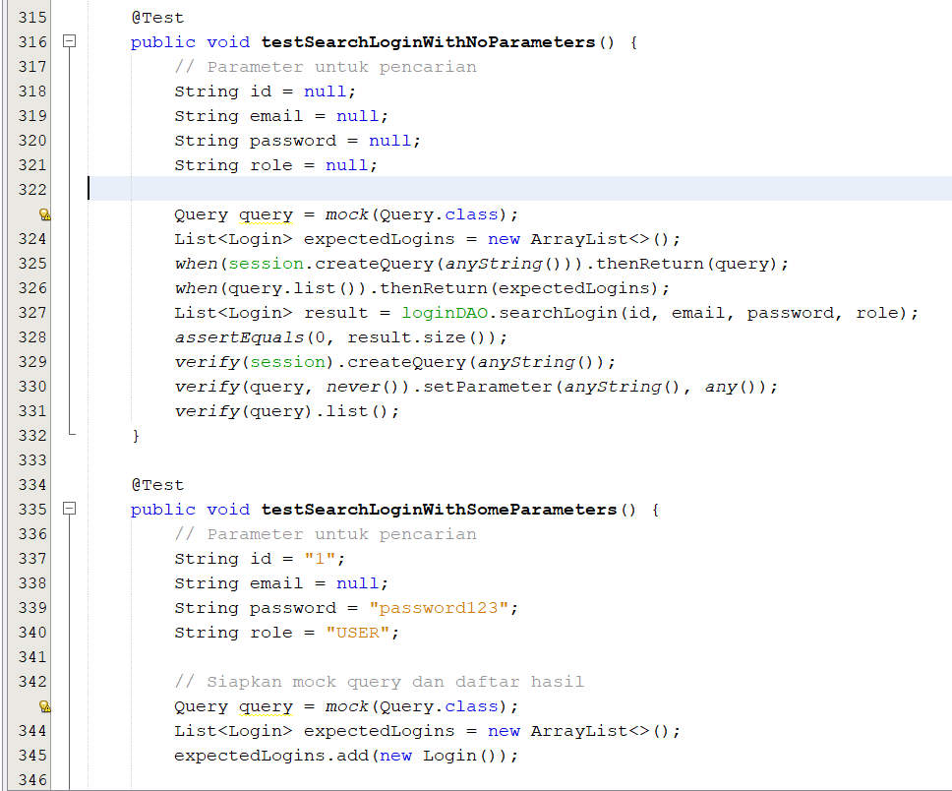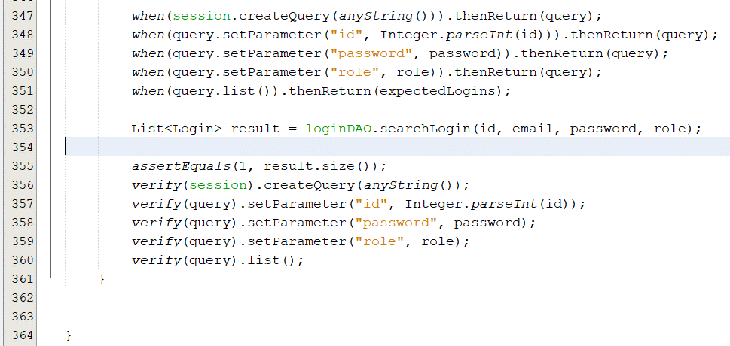

**TESTING IMPLEMENTATION**

**4. ReservationDAOTest.java**

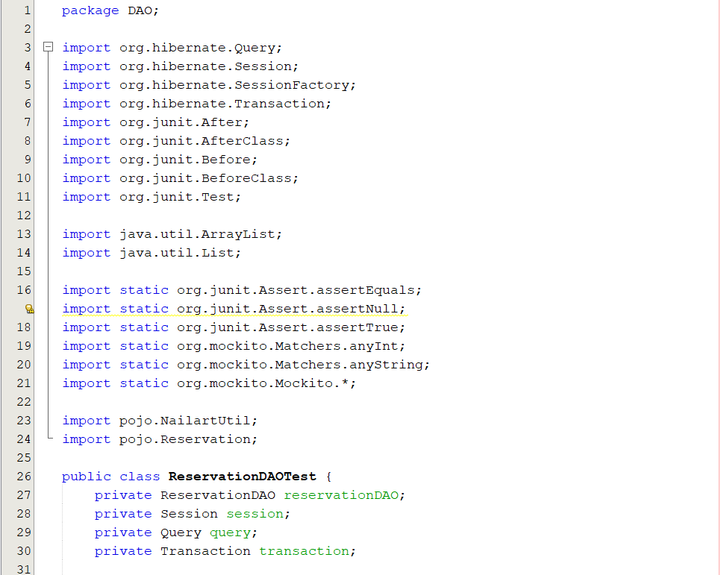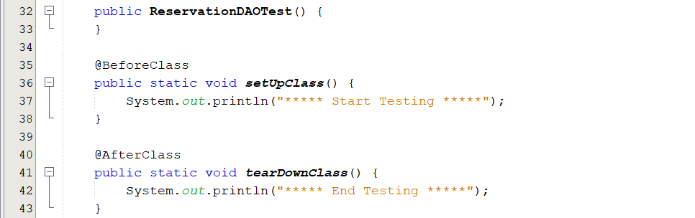

**TESTING IMPLEMENTATION**

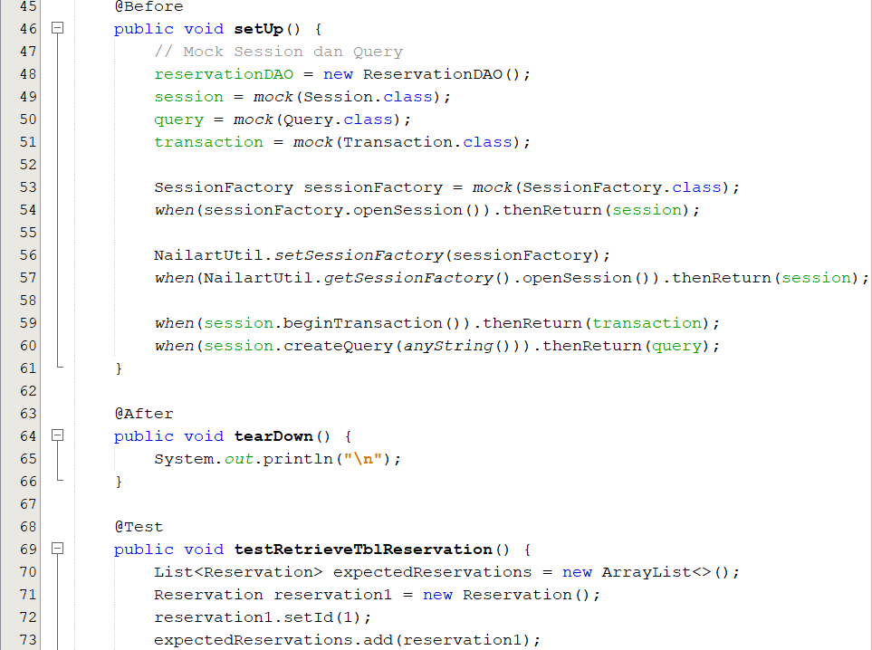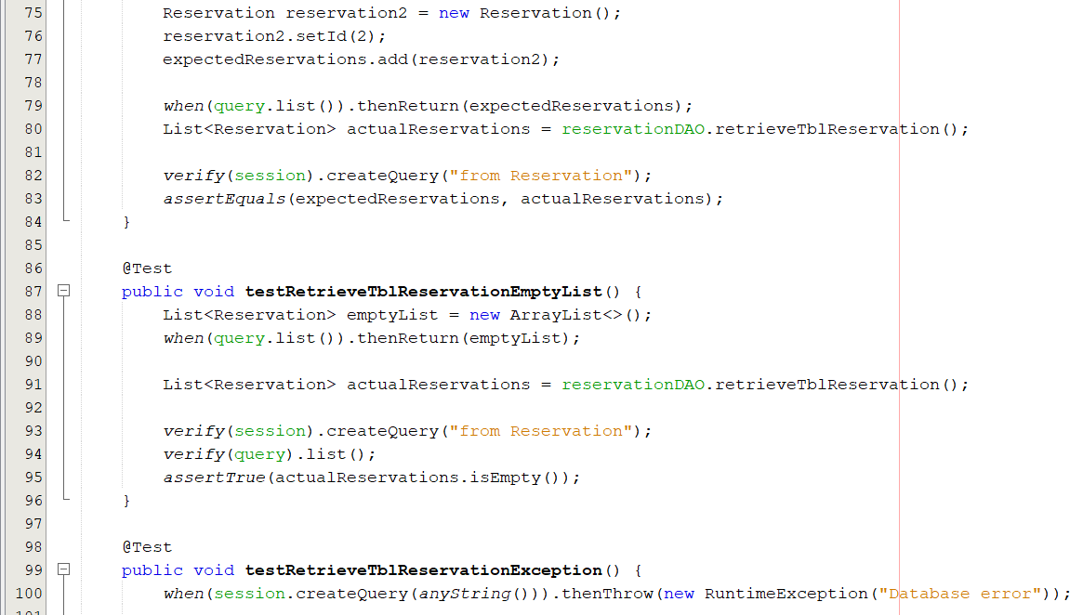

**TESTING IMPLEMENTATION**

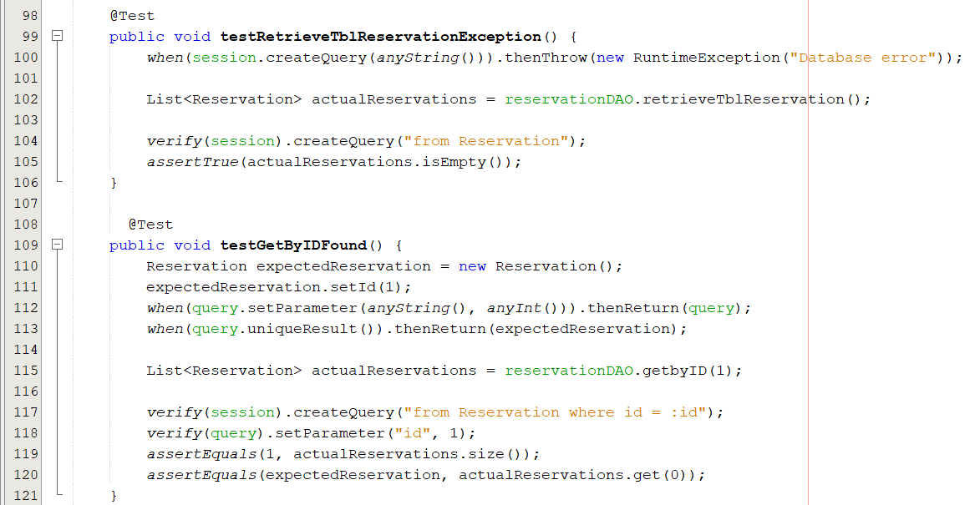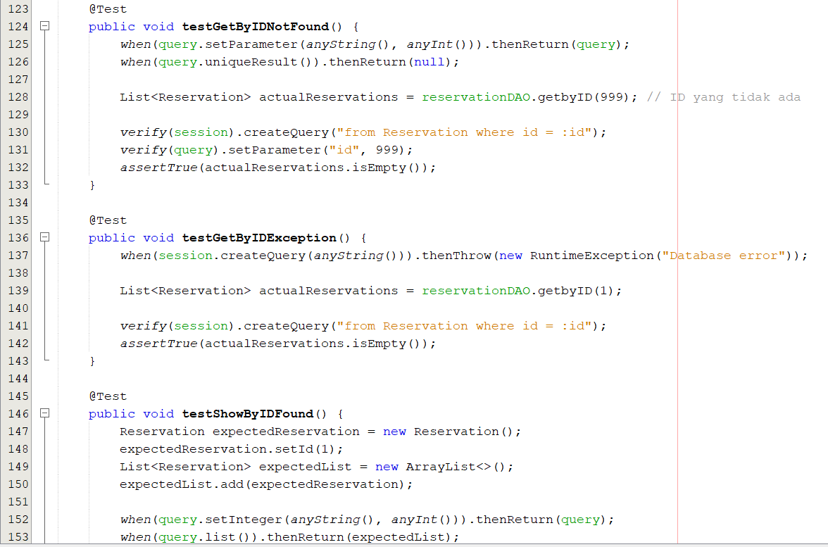

**TESTING IMPLEMENTATION**

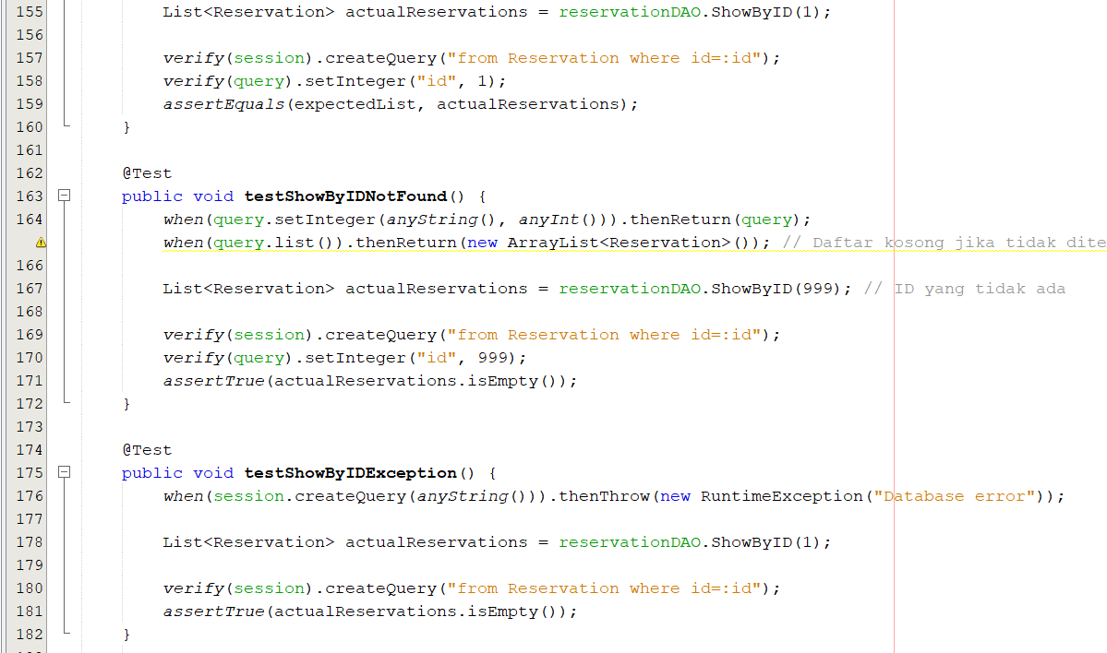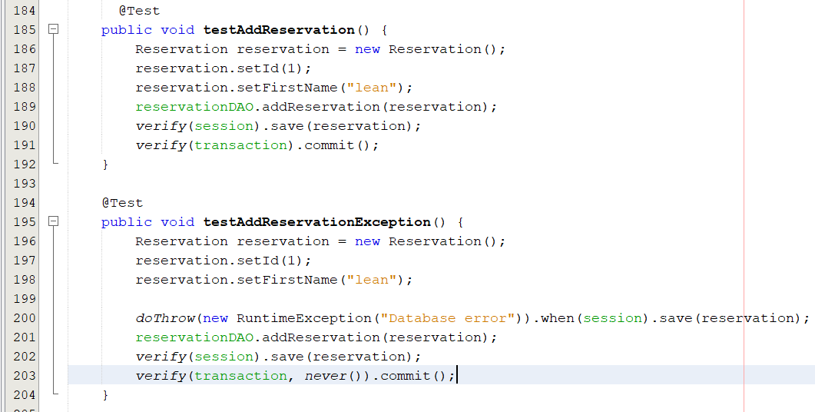

**TESTING IMPLEMENTATION**

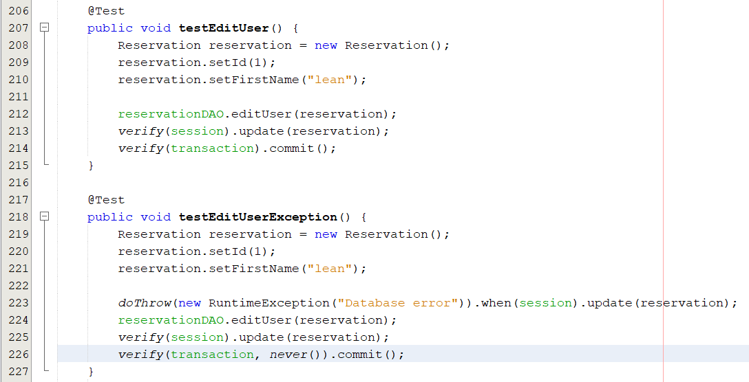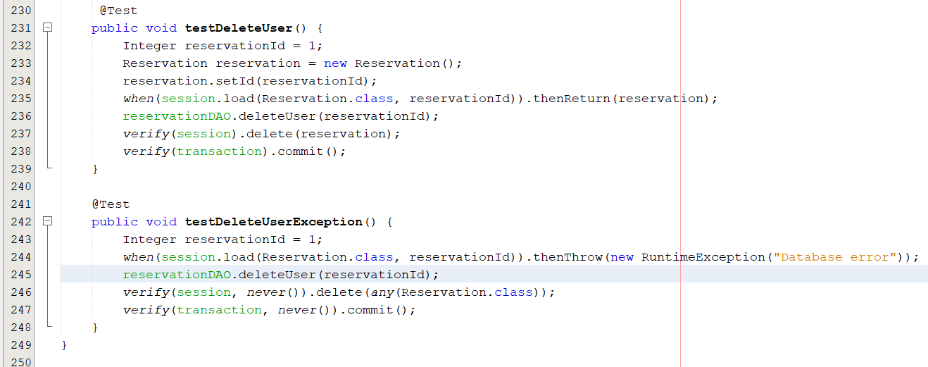

**TESTING IMPLEMENTATION**

**5. ScheduleDAOTest.java**

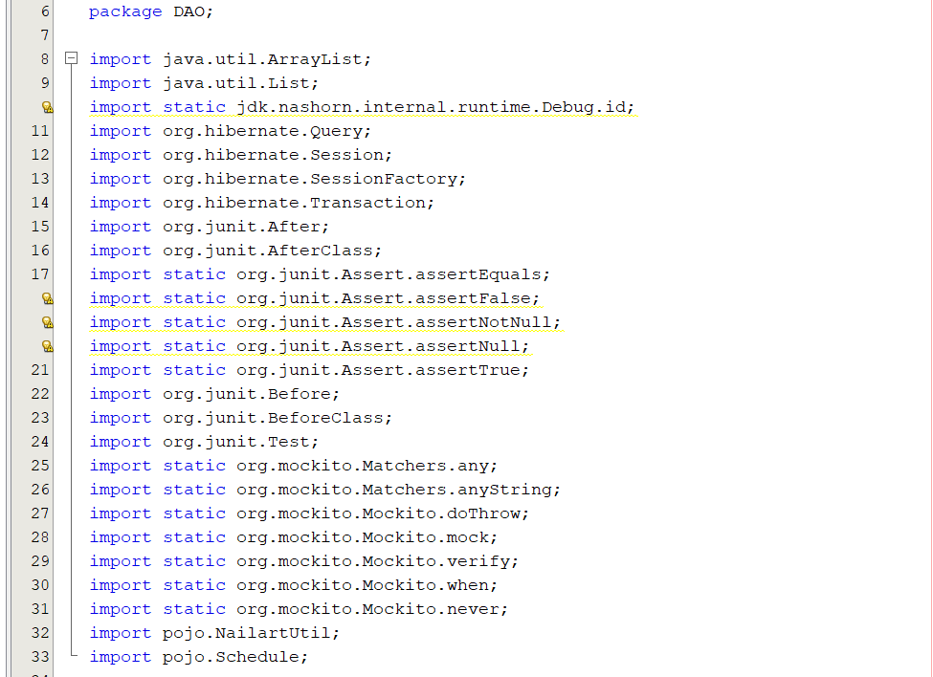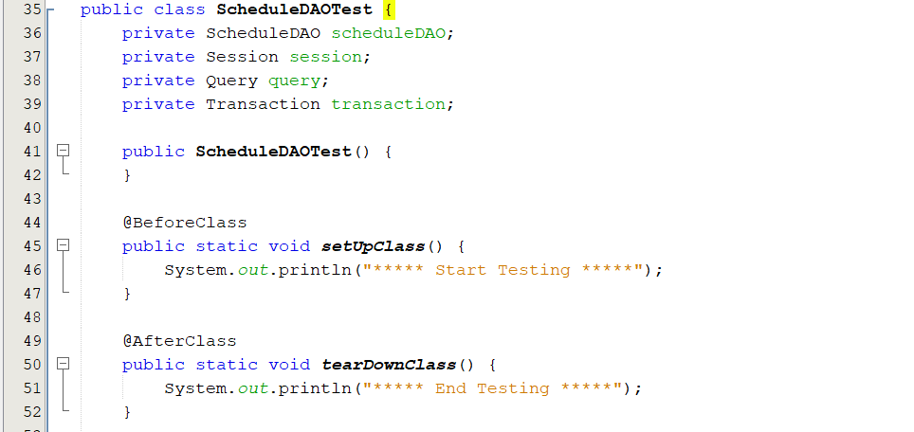

**TESTING IMPLEMENTATION**

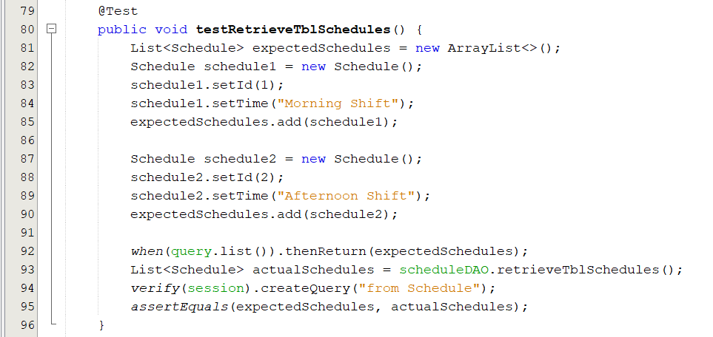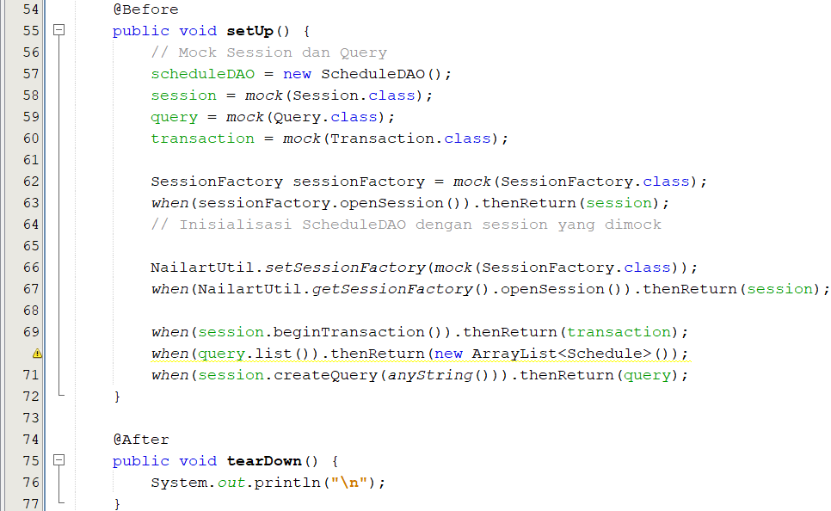

**TESTING IMPLEMENTATION**

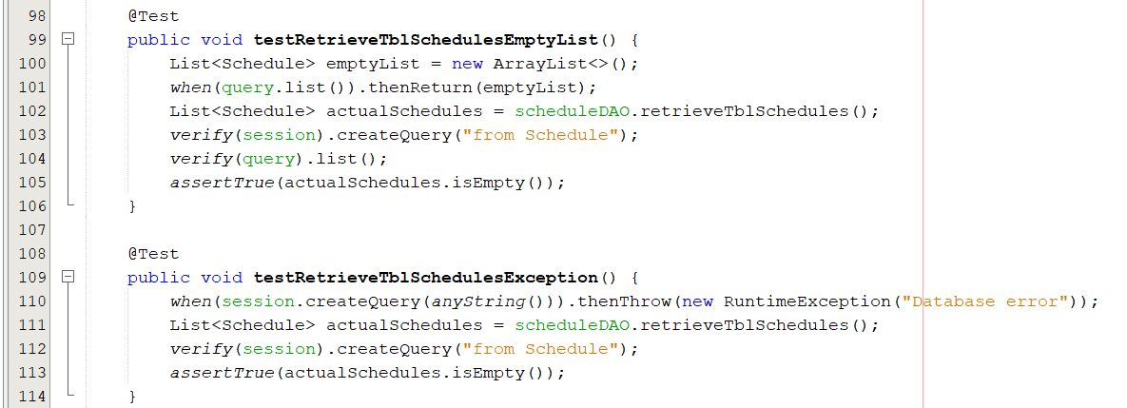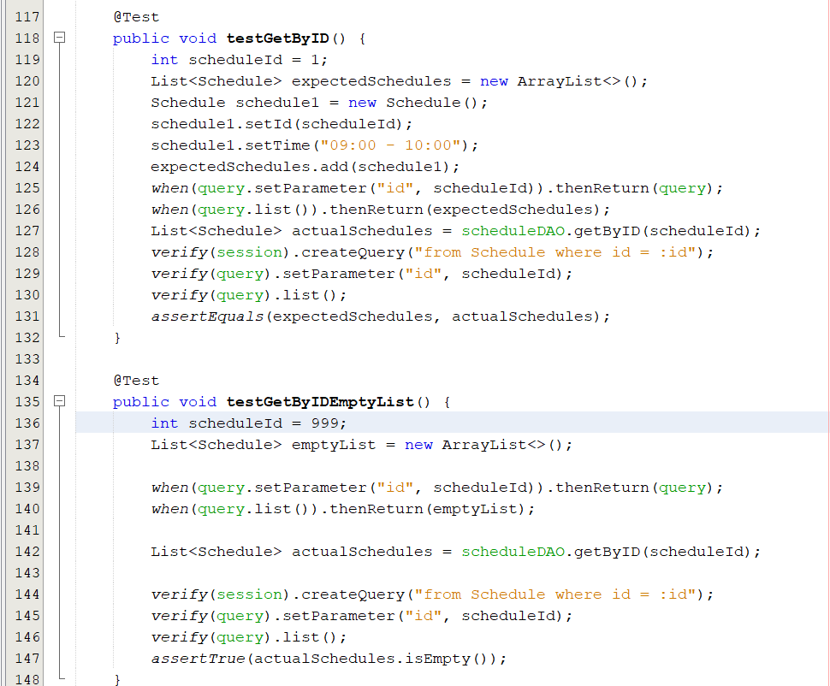

**TESTING IMPLEMENTATION**

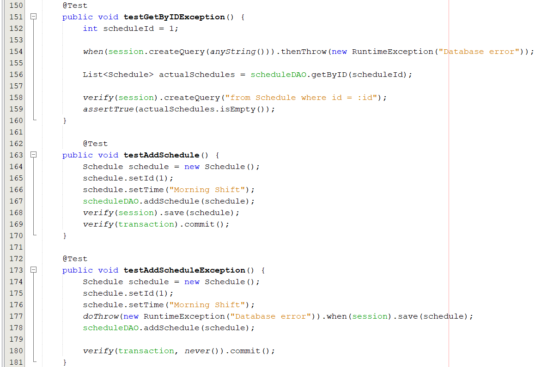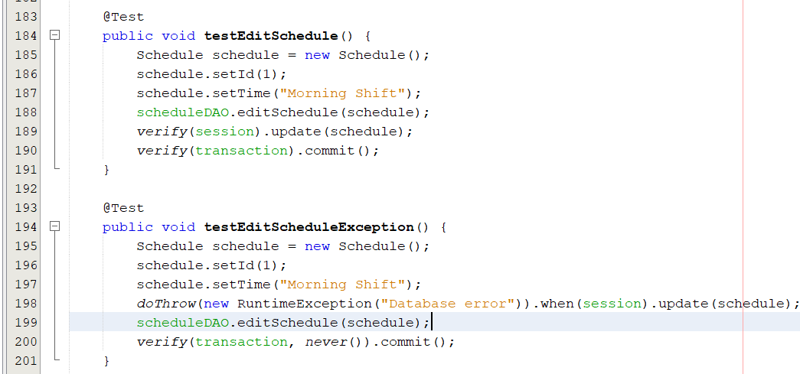

**TESTING IMPLEMENTATION**

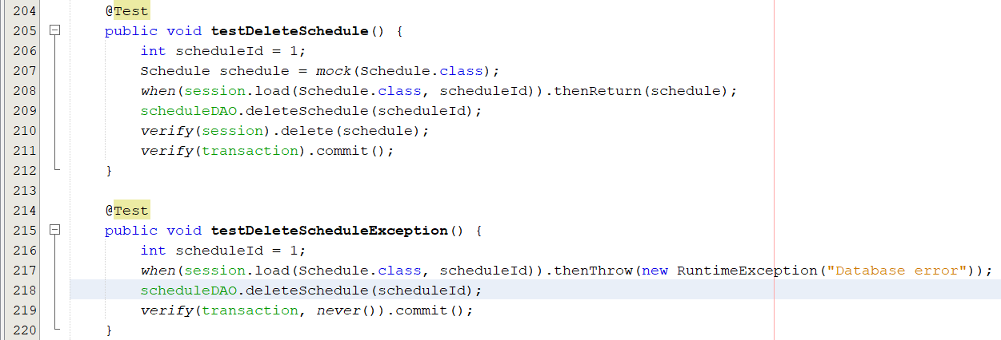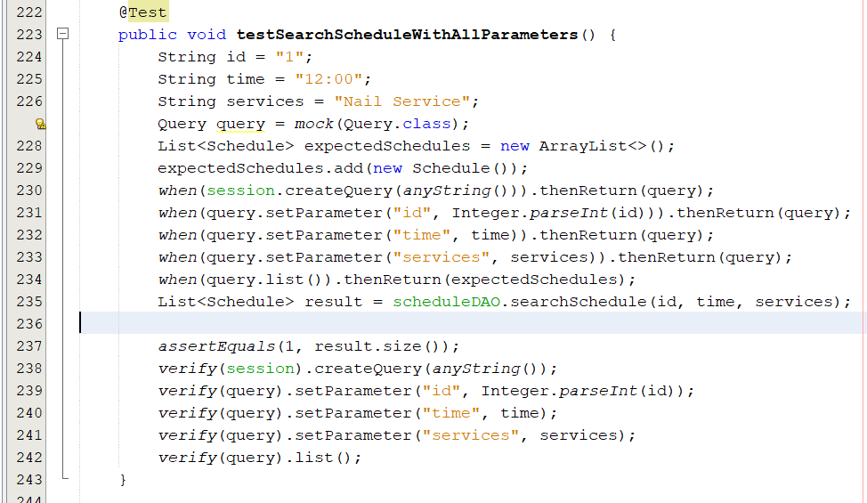

**TESTING IMPLEMENTATION**

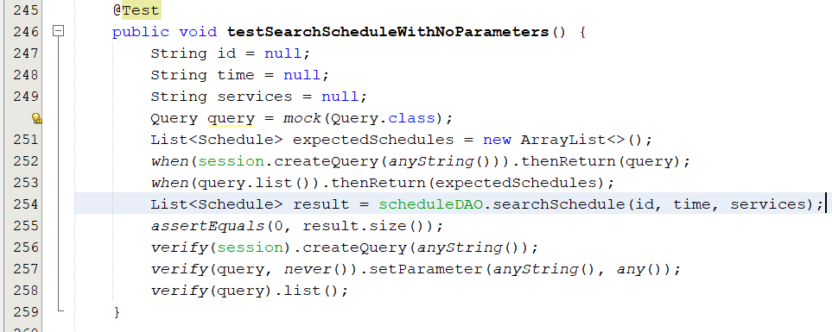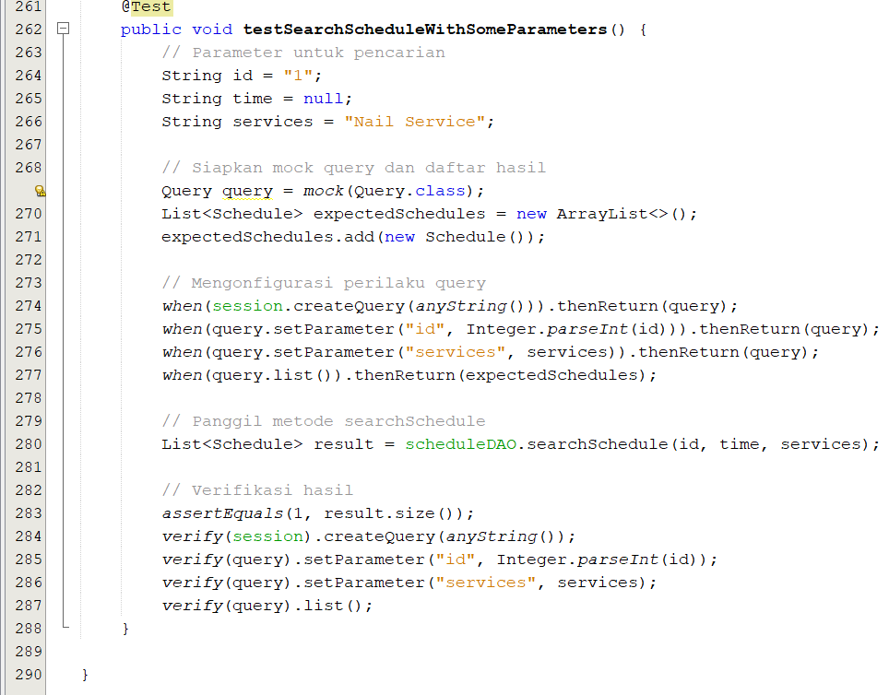

**TESTING IMPLEMENTATION**

**Pojo**

**1. CategoryTest.java**

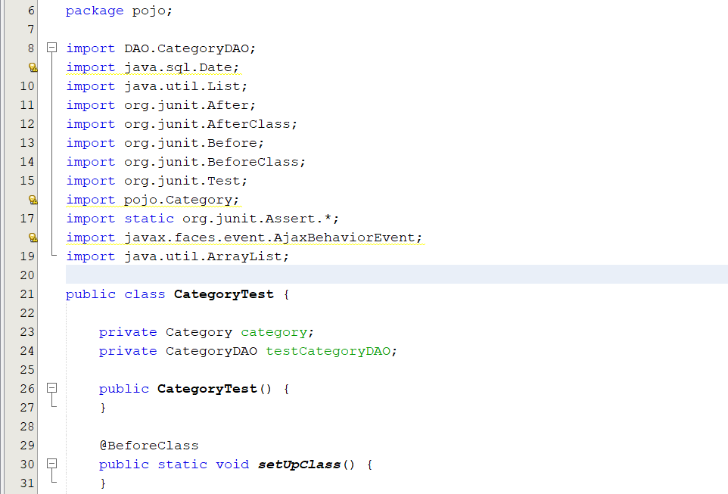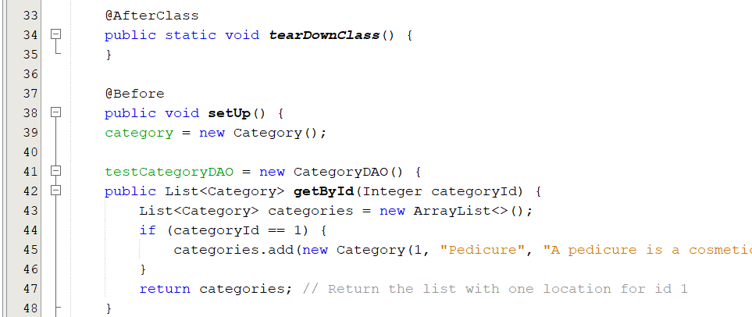

**TESTING IMPLEMENTATION**

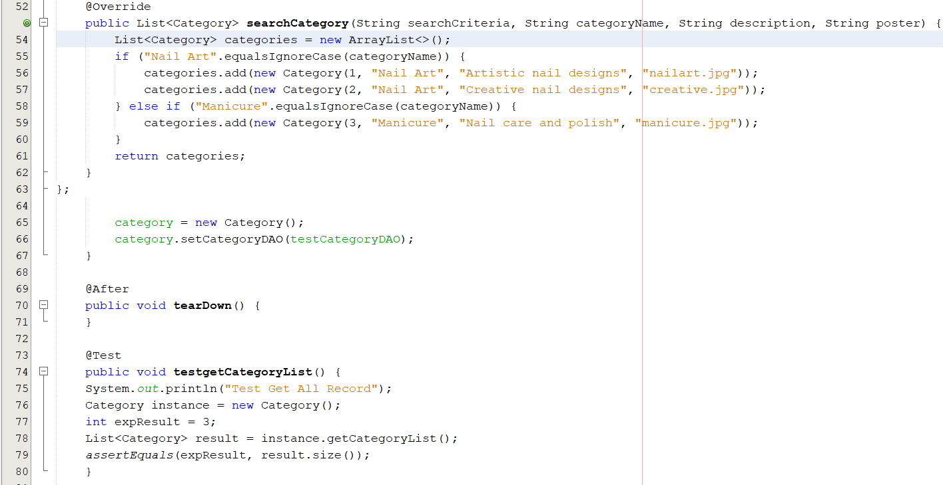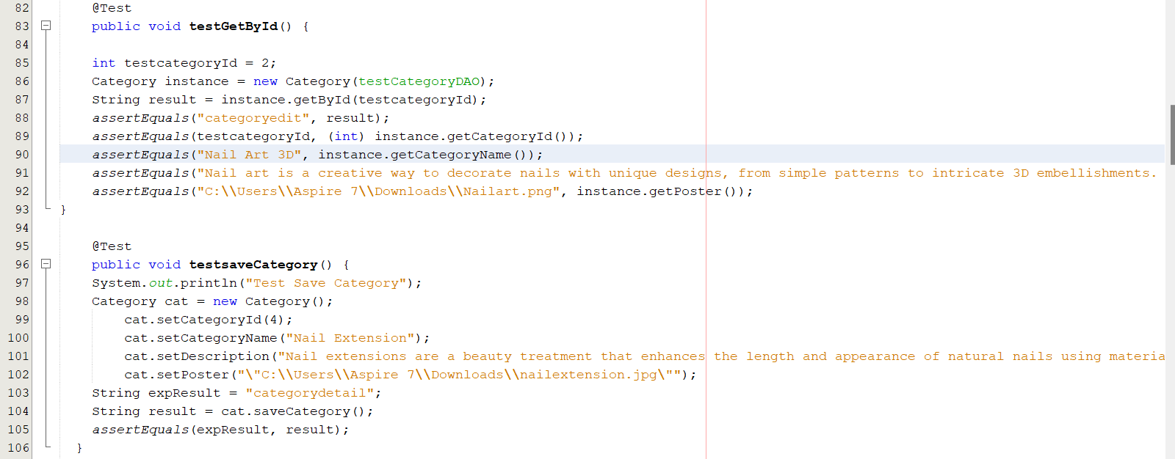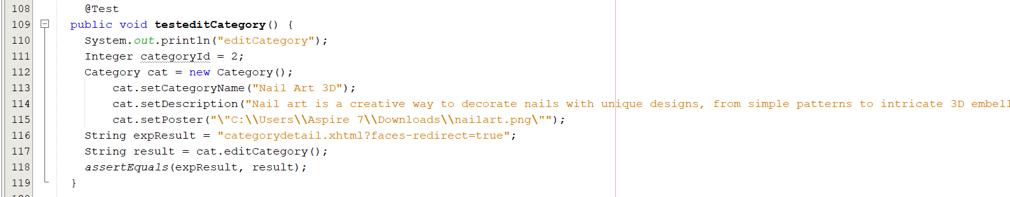

**TESTING IMPLEMENTATION**

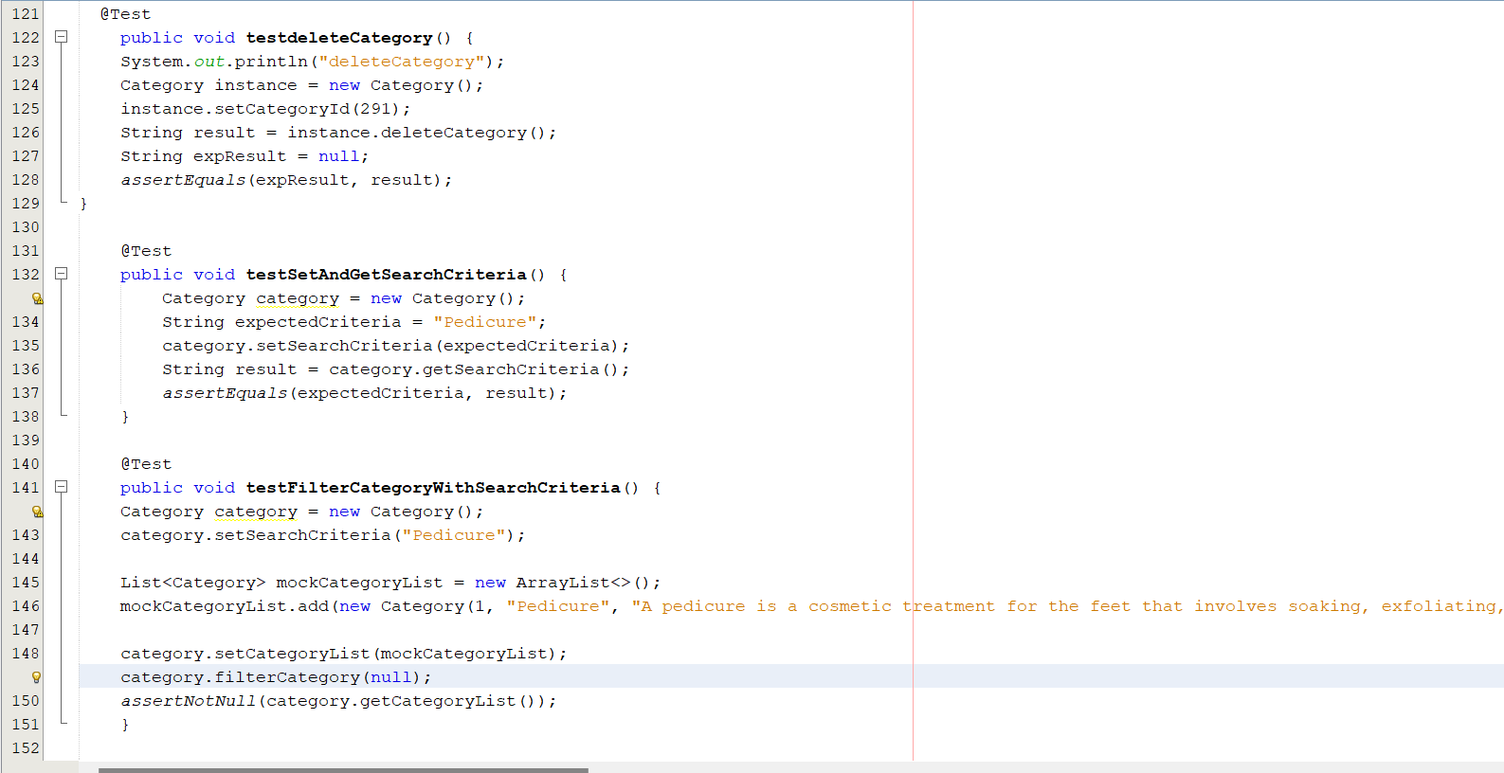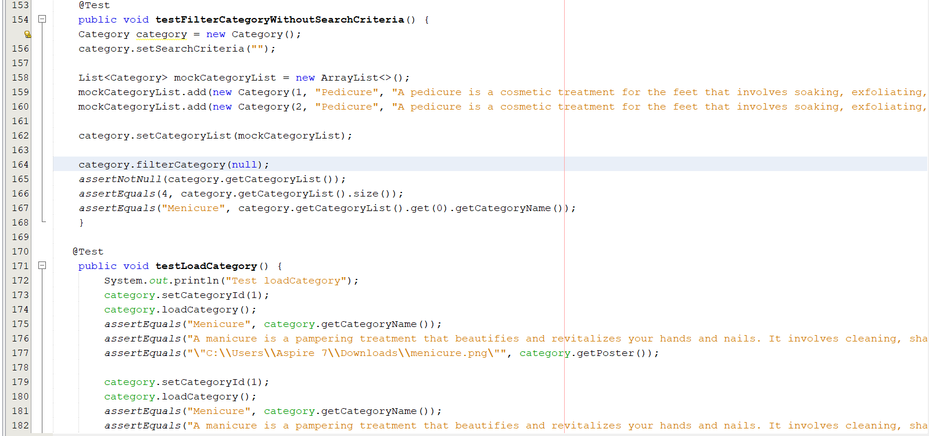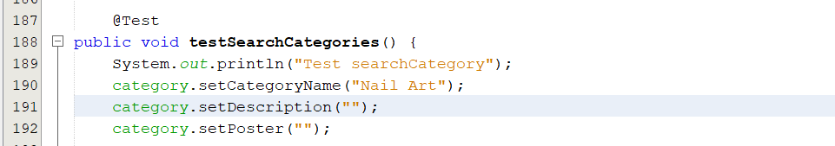

**TESTING IMPLEMENTATION**

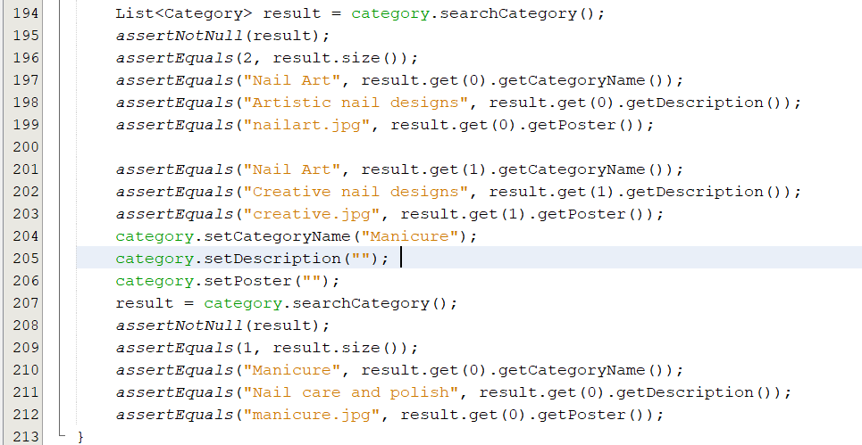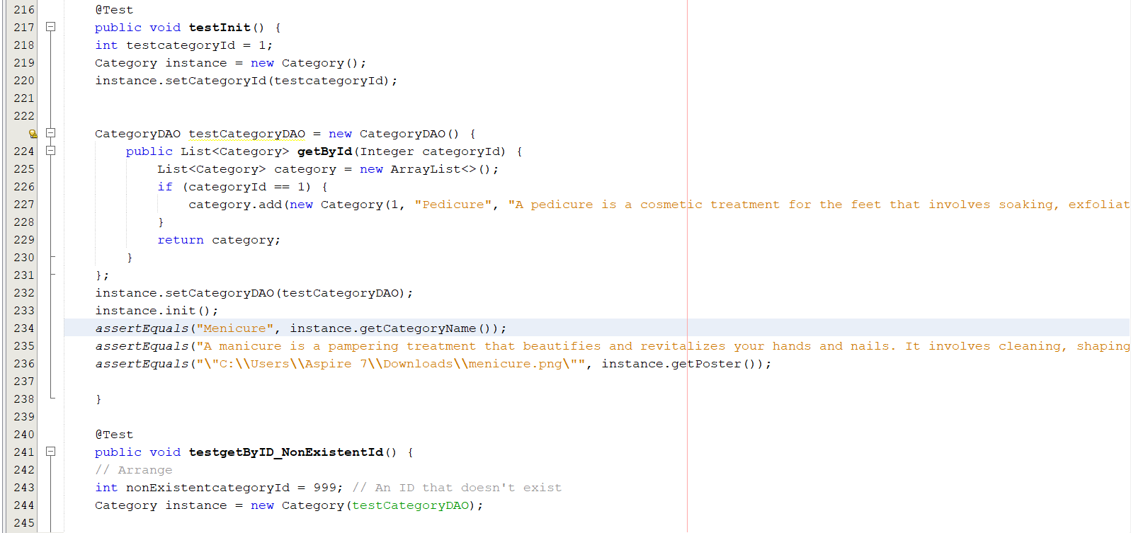

**TESTING IMPLEMENTATION**

**2. HttpSessionStub.java**

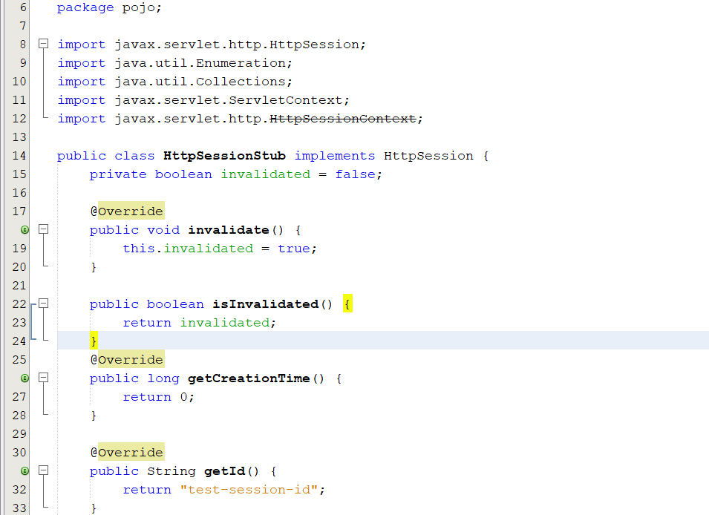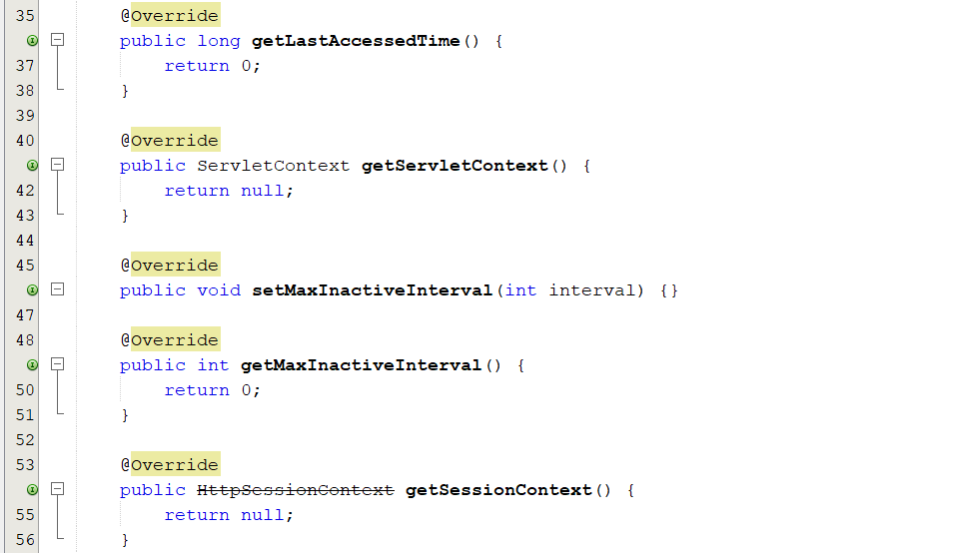

**TESTING IMPLEMENTATION**

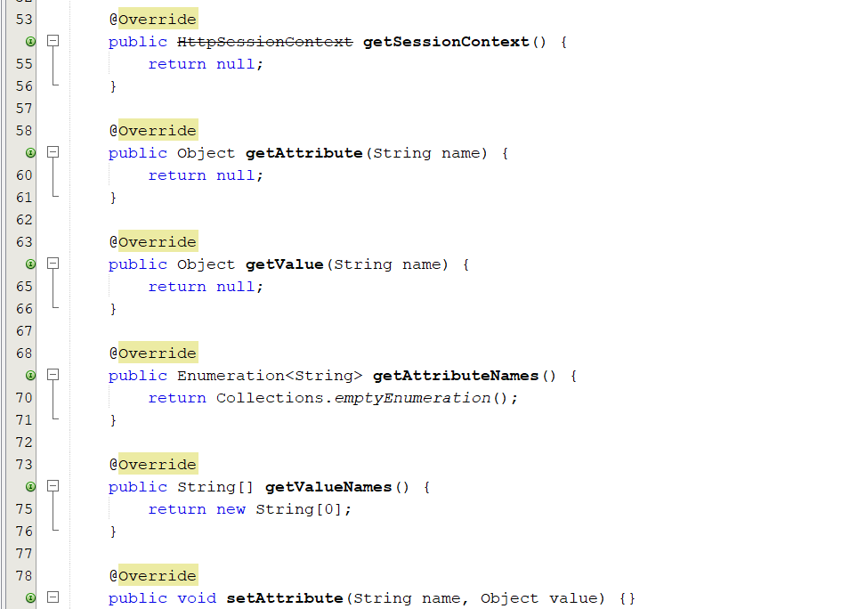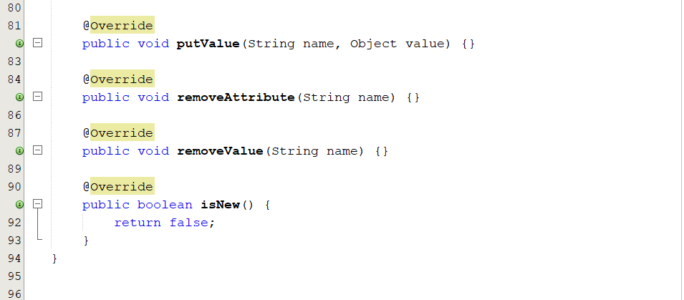

**TESTING IMPLEMENTATION**

**3. LocationTest.java**

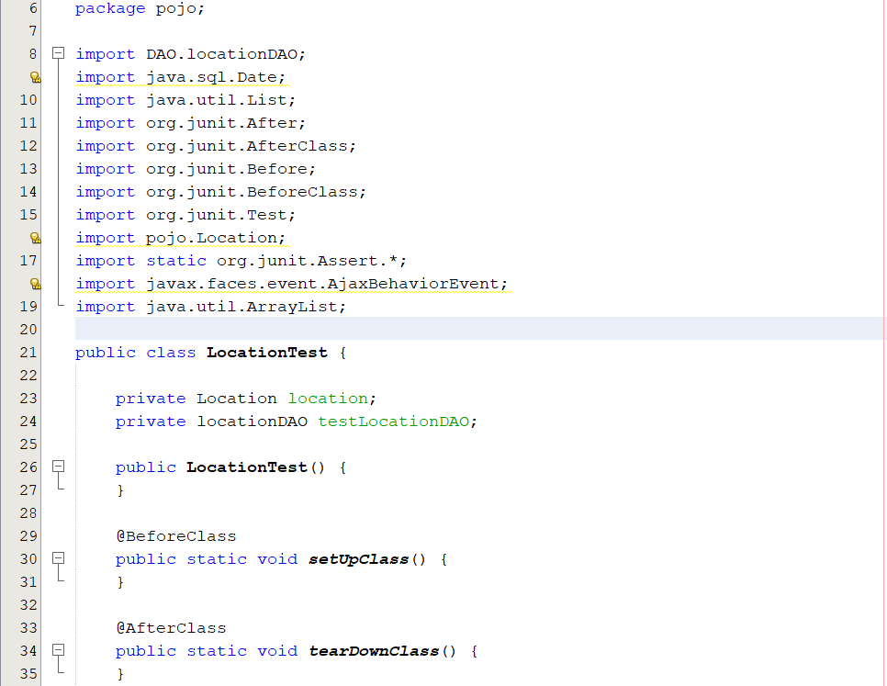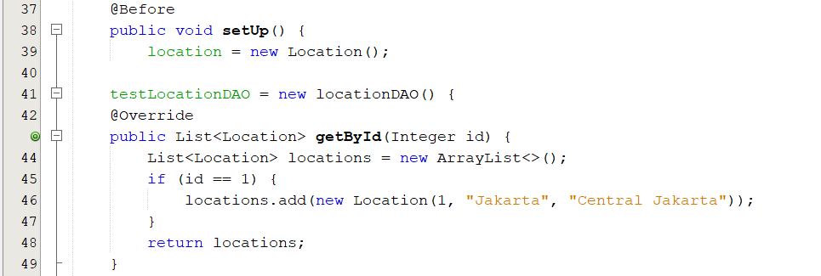

**TESTING IMPLEMENTATION**

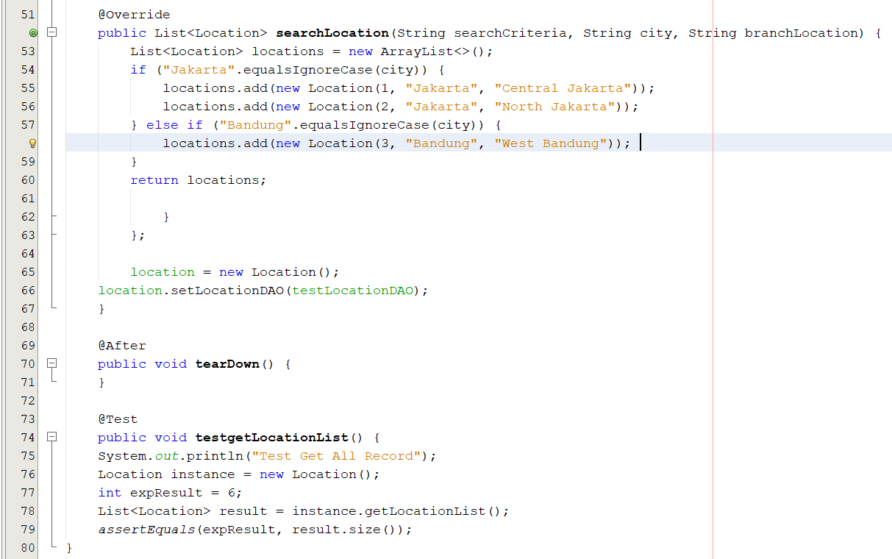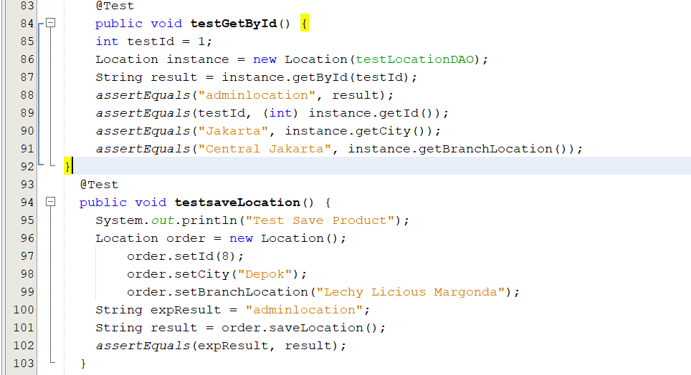

**TESTING IMPLEMENTATION**

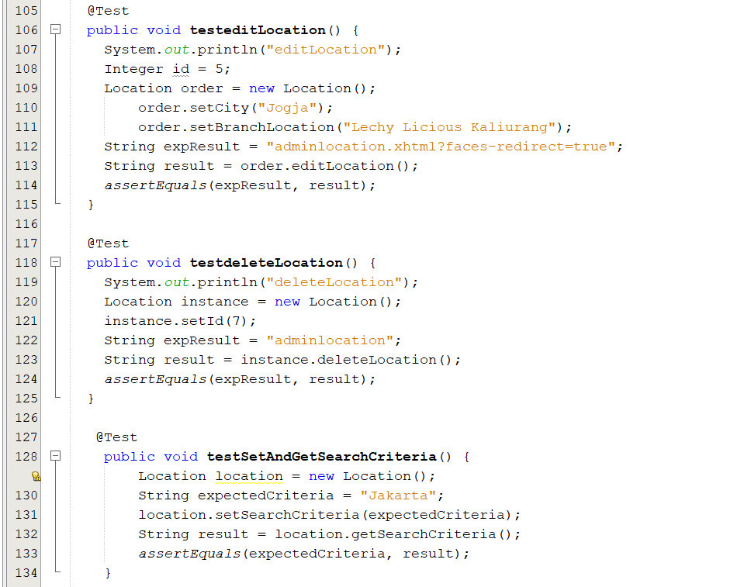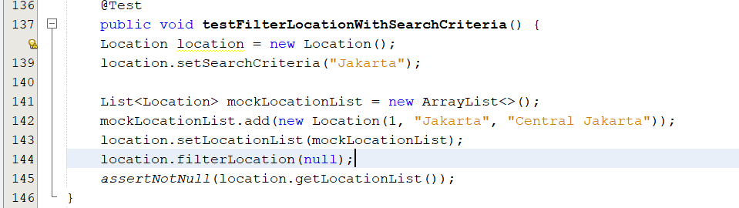

**TESTING IMPLEMENTATION**

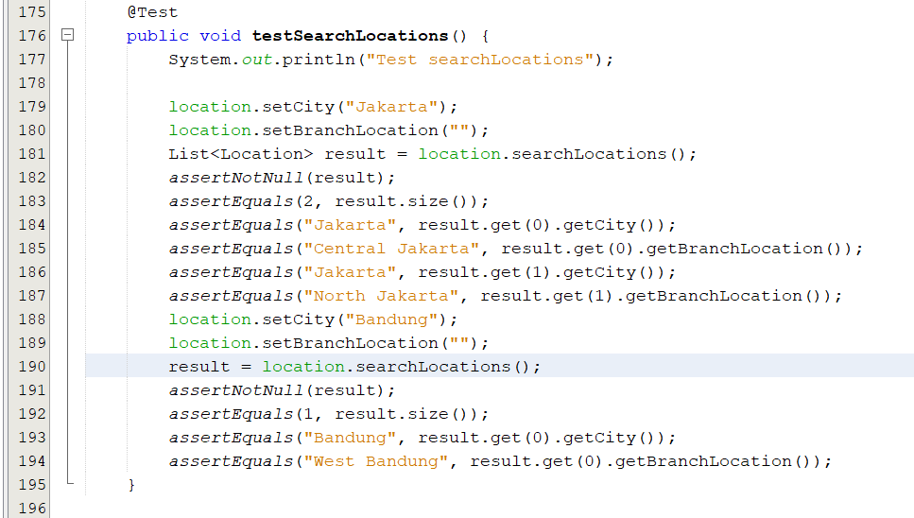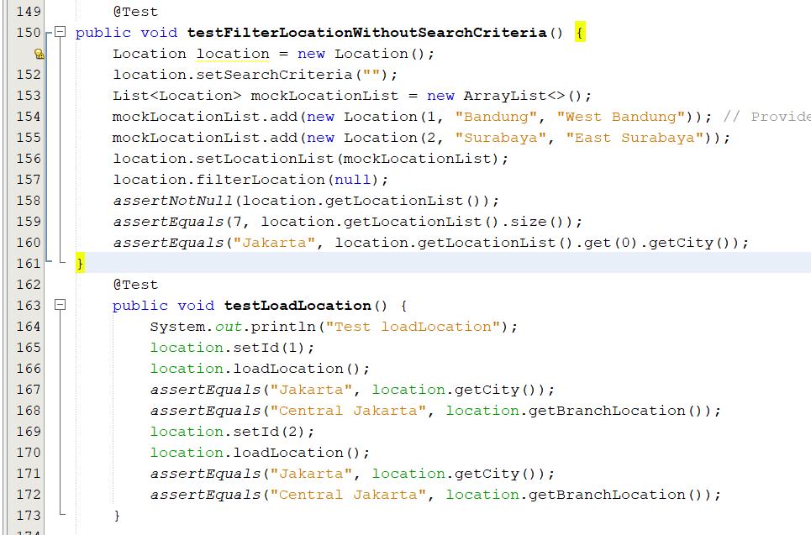

**TESTING IMPLEMENTATION**

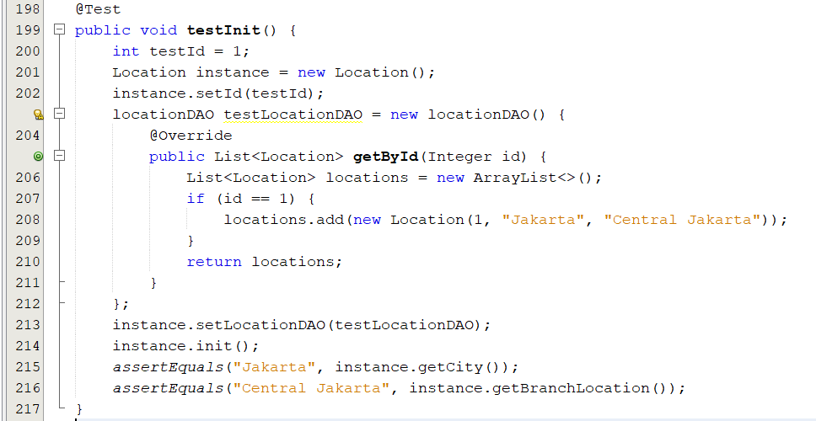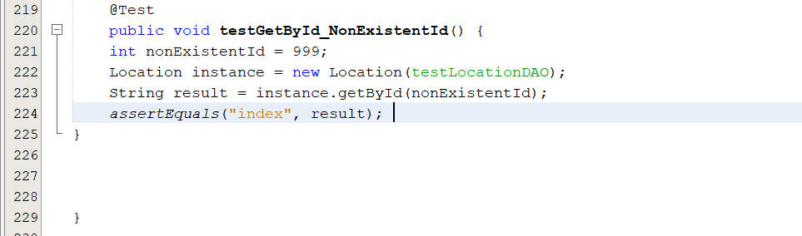

**TESTING IMPLEMENTATION**

**4. LoginTest.java**

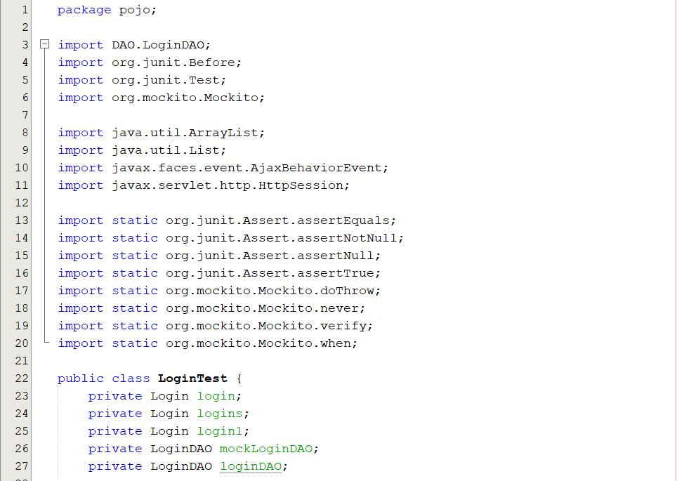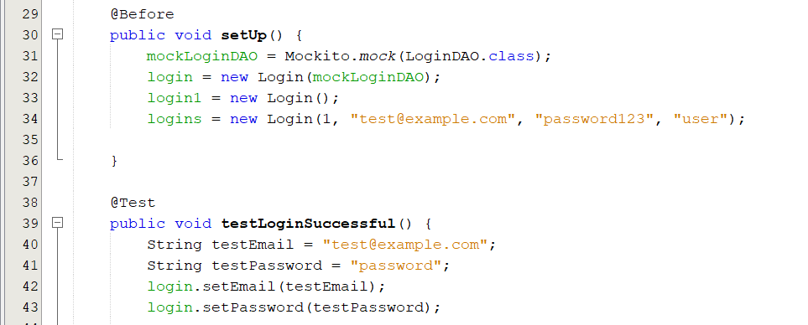

**TESTING IMPLEMENTATION**

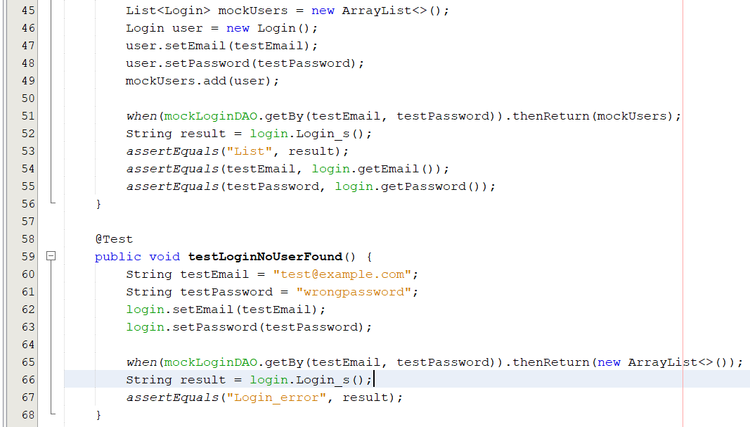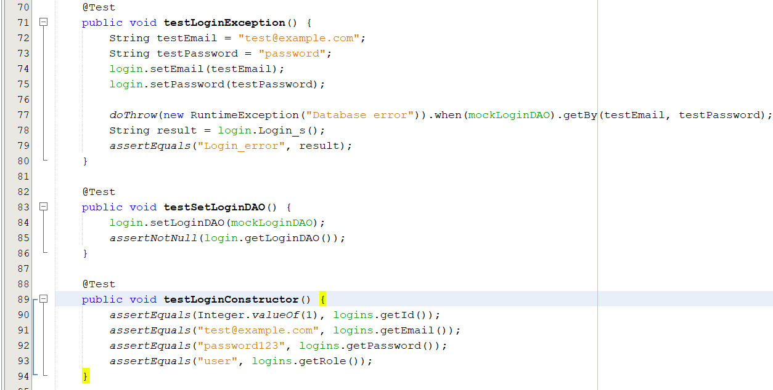

**TESTING IMPLEMENTATION**

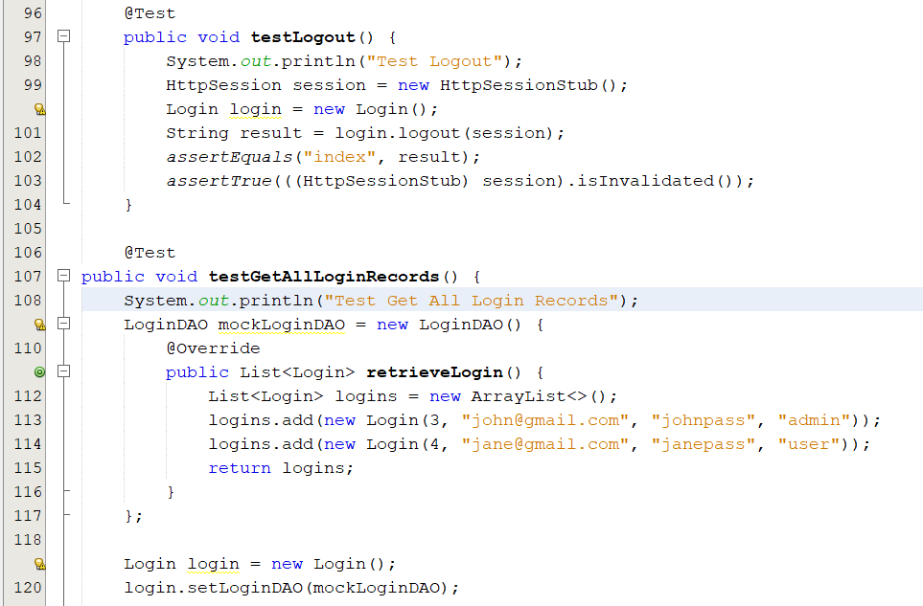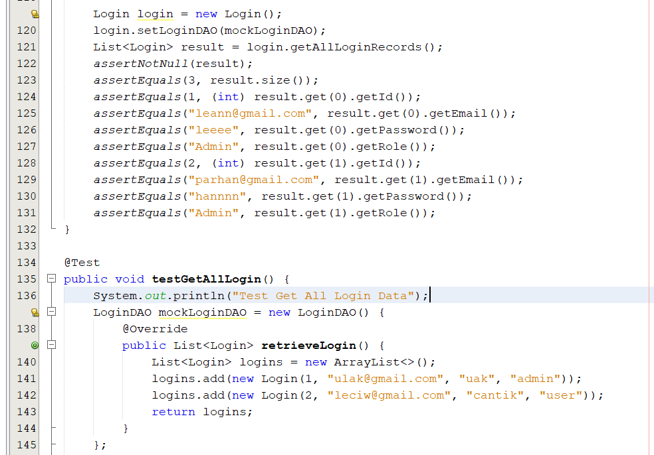

**TESTING IMPLEMENTATION**

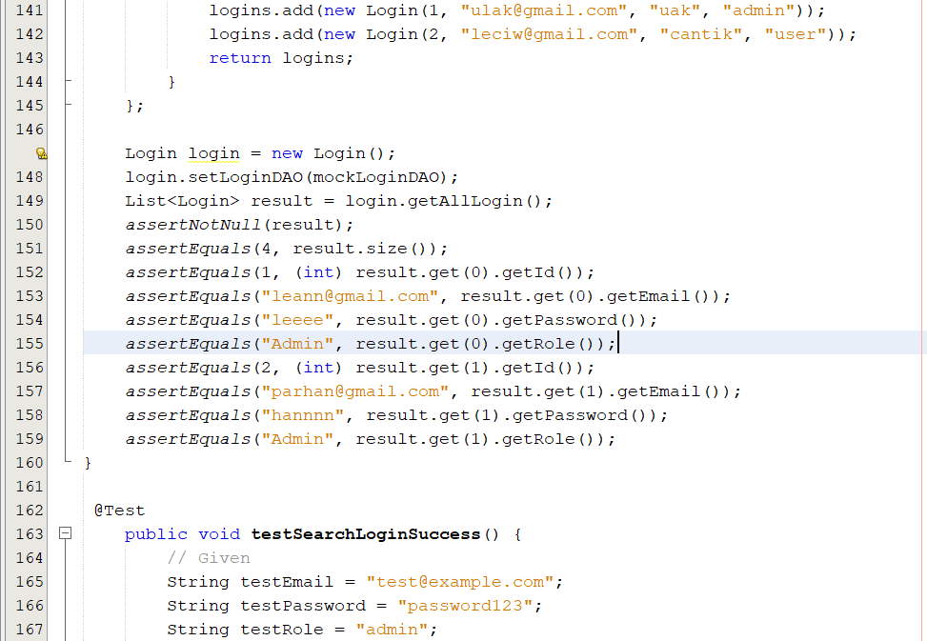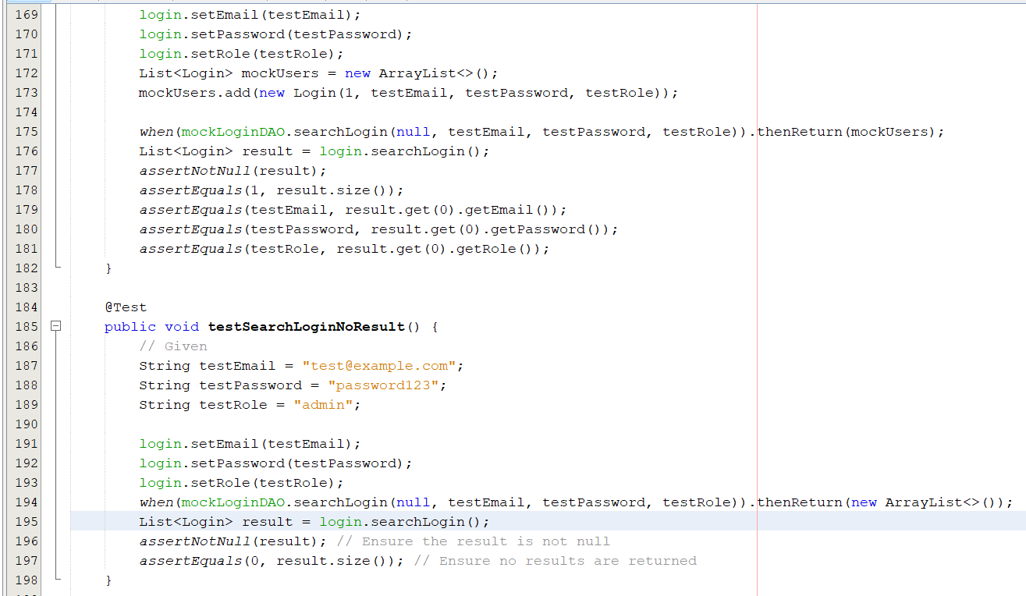

**TESTING IMPLEMENTATION**

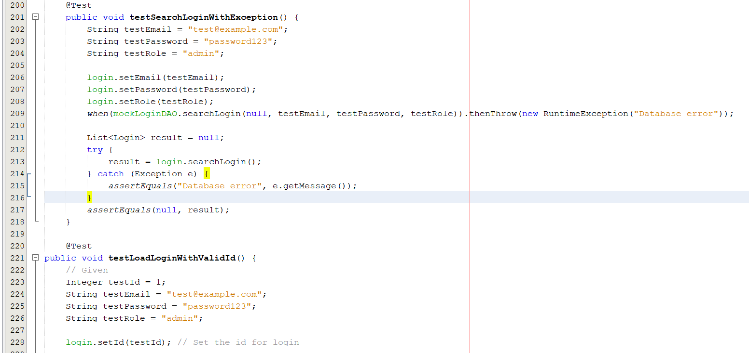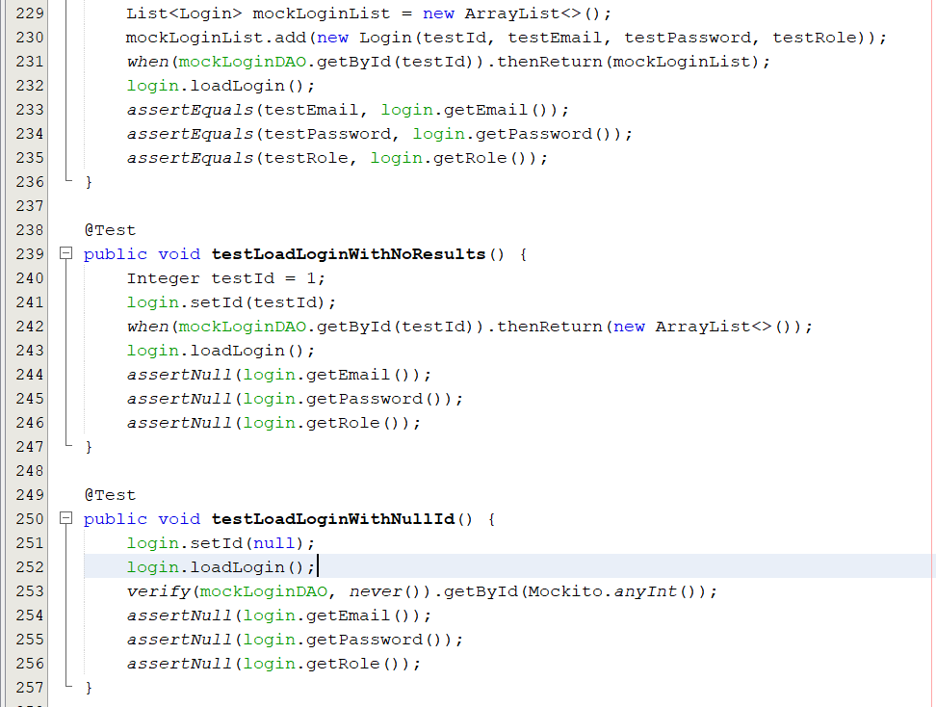

**TESTING IMPLEMENTATION**

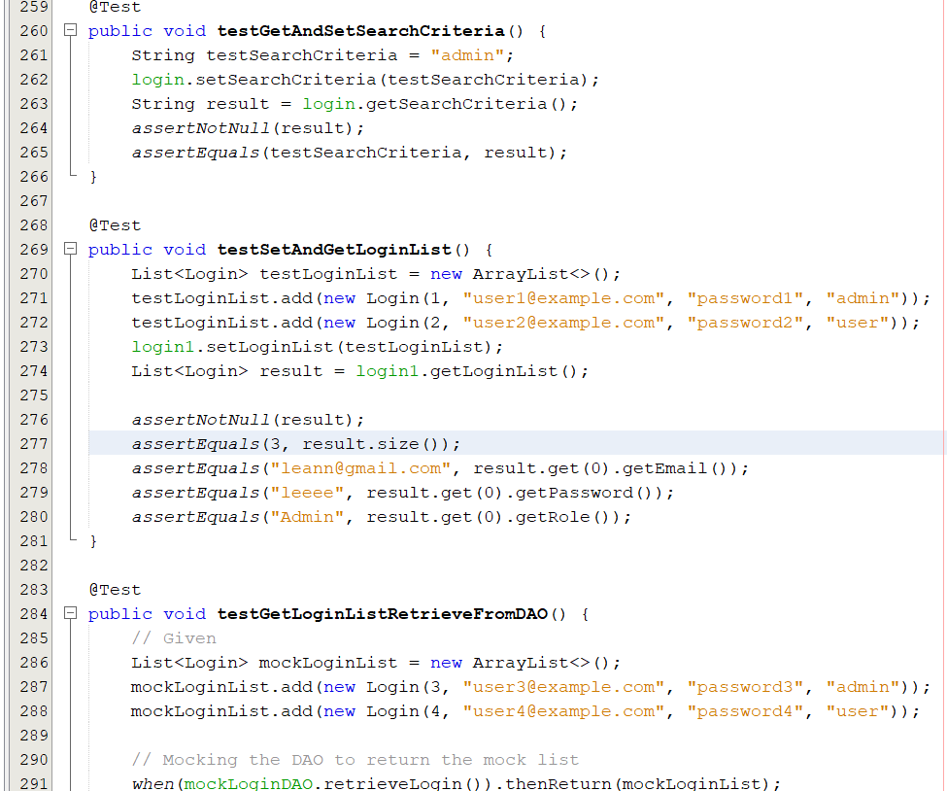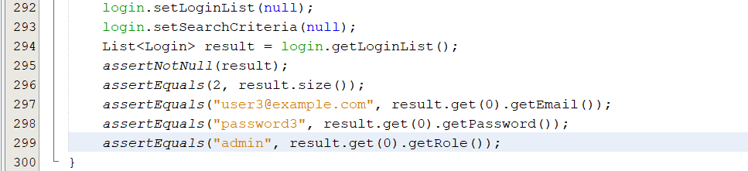

**TESTING IMPLEMENTATION**

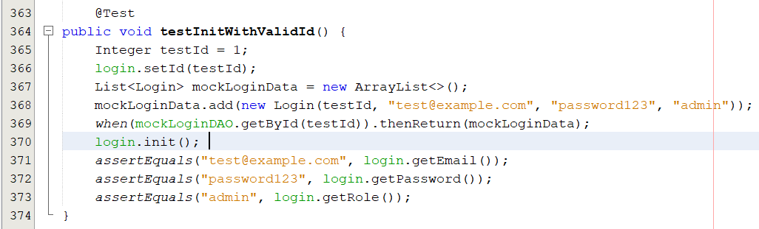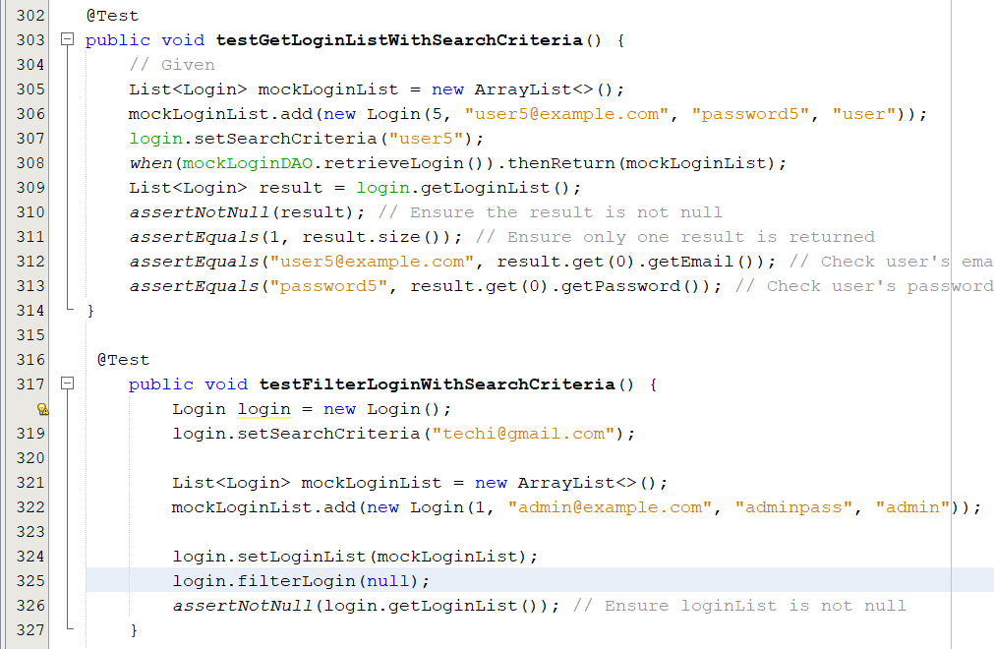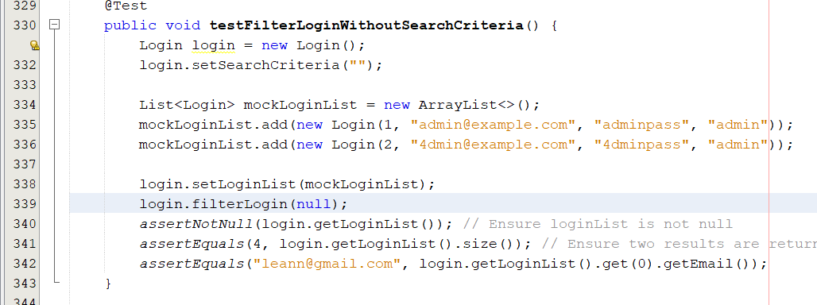

**TESTING IMPLEMENTATION**

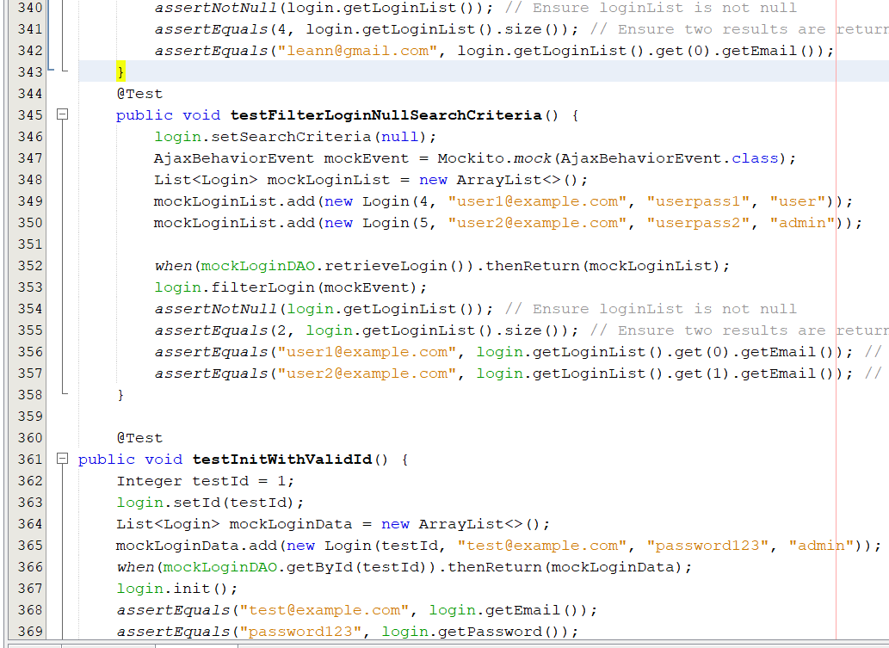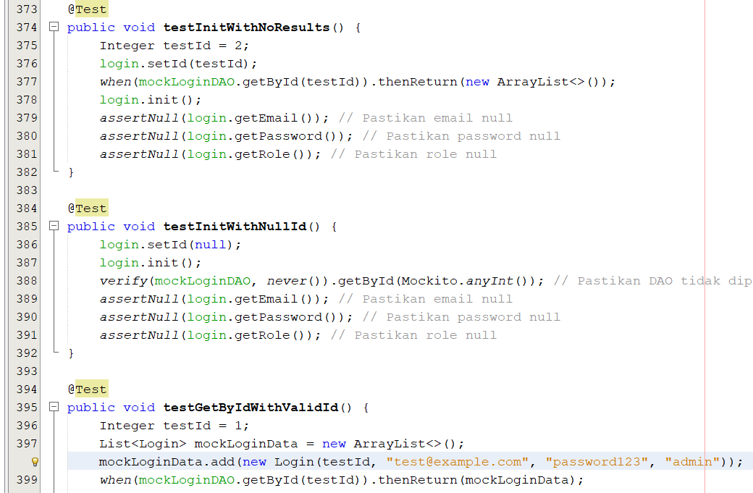

**TESTING IMPLEMENTATION**

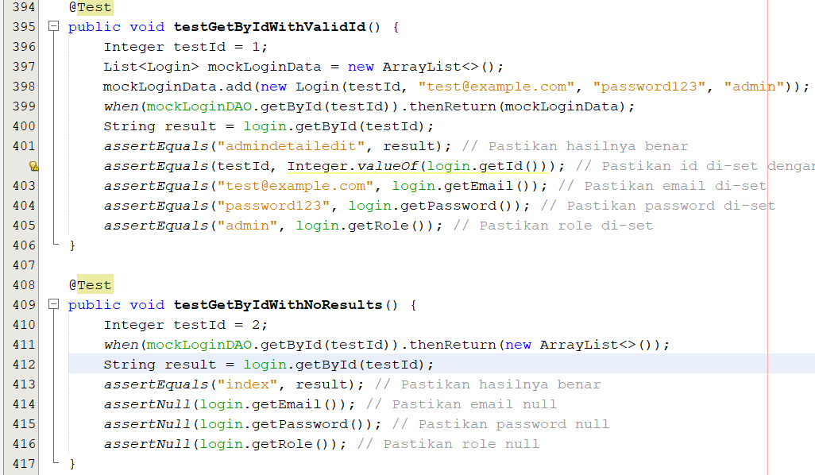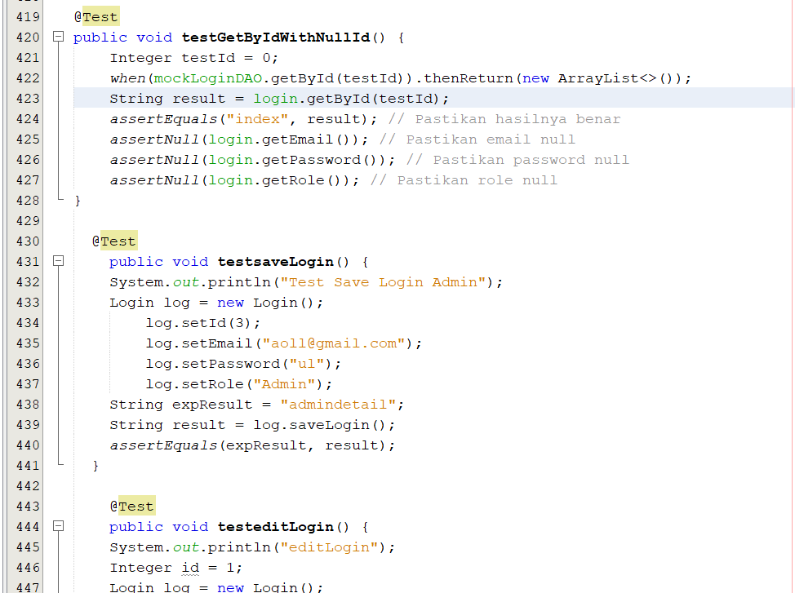

**TESTING IMPLEMENTATION**

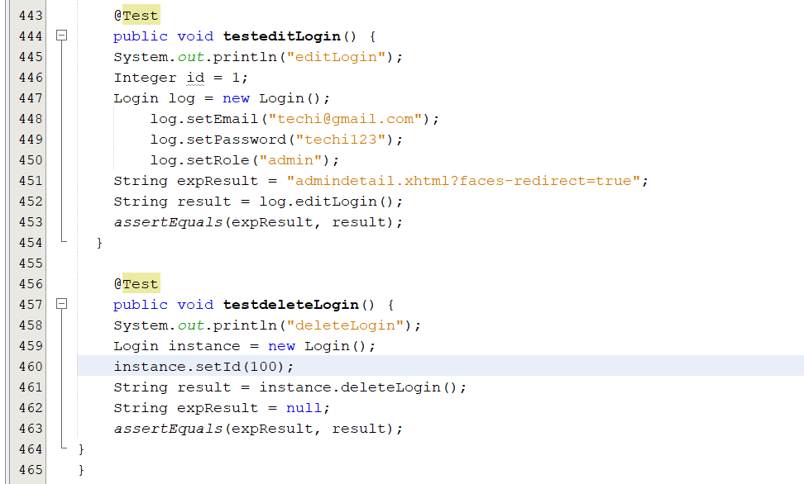

**5. NailArtTest.java**

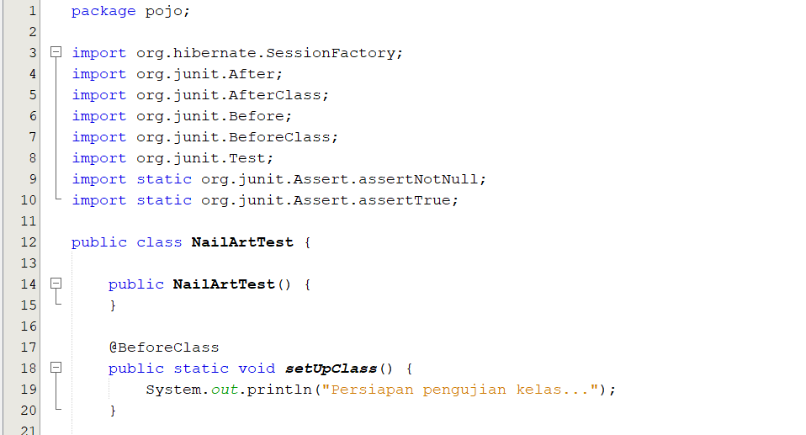

**TESTING IMPLEMENTATION**

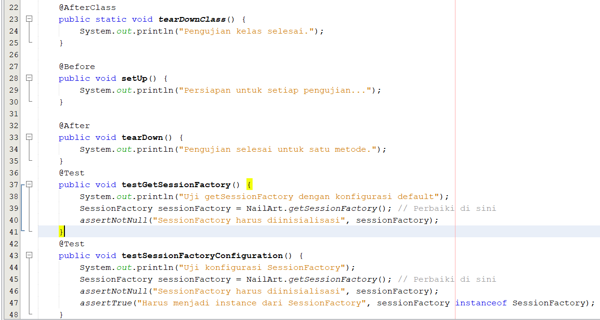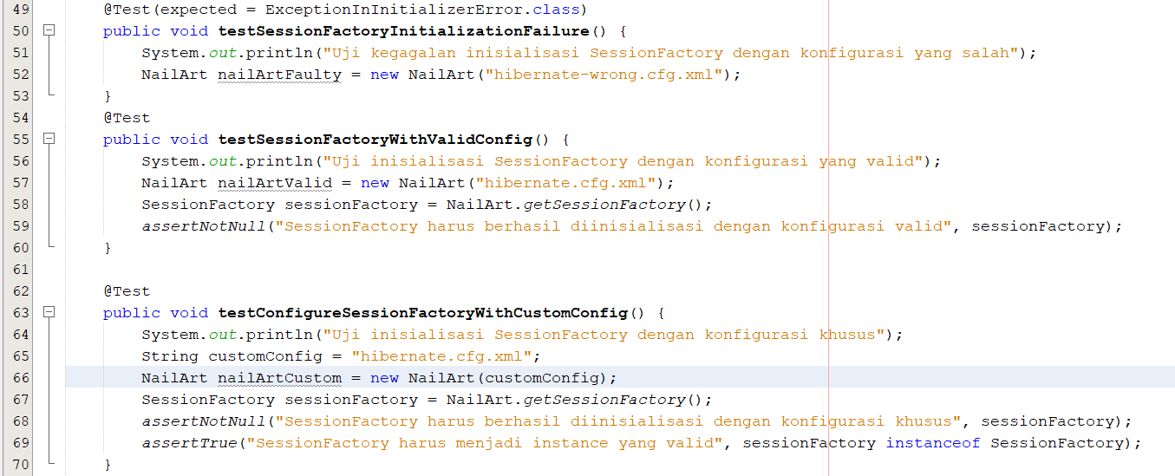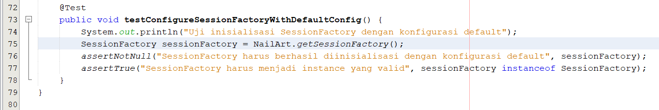

**TESTING IMPLEMENTATION**

**6. NailartUtilTest.java**

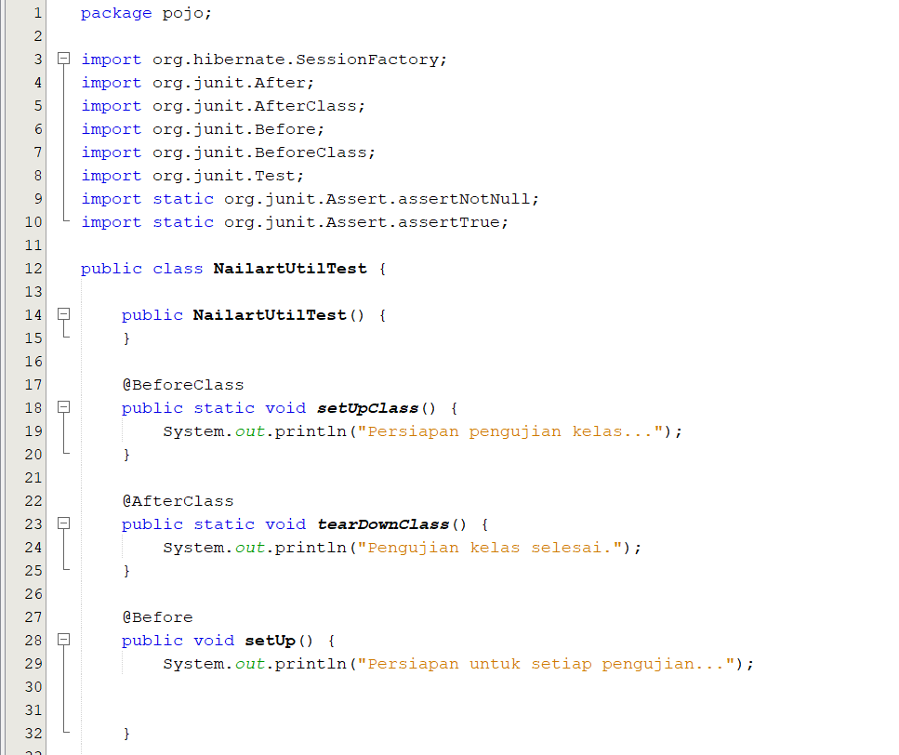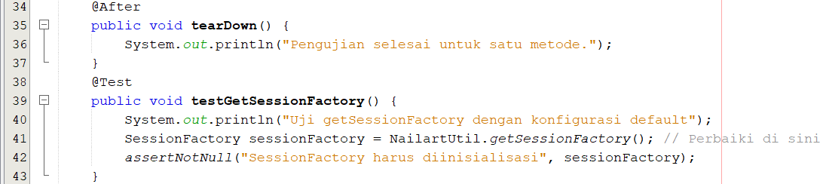

**TESTING IMPLEMENTATION**

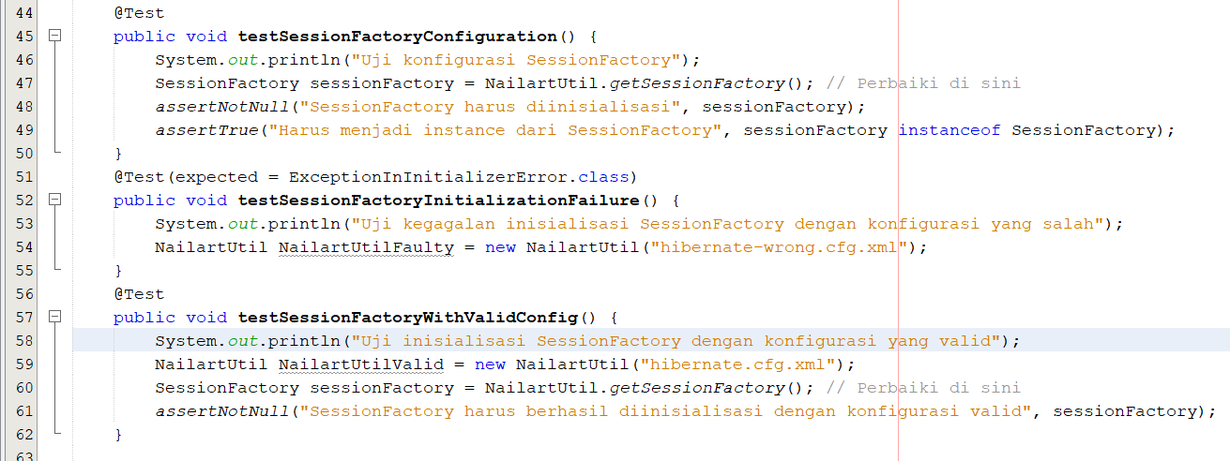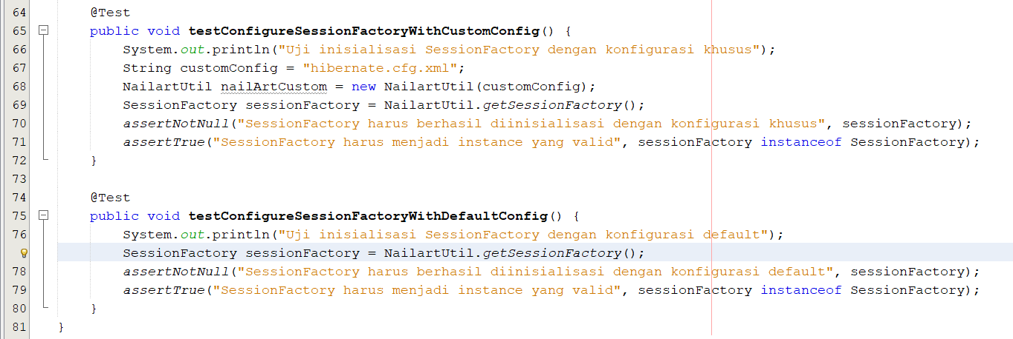

**TESTING IMPLEMENTATION**

**7. ReservationTest.java**

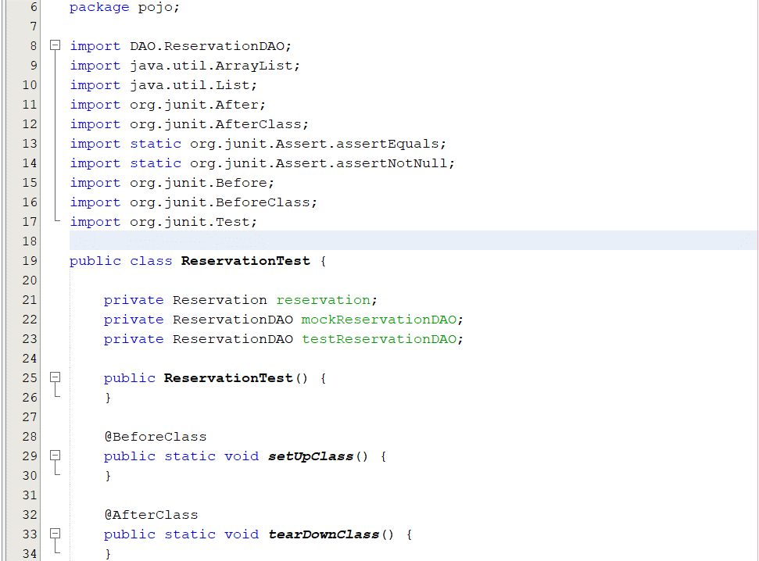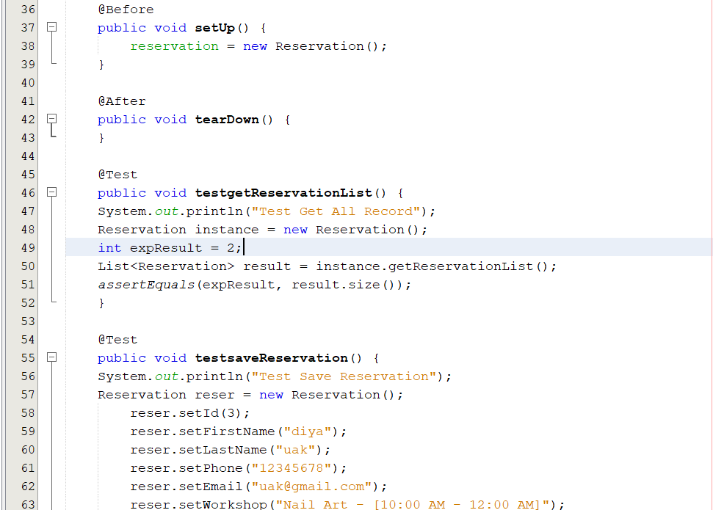

**TESTING IMPLEMENTATION**

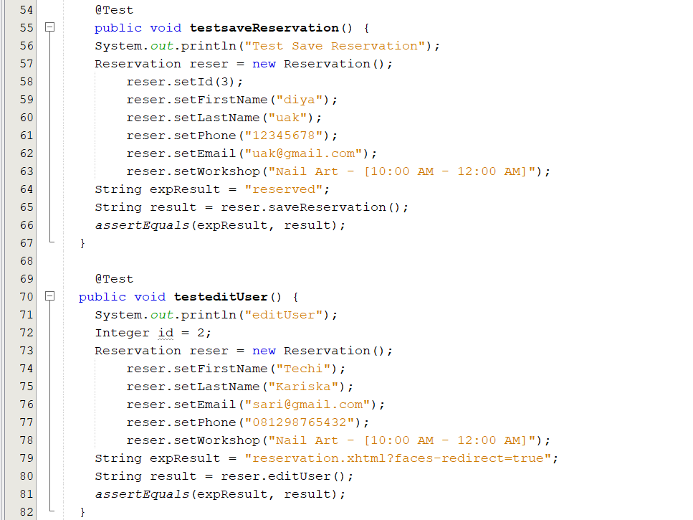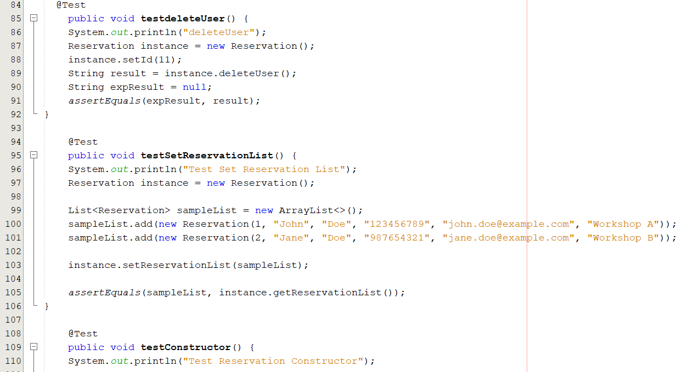

**TESTING IMPLEMENTATION**

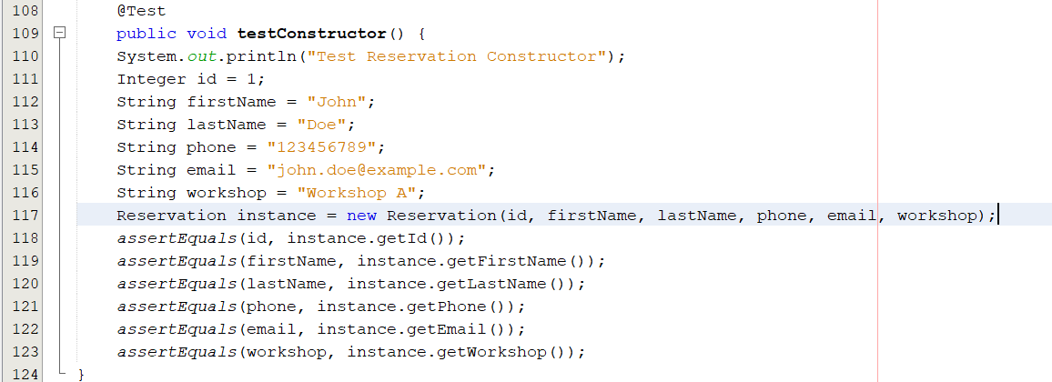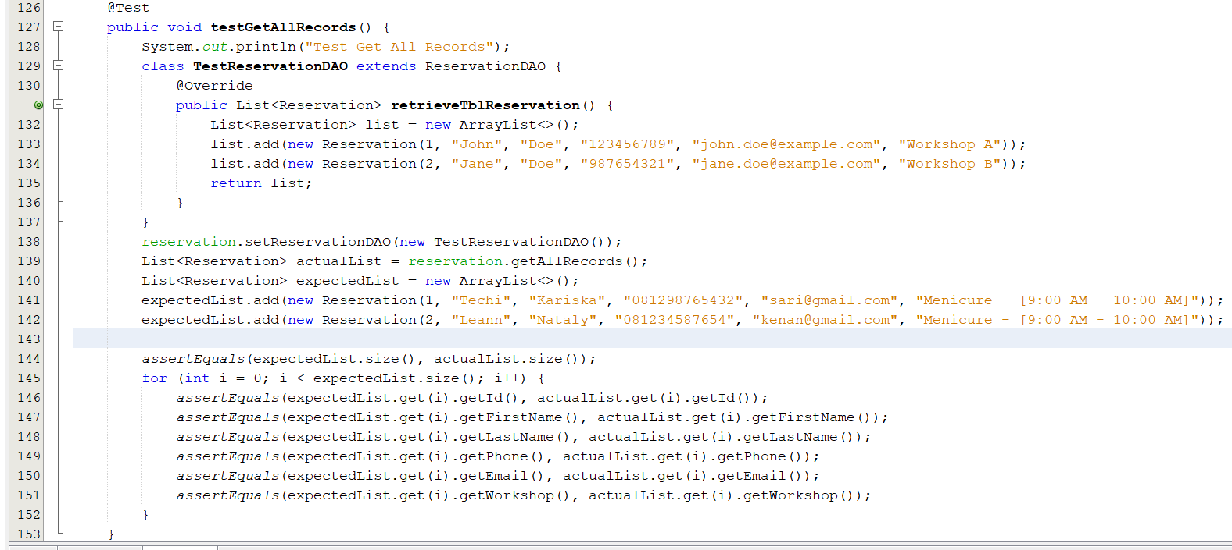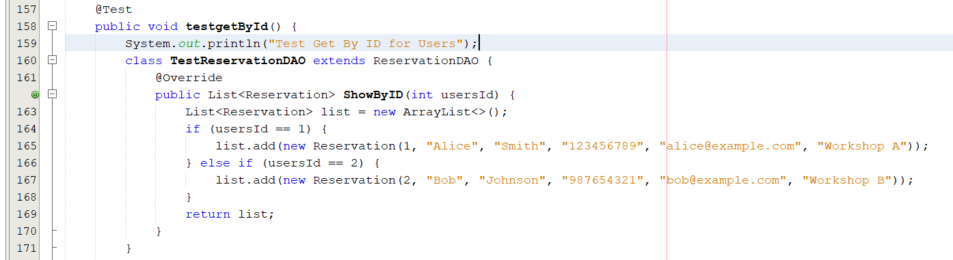

**TESTING IMPLEMENTATION**

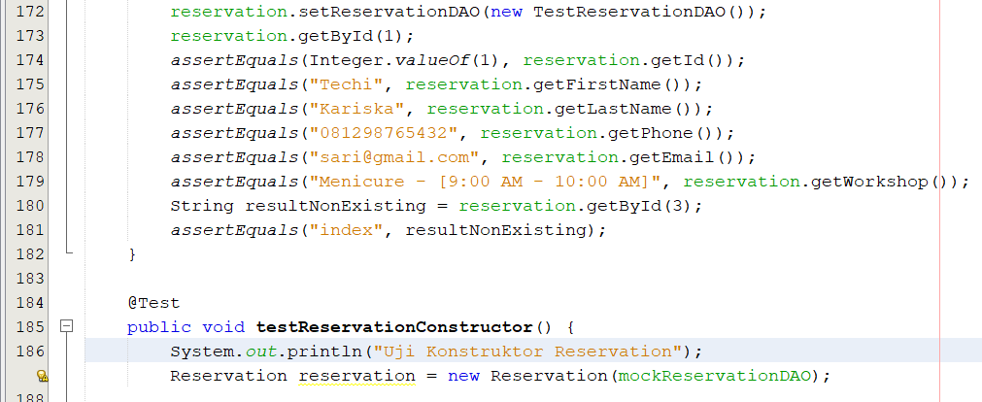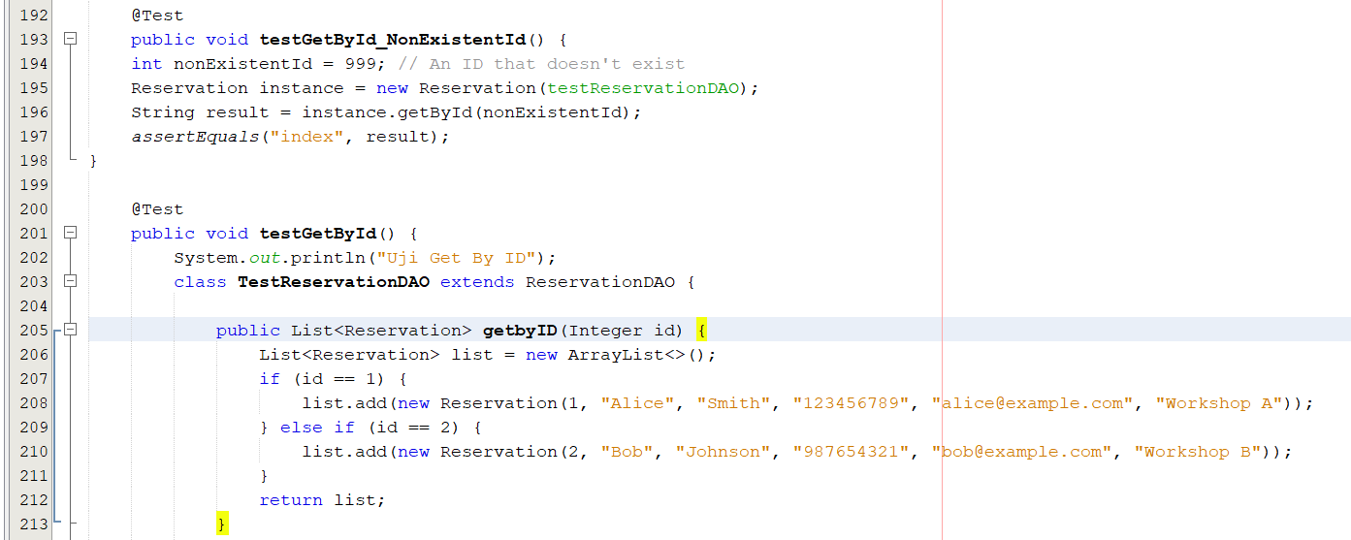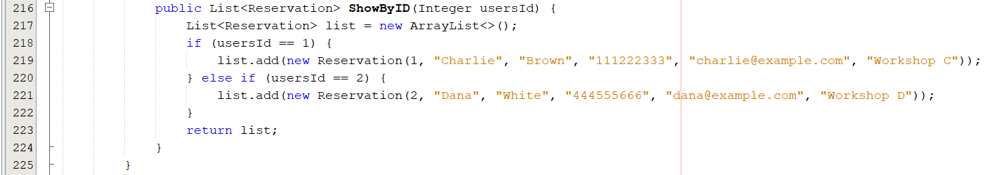

**TESTING IMPLEMENTATION**

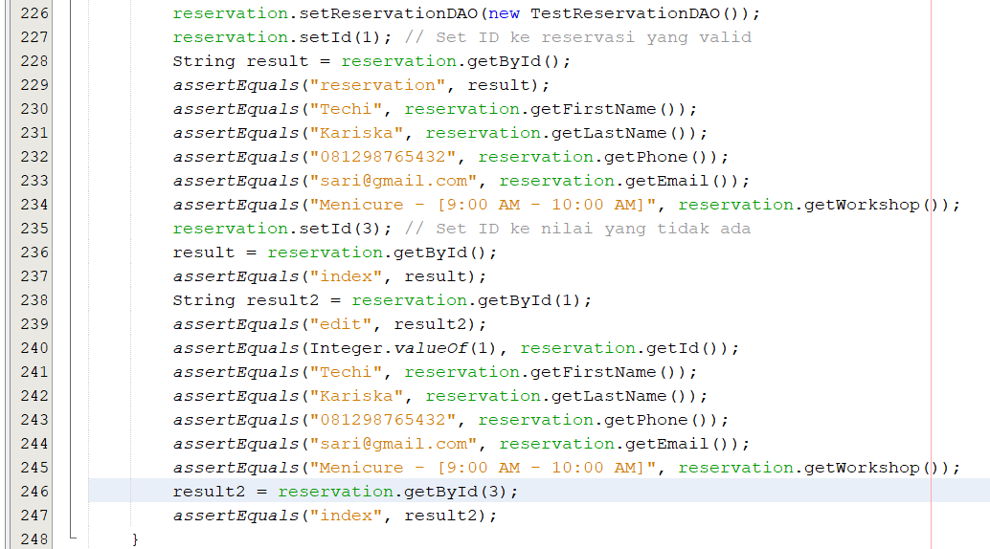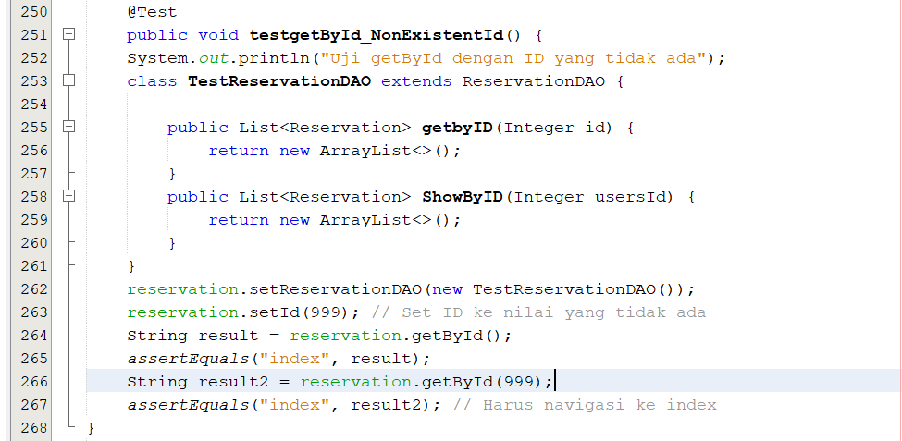

**TESTING IMPLEMENTATION**

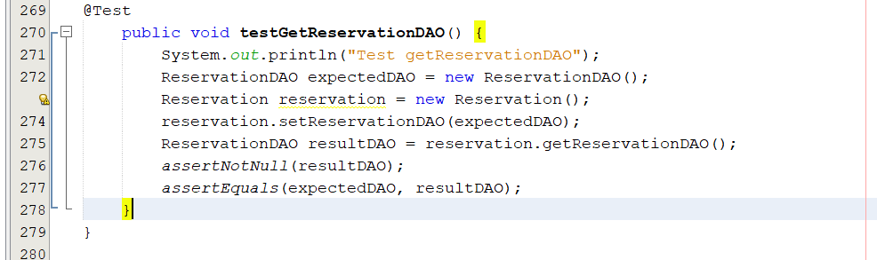

**8.ScheduleTest.java**

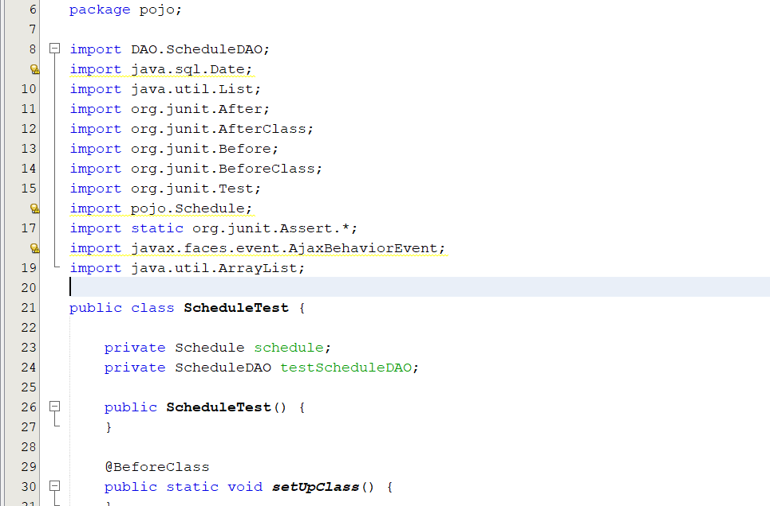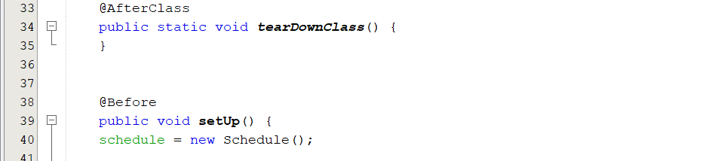

**TESTING IMPLEMENTATION**

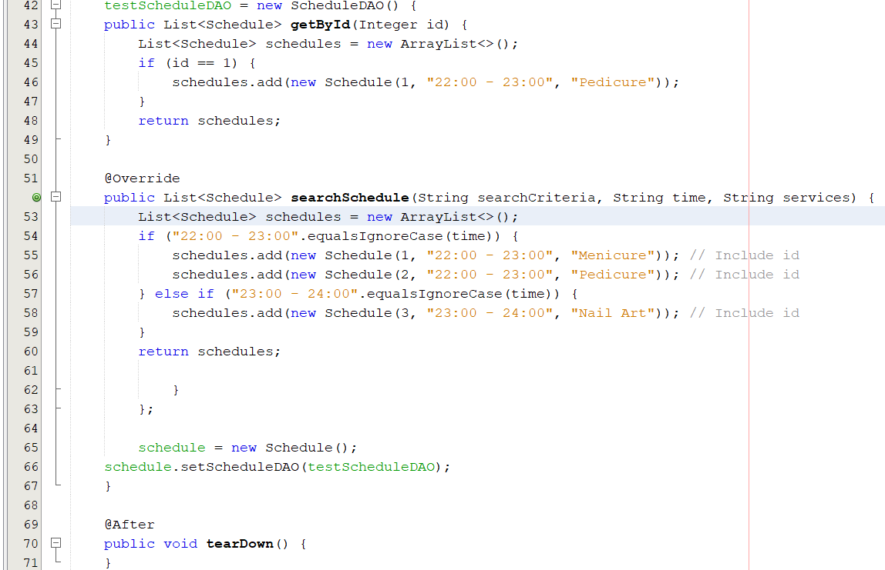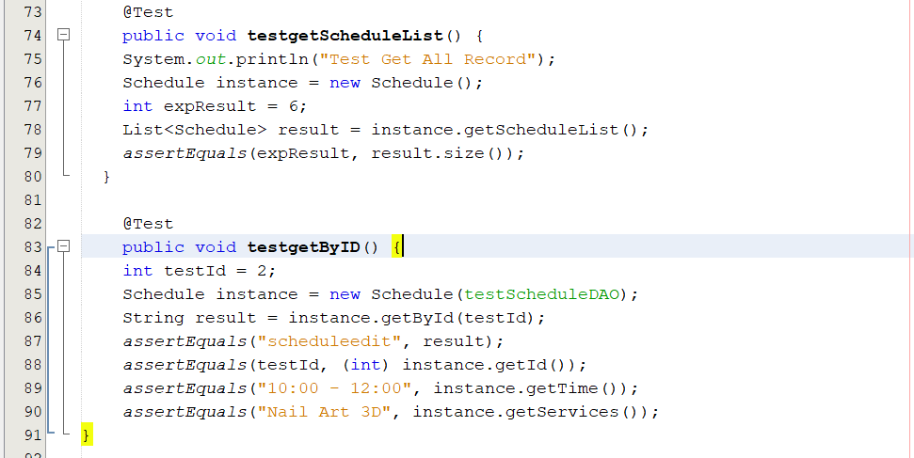

**TESTING IMPLEMENTATION**

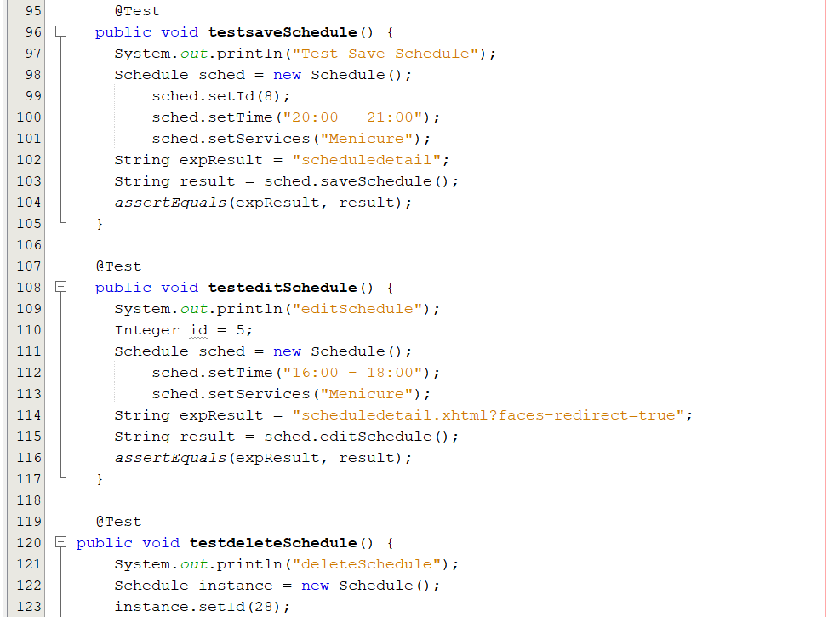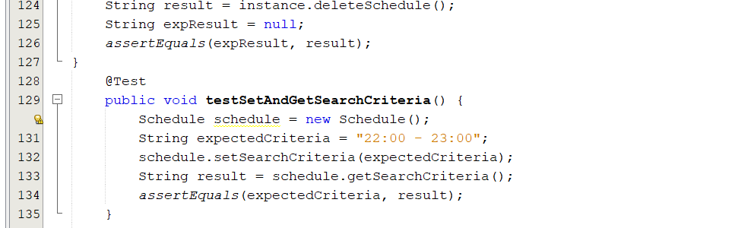

**TESTING IMPLEMENTATION**

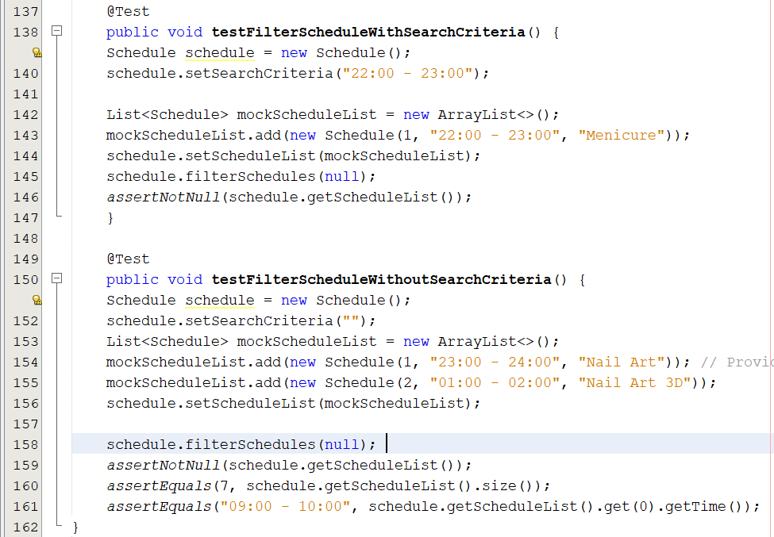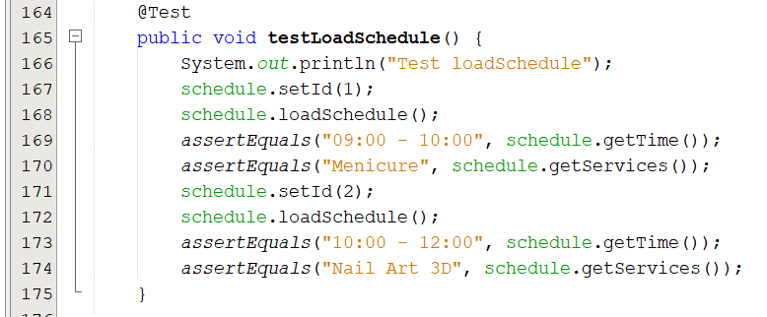

**TESTING IMPLEMENTATION**

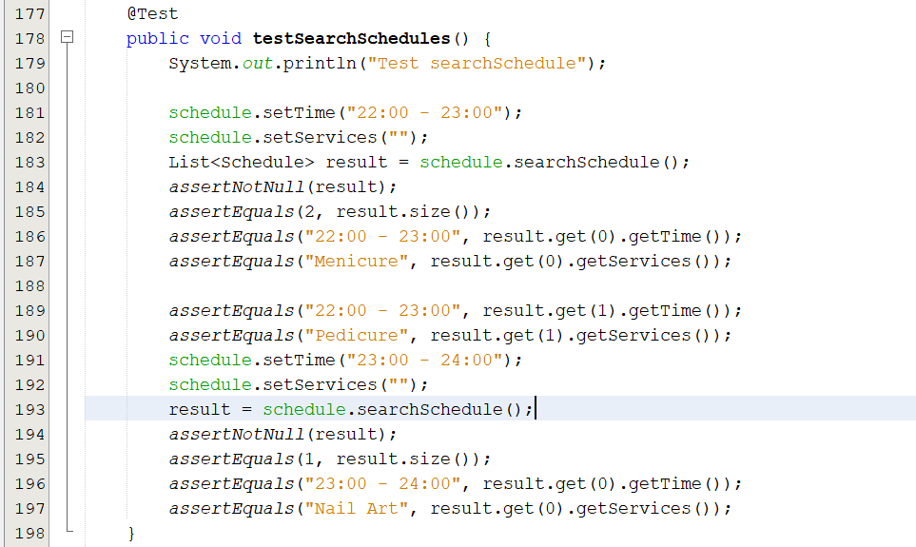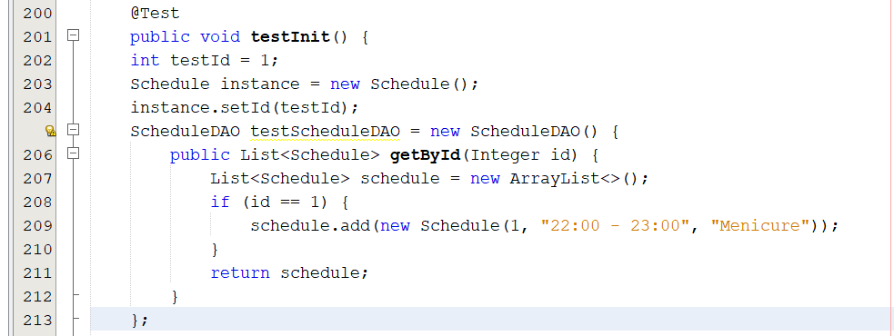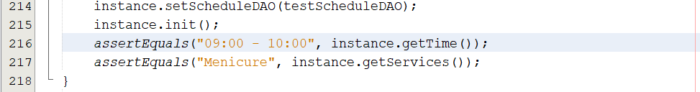

**TESTING IMPLEMENTATION**

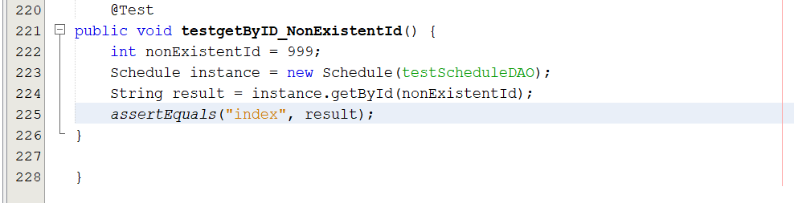

**TESTING IMPLEMENTATION**

**DAO Documentation**

**1. CategoryDAOTest.java**

**1.1 testAddCategory()**This test validates the method responsible for adding a new category to the system. It ensures that the category data is successfully inserted into the system and the appropriate session methods (save and commit) are invoked.

**1.2 testAddCategoryException()**This test ensures that when an exception occurs during the category addition (such as a database error), the system handles it gracefully without crashing. It also verifies that the transaction is not committed in the case of an error.

**1.3 testGetByID()**This test checks if the method to retrieve a category by its ID works correctly. It ensures that when a valid category ID is provided, the correct category information is returned and the session interacts correctly with the database.

**1.4 testGetByIDException()**This test simulates an error when retrieving a category by its ID, such as a database issue. It ensures the method properly catches and handles the exception without causing a system crash.

**1.5 testEditCategory()**This test validates the method that updates an existing category. It ensures that when valid category data is passed to the update method, the category details are successfully updated, and the transaction is committed.

**1.6 testEditCategoryException()**  
This test checks how the system behaves when an exception occurs during the category update process. It ensures that errors are handled properly, the transaction is not committed, and the system doesn't crash.

**TESTING IMPLEMENTATION**

**1.7 testDeleteCategory()**  
This test verifies that the method for deleting a category from the system works as expected. It checks if the category is successfully removed when a valid ID is provided and ensures that the delete and commit methods are invoked.

**1.8 testDeleteCategoryException()**  
This test ensures that when an exception occurs during the deletion process (such as a database error), the system handles the exception appropriately without crashing, and the transaction is not committed.

**1.9** **testRetrieveTblCategories()**  
This test ensures that the method to retrieve all categories works as expected. It checks that the list of categories is correctly returned when requested and that the session and query behave as expected.

**1.10 testRetrieveTblCategoriesException()**  
This test checks how the system behaves when an exception occurs while retrieving all categories. It ensures that the system handles the error properly without crashing and returns an empty list if an error occurs.

**1.11 testShowByIdWithValidId()**This test checks if the method to retrieve a category by ID using a specific query works correctly. It ensures that when a valid ID is provided, the correct category is returned.

**1.12 testShowByIdWithInvalidId()**  
This test checks how the system handles the case when a non-existent category ID is provided. It ensures that the system returns an empty list when no matching category is found.

**1.13 testShowByIdException()**  
This test simulates an exception when retrieving a category by its ID. It ensures that the system handles the exception properly and returns an empty list.

**TESTING IMPLEMENTATION**

**1.14 testSearchCategoryWithAllParameters()**  
This test verifies that the search method works when all parameters (category ID, name, description, and poster) are provided. It ensures the system returns the expected categories that match the search criteria.

**1.15 testSearchCategoryWithNoParameters()**  
This test ensures that the search method returns an empty list when no parameters are provided. It checks if the system behaves correctly when there are no filters applied.

**1.16 testSearchCategoryWithSomeParameters()**  
This test validates the search method when only some parameters (e.g., category ID and description) are provided. It ensures that the search returns the correct categories matching the given criteria.

**2. LocationDAOTest.java**

**2.1 testAddLocation()**This test validates the method responsible for adding a new Location to the system. It ensures that when valid data is provided, the Location is successfully inserted into the system and the transaction is committed.

**2.2 testAddLocationException()**This test ensures that when an exception occurs during the addition of a Location (such as a database error), the system handles it gracefully, without crashing, and the transaction is not committed.

**2.3 testGetById()**This test checks if the method to retrieve a Location by its ID works correctly. It ensures that when a valid ID is provided, the correct Location information is returned from the database.

**TESTING IMPLEMENTATION**

**2.4 testGetByIdException()**  
This test simulates an error when retrieving a Location by its ID, such as a database issue or invalid input. It ensures the method properly catches and handles the exception, and an empty list is returned.

**2.5 testEditLocation()**  
This test validates the method that updates existing Location data. It ensures that when valid data is passed to the update method, the Location details are successfully updated in the system and the transaction is committed.

**2.6 testEditLocationException()**  
This test checks how the system behaves when an exception occurs during the Location update process. It ensures that errors are handled properly, the transaction is not committed, and the system doesn't crash.

**2.7 testDeleteLocation()**  
This test verifies that the method for deleting a Location from the system works as expected. It checks if the Location is successfully removed when a valid ID is provided, and the transaction is committed.

**2.8 testDeleteLocationException()**  
This test ensures that when an exception occurs during the deletion process (like a database error), the system handles the exception appropriately without crashing, and the transaction is not committed.

**2.9 testDeleteLocationNotFound()**  
This test checks if the system properly handles the case where an attempt is made to delete a Location that doesn't exist. It ensures that no deletion occurs, and an appropriate response or message is returned.

**TESTING IMPLEMENTATION**

**2.10 testRetrieveTblLocations()**  
This test ensures that the method to retrieve all Location data from the system works as expected. It checks that the list of Locations is correctly returned when requested.

**2.11 testRetrieveTblLocationsException()**  
This test checks how the system behaves when an exception occurs while retrieving all Location data. It ensures that the system handles errors correctly and doesn't crash, returning an empty list or an appropriate error response.

**2.12 testSearchLocationById()**  
This test validates the method responsible for searching a Location by its ID. It ensures that when a valid ID is provided, the correct Location data is retrieved from the database.

**2.13 testSearchLocationByCity()**  
This test checks if the method to search for a Location by its city works correctly. It ensures that the correct list of Locations is returned when a valid city is provided.

**2.14 testSearchLocationByBranchLocation()**  
This test verifies the functionality of searching for a Location by its branch location. It ensures that the correct data is returned when a branch location is provided.

**2.15** **testSearchLocationWithNoParameters()**  
This test checks if the system correctly handles the scenario when no search parameters are provided. It ensures that all Locations are returned without filtering.

**2.16 testSearchLocationException()**  
This test simulates a database error during a Location search and checks if the system handles it gracefully, returning an empty list without crashing.

**3. LoginDAOTest.java**

**3.1 testAddData()**  
This test validates the method responsible for adding new login data to the system. It ensures that the addition works as expected and that the login data is successfully inserted into the database.

**3.2 testAddDataException()**This test ensures that when an exception occurs during the data addition (such as a database error), the system handles it gracefully, without crashing, and returns the correct error message or response.

**3.3 testGetLoginById()**This test checks if the method to retrieve login data by its ID works correctly. It ensures that when a valid login ID is provided, the correct login information is returned.

**3.4 testGetLoginByIdException()**  
This test simulates an error when retrieving login data by its ID, such as a database issue or invalid input. It ensures the method properly catches and handles the exception.

**3.5 testUpdateLogin()**  
This test validates the method that updates existing login data. It ensures that when valid data is passed to the update method, the login details are successfully updated in the system.

**3.6 testUpdateLoginException()**This test checks how the system behaves when an exception occurs during the login update process. It ensures that errors are handled properly, and the system doesn't crash.

**3.7 testDeleteLogin()**  
This test verifies that the method for deleting a login from the system works as expected. It checks if the login is successfully removed when a valid ID is provided.

**TESTING IMPLEMENTATION**

**3.8 testDeleteLoginException()**  
This test ensures that when an exception occurs during the deletion process (like a database error), the system handles the exception appropriately without crashing.

**3.9 testDeleteLoginNotFound()**  
This test checks if the system properly handles the case where an attempt is made to delete a login that doesn't exist. It ensures the system returns a "not found" message or appropriate response.

**3.10 testGetAllLogins()**  
This test ensures that the method to retrieve all logins from the system works as expected. It checks that the list of logins is correctly returned when requested.

**3.11 testGetAllLoginsException()**  
This test checks how the system behaves when an exception occurs while retrieving all logins. It ensures that the system handles errors correctly and doesn't crash, returning the appropriate error response.

**4. ReservationDAOTest.java**

**4.1 testRetrieveTblReservation()**This test validates the method responsible for retrieving all reservation data from the database. It ensures that when there are reservations present, the correct list of reservations is returned.

**4.2 testRetrieveTblReservationEmptyList()**  
This test checks the behavior of the system when there are no reservations in the database. It ensures that the method returns an empty list when there are no reservations.

**4.3 testRetrieveTblReservationException()**  
This test ensures that when an exception occurs during the retrieval of reservations (such as a database error), the system handles it gracefully, returning an empty list without crashing.

**TESTING IMPLEMENTATION**

**4.4 testGetByIDFound()**  
This test verifies that the method for retrieving a reservation by its ID works correctly. It ensures that when a valid ID is provided, the correct reservation information is returned.

**4.5 testGetByIDNotFound()**  
This test checks the behavior of the system when an attempt is made to retrieve a reservation by an ID that does not exist. It ensures that the method returns an empty list in this case.

**4.6 testGetByIDException()**  
This test ensures that when an exception occurs during the retrieval of a reservation by ID, the system handles it correctly without crashing, returning an empty list.

**4.7 testShowByIDFound()**  
This test validates the method that shows reservation details by its ID. It ensures that when a valid ID is provided, the correct reservation information is returned in a list.

**4.8 testShowByIDNotFound()**  
This test checks the behavior of the system when an attempt is made to show a reservation that does not exist. It ensures that the method returns an empty list when no reservation is found.

**4.9 testShowByIDException()**  
This test ensures that when an exception occurs during the show by ID process, the system handles it gracefully, returning an empty list without crashing.

**4.10 testAddReservation()**  
This test validates the method responsible for adding a new reservation to the database. It ensures that when valid reservation data is provided, the reservation is successfully saved.

**TESTING IMPLEMENTATION**

**TESTING IMPLEMENTATION**

**4.11 testAddReservationException()**  
This test checks how the system behaves when an exception occurs during the addition of a reservation (such as a database error). It ensures that the system does not crash and that the transaction is not committed.

**4.12 testEditUser()**  
This test verifies that the method for editing an existing reservation works correctly. It ensures that when valid reservation data is provided, the reservation is successfully updated in the database.

**4.13 testEditUserException()**  
This test ensures that when an exception occurs during the editing of a reservation, the system handles it properly without crashing, and the transaction is not committed.

**4.14 testDeleteUser()**  
This test validates the method for deleting a reservation from the database. It ensures that when a valid reservation ID is provided, the reservation is successfully deleted and the transaction is committed.

**4.15 testDeleteUserException()**  
This test checks the behavior of the system when an exception occurs during the deletion of a reservation. It ensures that the delete operation is not performed and the transaction is not committed if an error occurs.

**5. ScheduleDAOTest.java**

**5.1 testRetrieveTblSchedules()**

This test validates the method responsible for retrieving all schedule data from the database. It ensures that when schedules are available, the correct list of schedules is returned.

**TESTING IMPLEMENTATION**

**5.2 testRetrieveTblSchedulesEmptyList()**  
This test checks the system's behavior when there are no schedules in the database. It ensures that the method returns an empty list when no schedules are present.

**5.3 testRetrieveTblSchedulesException()**  
This test ensures that when an exception occurs during the retrieval of schedules (such as a database error), the system handles it gracefully by returning an empty list without crashing.

**5.4 testGetByID()**  
This test verifies that the method for retrieving a schedule by its ID works correctly. It ensures that when a valid ID is provided, the correct schedule information is returned.

**5.5 testGetByIDEmptyList()**  
This test checks the system's behavior when an attempt is made to retrieve a schedule by an ID that does not exist. It ensures that the method returns an empty list in this case.

**5.6 testGetByIDException()**  
This test ensures that when an exception occurs during the retrieval of a schedule by ID, the system handles it properly without crashing, returning an empty list.

**5.7 testAddSchedule()**  
This test validates the method responsible for adding a new schedule to the database. It ensures that when valid schedule data is provided, the schedule is successfully saved.

**5.8 testAddScheduleException()**  
This test checks how the system behaves when an exception occurs during the addition of a schedule (such as a database error). It ensures that the system does not crash and that the transaction is not committed.

**5.9 testEditSchedule()**  
This test verifies that the method for editing an existing schedule works correctly. It ensures that when valid schedule data is provided, the schedule is successfully updated in the database.

**TESTING IMPLEMENTATION**

**5.10 testEditScheduleException()**  
This test ensures that when an exception occurs during the editing of a schedule, the system handles it properly without crashing, and the transaction is not committed.

**5.11 testDeleteSchedule()**  
This test validates the method for deleting a schedule from the database. It ensures that when a valid schedule ID is provided, the schedule is successfully deleted, and the transaction is committed.

**5.12 testDeleteScheduleException()**  
This test checks the system's behavior when an exception occurs during the deletion of a schedule. It ensures that the delete operation is not performed and that the transaction is not committed if an error occurs.

**5.13 testSearchScheduleWithAllParameters()**  
This test validates the schedule search method when all parameters are provided. It ensures that when valid parameters are given, the corresponding list of schedules is returned.

**5.14 testSearchScheduleWithNoParameters()**  
This test checks the system's behavior when no parameters are provided for the schedule search. It ensures that the method returns an empty list in this case.

**5.15 testSearchScheduleWithSomeParameters()**  
This test verifies that the schedule search method works correctly when only some parameters are provided. It ensures that the corresponding list of schedules is returned when certain parameters are valid.

**TESTING IMPLEMENTATION**

**Pojo**

**1. CategoryTest.java**

**1.1 testgetCategoryList()**  
This test validates the method that retrieves the list of all categories. It ensures that the expected number of categories (3) is returned when the method is invoked.

**1.2 testGetById()**  
This test verifies the method for retrieving a category by its ID. It ensures that when a valid ID is provided, the correct category details are returned, including the category name, description, and poster.

**1.3 testsaveCategory()**  
This test validates the method responsible for saving a new category. It checks that the method correctly returns the expected navigation outcome when a valid category is saved.

**1.4 testeditCategory()**This test ensures that the method for editing an existing category functions correctly. It verifies that when valid data is provided, the method returns the expected navigation outcome after editing.

**1.5 testdeleteCategory()**This test checks the method for deleting a category. It verifies that when a category ID is provided, the category is successfully deleted, and the expected result is returned.

**1.6 testSetAndGetSearchCriteria()**  
This test verifies the getter and setter for the search criteria in the category. It ensures that when a search criteria is set, it can be retrieved correctly.

**1.7 testFilterCategoryWithSearchCriteria()**  
This test validates the filtering of categories based on the search criteria. It ensures that the filtered list contains the correct categories when a valid search criteria is applied.

**TESTING IMPLEMENTATION**

**1.8 testFilterCategoryWithoutSearchCriteria()**  
This test checks the behavior of the category filtering when no search criteria is provided. It ensures that all categories are returned in this case.

**1.9 testLoadCategory()**  
This test verifies the method for loading category details based on its ID. It ensures that the correct category information is loaded and can be retrieved.

**1.10 testSearchCategories()**  
This test checks the method responsible for searching categories. It verifies that the correct categories are returned based on the search criteria provided.

**1.11 testInit()**  
This test ensures that the initialization method sets the correct category details based on the category ID. It verifies that the category name, description, and poster are set correctly.

**1.12 testgetByID_NonExistentId()**  
This test validates the behavior of the method when attempting to retrieve a category by a non-existent ID. It ensures that the expected navigation outcome is returned when the ID does not exist.

**2. LocationTest.java**

**2.1 testgetLocationList()**  
This test validates the method responsible for retrieving the list of all locations. It ensures that the expected number of locations (6) is returned when the method is invoked.

**2.2 testGetById()**  
This test verifies the method for retrieving a location by its ID. It ensures that when a valid ID is provided, the correct location details are returned, including the city and branch location.

**TESTING IMPLEMENTATION**

**2.3 testsaveLocation()**  
This test validates the method responsible for saving a new location. It checks that the method correctly returns the expected navigation outcome when a valid location is saved.

**2.4 testeditLocation()**  
This test ensures that the method for editing an existing location functions correctly. It verifies that when valid data is provided, the method returns the expected navigation outcome after editing.

**2.5 testdeleteLocation()**  
This test checks the method for deleting a location. It verifies that when a location ID is provided, the location is successfully deleted, and the expected result is returned.

**2.6 testSetAndGetSearchCriteria()**  
This test verifies the getter and setter for the search criteria in the location class. It ensures that when a search criteria is set, it can be retrieved correctly.

**2.7 testFilterLocationWithSearchCriteria()**  
This test validates the filtering of locations based on the search criteria. It ensures that the filtered list contains the correct locations when a valid search criteria is applied.

**2.8 testFilterLocationWithoutSearchCriteria()**  
This test checks the behavior of the location filtering when no search criteria is provided. It ensures that all locations are returned in this case.

**2.9 testLoadLocation()**  
This test verifies the method for loading location details based on its ID. It ensures that the correct location information is loaded and can be retrieved.

**2.10 testSearchLocations()**  
This test checks the method responsible for searching locations. It verifies that the correct locations are returned based on the provided search criteria.

**TESTING IMPLEMENTATION**

**2.11 testInit()**  
This test ensures that the initialization method sets the correct location details based on the location ID. It verifies that the city and branch location are set correctly.

**2.12 testGetById_NonExistentId()**  
This test validates the behavior of the method when attempting to retrieve a location by a non-existent ID. It ensures that the expected navigation outcome is returned when the ID does not exist.

**3. LoginTest.java**

**3.1 testgetLocationList()**  
This test validates the method responsible for retrieving the list of all locations. It ensures that the expected number of locations (6) is returned when the method is invoked.

**3.2 testGetById()**This test verifies the method for retrieving a location by its ID. It ensures that when a valid ID is provided, the correct location details are returned, such as the city and branch location.

**3.3 testsaveLocation()**This test validates the method responsible for saving a new location. It checks that the method correctly returns the expected navigation outcome when a valid location is saved.

**3.4 testeditLocation()**  
This test ensures that the method for editing an existing location functions correctly. It verifies that when valid data is provided, the method returns the expected navigation outcome after editing.

**3.5 testdeleteLocation()**This test checks the method for deleting a location. It verifies that when a location ID is provided, the location is successfully deleted, and the expected result is returned.

**TESTING IMPLEMENTATION**

**3.6 testSetAndGetSearchCriteria()**  
This test verifies the getter and setter for the search criteria in the location class. It ensures that when a search criteria is set, it can be retrieved correctly.

**3.7 testFilterLocationWithSearchCriteria()**  
This test validates the filtering of locations based on the search criteria. It ensures that the filtered list contains the correct locations when valid search criteria are applied.

**3.8 testFilterLocationWithoutSearchCriteria()**  
This test checks the behavior of the location filtering when no search criteria are provided. It ensures that all locations are returned in this case.

**3.9 testLoadLocation()**  
This test verifies the method for loading location details based on its ID. It ensures that the correct location information is loaded and can be retrieved.

**3.10 testSearchLocations()**  
This test checks the method responsible for searching locations. It verifies that the correct locations are returned based on the provided search criteria.

**3.11 testInit()**  
This test ensures that the initialization method sets the correct location details based on the location ID. It verifies that the city and branch location are set correctly.

**3.12 testGetById_NonExistentId()**  
This test validates the behavior of the method when attempting to retrieve a location by a non-existent ID. It ensures that the expected navigation outcome is returned when the ID does not exist.

**TESTING IMPLEMENTATION**

**4. NailArtTest.java**

**4.1 testGetSessionFactory()**  
This test verifies that the SessionFactory is successfully initialized using the default configuration. It ensures that when the method is called, the SessionFactory is not null, meaning that the initialization process has completed correctly.

**4.2 testSessionFactoryConfiguration()**  
This test checks the configuration of the SessionFactory. It ensures that when the SessionFactory is retrieved, it is properly initialized and is an instance of SessionFactory. This confirms that the configuration is working as expected.

**4.3 testSessionFactoryInitializationFailure()**  
This test is designed to simulate a failure in initializing the SessionFactory due to a wrong configuration file. It expects an ExceptionInInitializerError to be thrown when an invalid configuration is used, ensuring that the system fails as expected under incorrect configurations.

**4.4 testSessionFactoryWithValidConfig()**  
This test ensures that the SessionFactory is correctly initialized when a valid custom configuration is provided. It uses a correct configuration file (hibernate.cfg.xml) and verifies that the SessionFactory is not null, confirming successful initialization.

**4.5 testConfigureSessionFactoryWithCustomConfig()**  
This test validates the initialization of the SessionFactory using a custom configuration. It verifies that when a valid custom configuration file is provided, the SessionFactory is successfully initialized and is an instance of SessionFactory, ensuring that the system can handle different configurations properly.

**4.6 testConfigureSessionFactoryWithDefaultConfig()**  
This test checks the initialization of the SessionFactory using the default configuration. It ensures that the system can correctly initialize the SessionFactory without specifying a custom configuration file, and that the SessionFactory is valid and properly configured.

**TESTING IMPLEMENTATION**

**5. NailartUtillTest.java**

**5.1 testGetSessionFactory()**This test verifies that the SessionFactory is successfully initialized using the default configuration. It checks that when the getSessionFactory method is invoked, the resulting SessionFactory is not null, confirming that the initialization process is complete.

**5.2 testSessionFactoryConfiguration()**  
This test checks the configuration of the SessionFactory. It ensures that the SessionFactory is properly initialized and that it is indeed an instance of SessionFactory. This validates that the configuration settings are correct.

**5.3 testSessionFactoryInitializationFailure()**  
This test simulates a failure in initializing the SessionFactory by providing an incorrect configuration file. It expects an ExceptionInInitializerError to be thrown when the invalid configuration is used, verifying that the system correctly handles initialization failures.

**5.4 testSessionFactoryWithValidConfig()**This test ensures that the SessionFactory is correctly initialized with a valid custom configuration. It uses a valid configuration file (hibernate.cfg.xml) and verifies that the resulting SessionFactory is not null, indicating successful initialization.

**5.5** **testConfigureSessionFactoryWithCustomConfig()**  
This test validates the initialization of the SessionFactory using a custom configuration. It confirms that when a valid custom configuration file is provided, the SessionFactory is successfully initialized and is an instance of SessionFactory, ensuring proper handling of various configurations.

**TESTING IMPLEMENTATION**

**5.6 testConfigureSessionFactoryWithDefaultConfig()**  
This test checks the initialization of the SessionFactory using the default configuration. It verifies that the SessionFactory is correctly initialized without specifying a custom configuration file, confirming that the system can initialize the SessionFactory successfully using default settings.

**6. ReservationTest.java**

**6.1 testgetReservationList()**  
This test verifies that the getReservationList method returns the correct number of reservation records. It expects the list to contain two records (or one additional if needed) and checks that the size of the returned list matches this expectation.

**6.2 testsaveReservation()**  
This test checks the saveReservation method to ensure that a reservation can be successfully saved. It sets the fields of a new Reservation object and verifies that the method returns the expected result ("reserved"), indicating that the reservation has been saved correctly.

**6.3 testeditUser()**  
This test verifies the editUser method by attempting to edit a reservation's details. It checks that the method returns the correct redirect URL after editing, confirming the expected behavior when a user edits their reservation.

**6.4 testdeleteUser()**This test checks the deleteUser method to ensure that a reservation can be deleted. It sets an ID for the reservation to be deleted and verifies that the result matches the expected output (null) after deletion.

**6.5 testSetReservationList()**  
This test verifies that the setReservationList method correctly sets a list of reservations and that the getReservationList method retrieves it properly. It creates a sample list of reservations, sets it, and checks that the retrieved list matches the expected list.

**TESTING IMPLEMENTATION**

**6.6 testConstructor()**  
This test checks the constructor of the Reservation class to ensure that all fields are initialized correctly. It creates a new Reservation object using sample data and verifies that the object's properties match the expected values.

**6.7 testGetAllRecords()**  
This test verifies the getAllRecords method by using a temporary ReservationDAO implementation. It ensures that the method returns a list of expected reservation records, confirming that the retrieval works as intended.

**6.8 testgetById()**  
This test checks the getById method for both existing and non-existing reservation IDs. It verifies that when a valid ID is provided, the reservation's details are correctly populated. It also checks that providing a non-existing ID returns the expected result ("index").

**6.9 testGetById_NonExistentId()**  
This test checks the behavior of the getById method when provided with an ID that does not exist. It verifies that the method correctly navigates to the "index" when no reservation is found.

**6.10 testGetReservationDAO()**  
This test checks the getReservationDAO method to ensure it retrieves the correct instance of ReservationDAO. It verifies that the DAO is not null and that it matches the expected DAO instance.

**7. ScheduleTest.java**

**7.1 testgetScheduleList()**This test validates the method responsible for retrieving the list of all schedules. It ensures that the expected number of schedules (e.g., 5) is returned when the method is invoked.

**TESTING IMPLEMENTATION**

**7.2 testGetById()**  
This test verifies the method for retrieving a schedule by its ID. It ensures that when a valid ID is provided, the correct schedule details are returned, including the schedule name, date, and time.

**7.3 testsaveSchedule()**  
This test validates the method responsible for saving a new schedule. It checks that the method correctly returns the expected navigation outcome when a valid schedule is saved.

**7.4 testeditSchedule()**  
This test ensures that the method for editing an existing schedule functions correctly. It verifies that when valid data is provided, the method returns the expected navigation outcome after editing.

**7.5 testdeleteSchedule()**  
This test checks the method for deleting a schedule. It verifies that when a schedule ID is provided, the schedule is successfully deleted, and the expected result is returned.

**7.6 testSetAndGetSearchCriteria()**  
This test verifies the getter and setter for the search criteria in the schedule class. It ensures that when a search criteria is set, it can be retrieved correctly.

**7.7 testFilterScheduleWithSearchCriteria()**  
This test validates the filtering of schedules based on the search criteria. It ensures that the filtered list contains the correct schedules when a valid search criteria is applied.

**7.8 testFilterScheduleWithoutSearchCriteria()**  
This test checks the behavior of the schedule filtering when no search criteria is provided. It ensures that all schedules are returned in this case.

**7.9 testLoadSchedule()**  
This test verifies the method for loading schedule details based on its ID. It ensures that the correct schedule information is loaded and can be retrieved.

**TESTING IMPLEMENTATION**

**7.10 testSearchSchedules()**  
This test checks the method responsible for searching schedules. It verifies that the correct schedules are returned based on the provided search criteria.

**7.11 testInit()**  
This test ensures that the initialization method sets the correct schedule details based on the schedule ID. It verifies that the schedule name, date, and time are set correctly.

**7.12 testGetById_NonExistentId()**  
This test validates the behavior of the method when attempting to retrieve a schedule by a non-existent ID. It ensures that the expected navigation outcome is returned when the ID does not exist.

**TESTING IMPLEMENTATION**

**DAO**

**1. CategoryDAOTest.java**

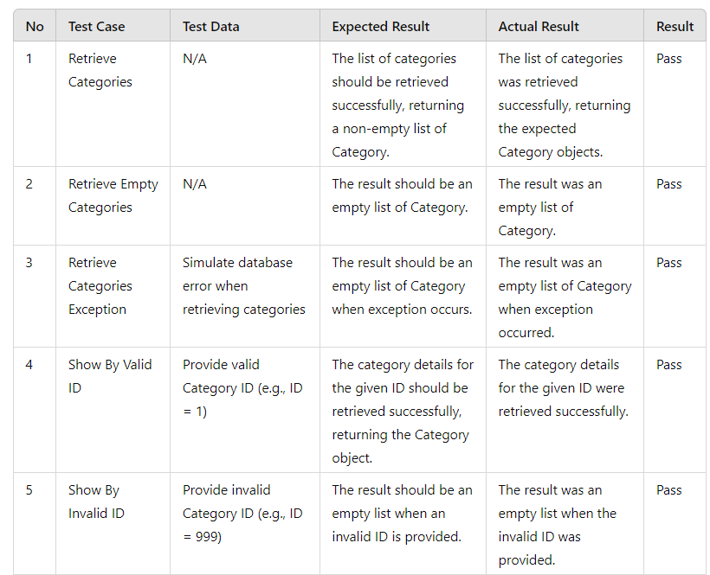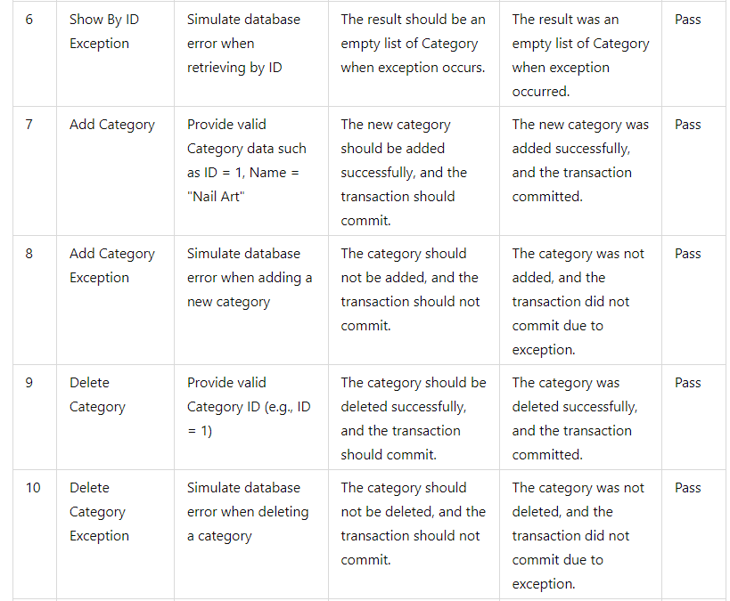

**TESTING IMPLEMENTATION**

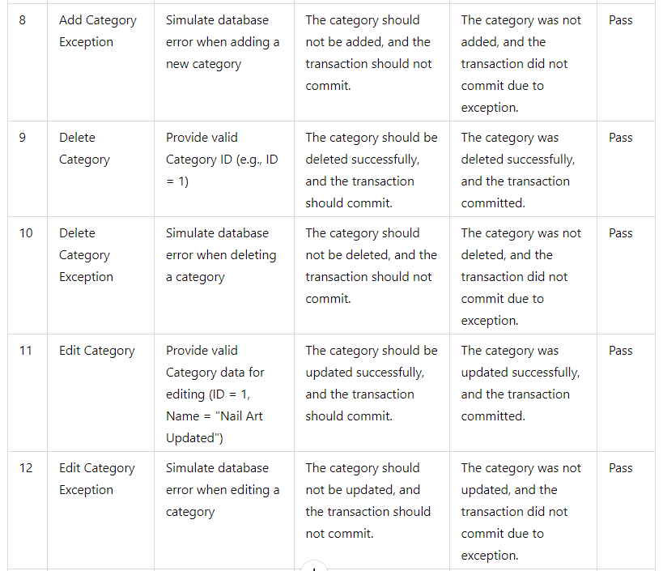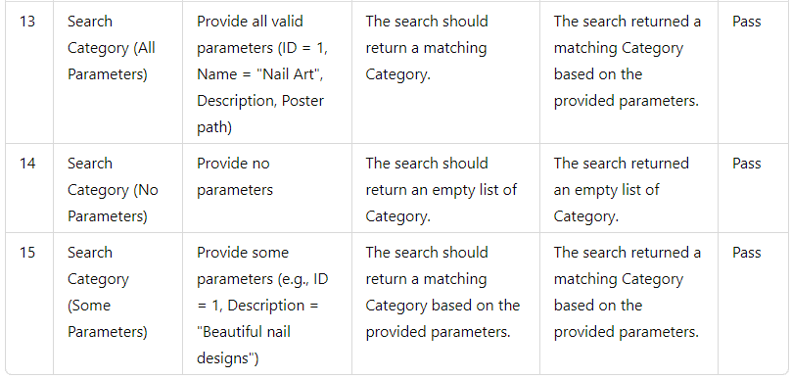

**TESTING IMPLEMENTATION**

**2. LocationDAOTest.java**

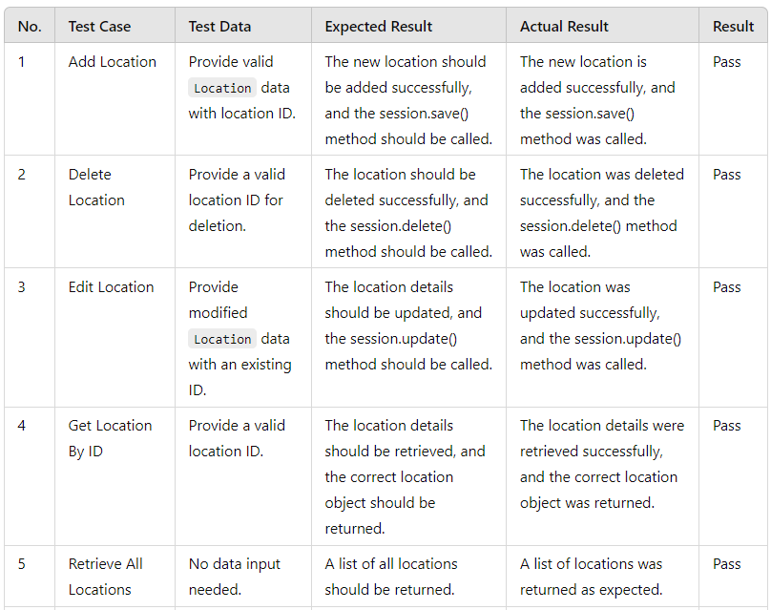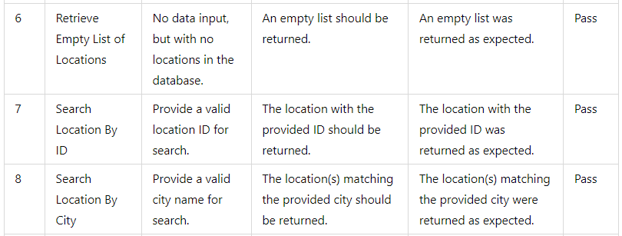

**TESTING IMPLEMENTATION**

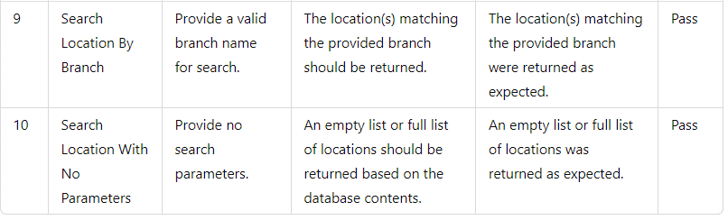

**3. LoginDAOTest.java**

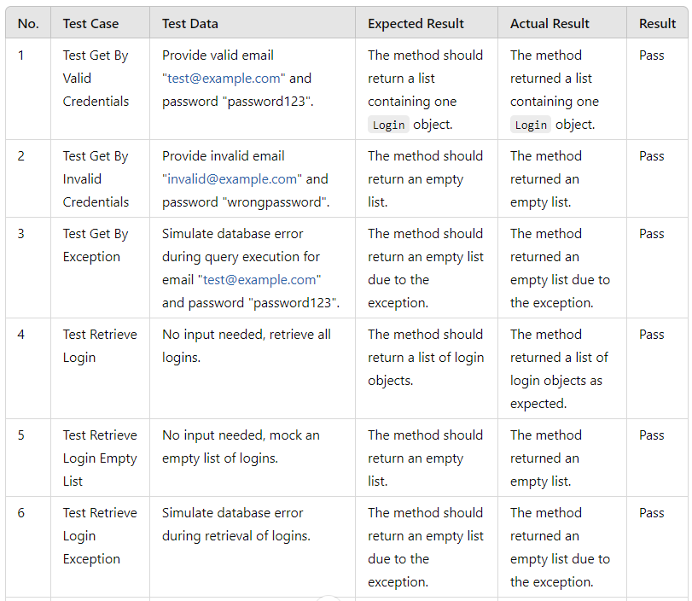

**TESTING IMPLEMENTATION**

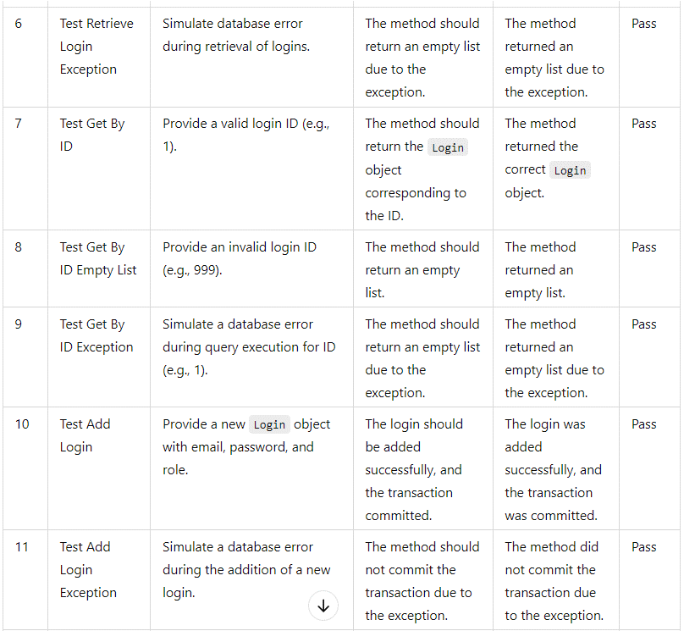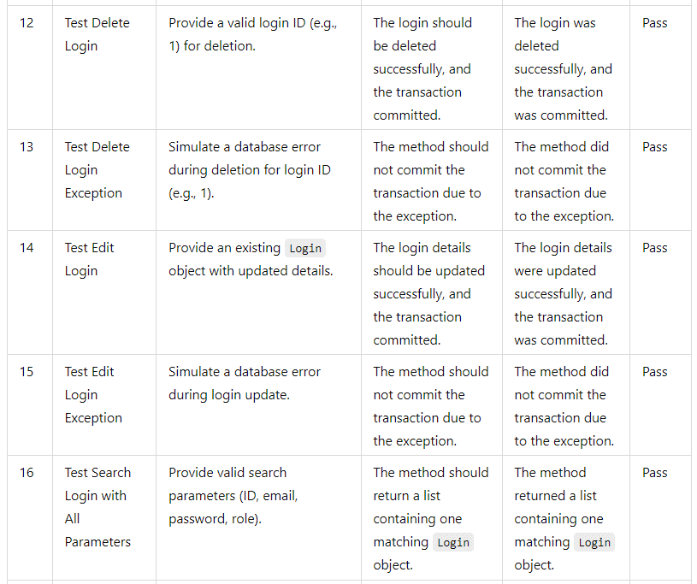

**TESTING IMPLEMENTATION**

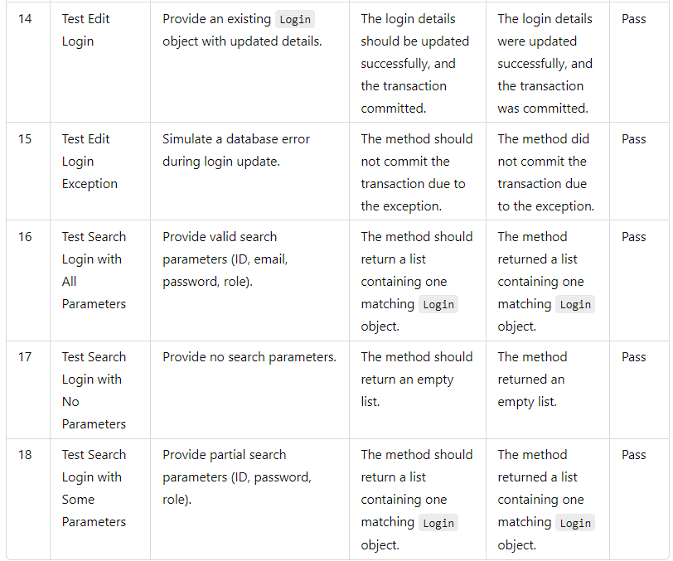

**4. ReservationDAOTest.java**

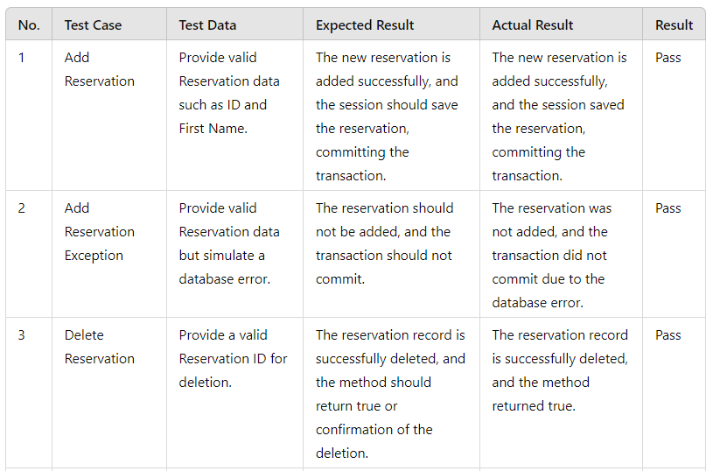

**TESTING IMPLEMENTATION**

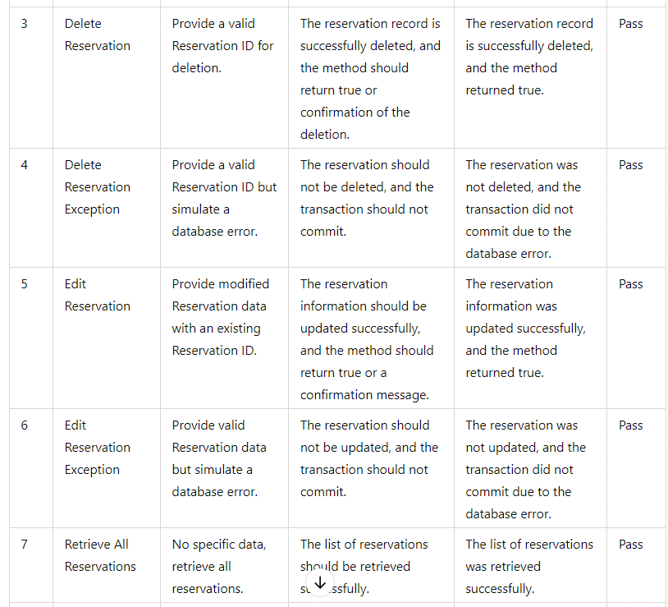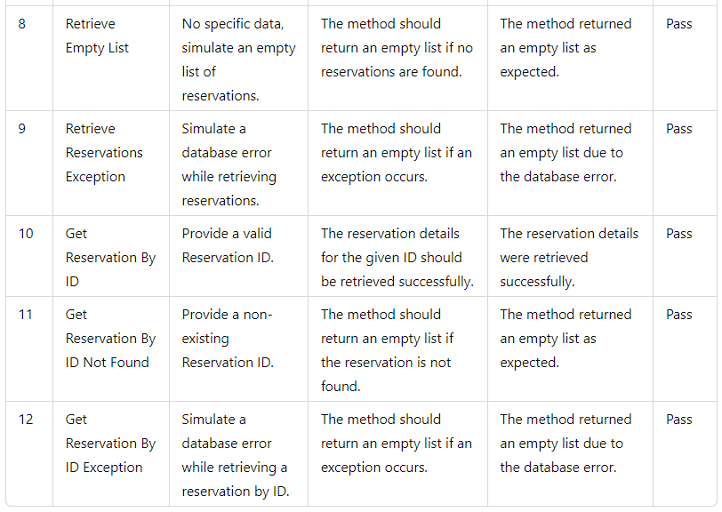

**TESTING IMPLEMENTATION**

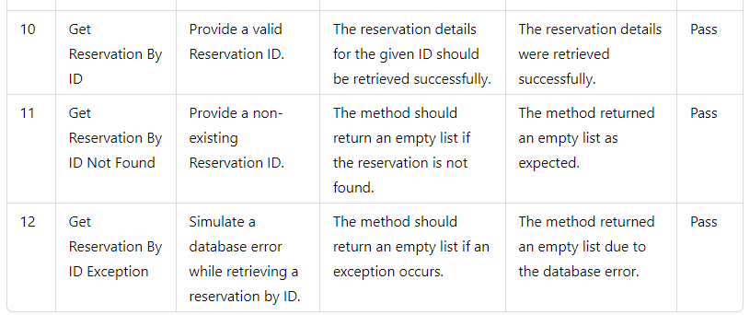

**3. ScheduleDAOTest.java**

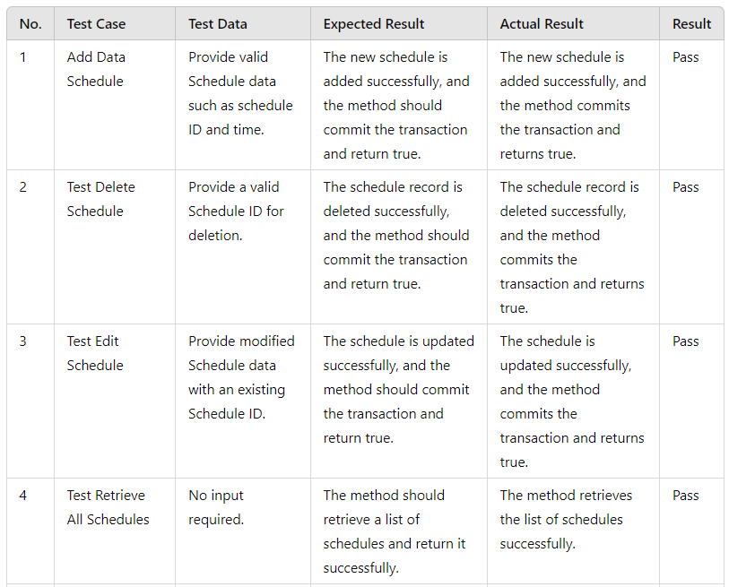

**TESTING IMPLEMENTATION**

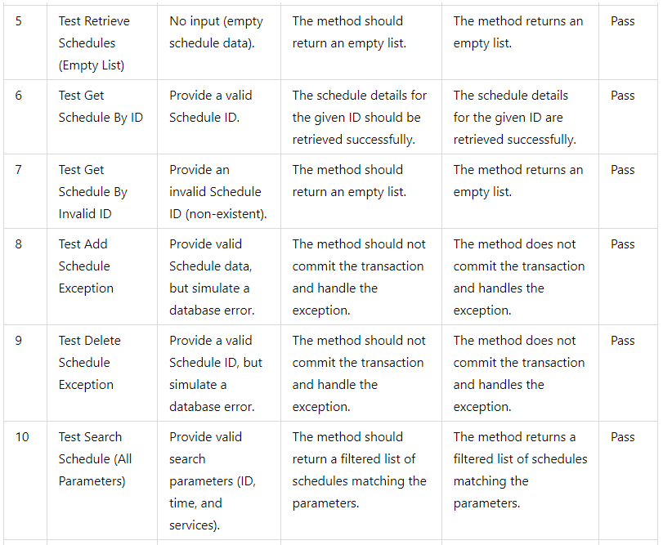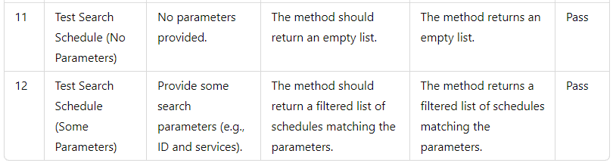

**TESTING IMPLEMENTATION**

**POJO**

**1. CategoryTest.java**

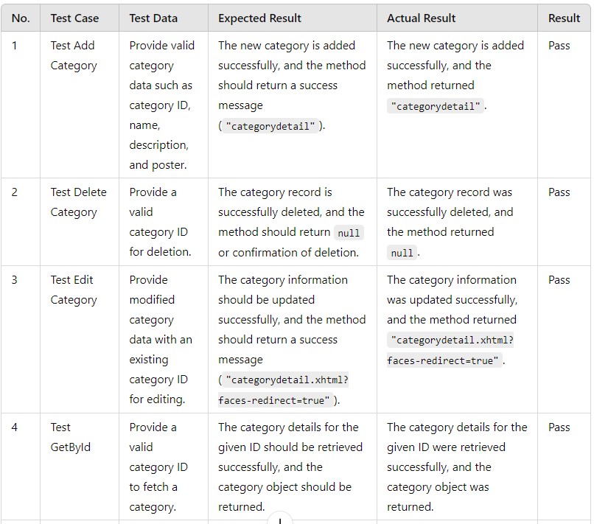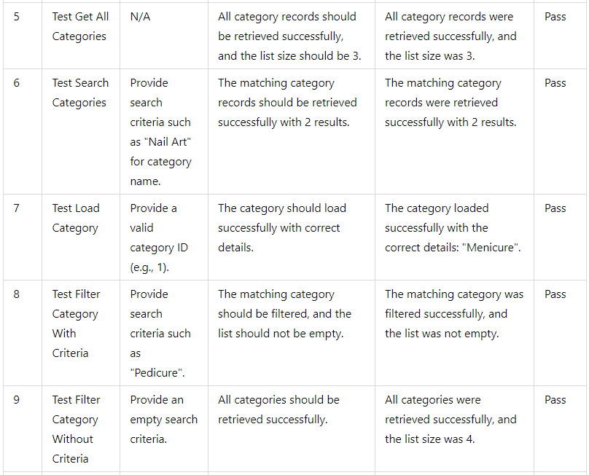

**TESTING IMPLEMENTATION**

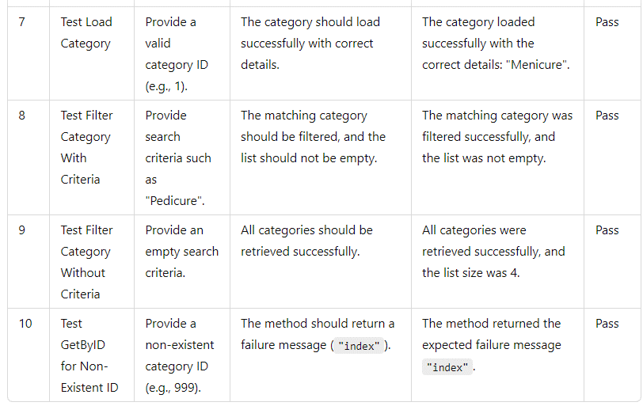

**2. LocationTest.java**

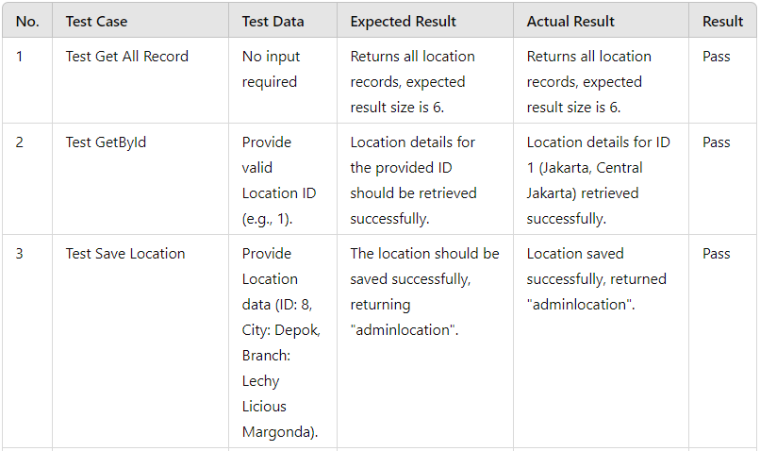

**TESTING IMPLEMENTATION**

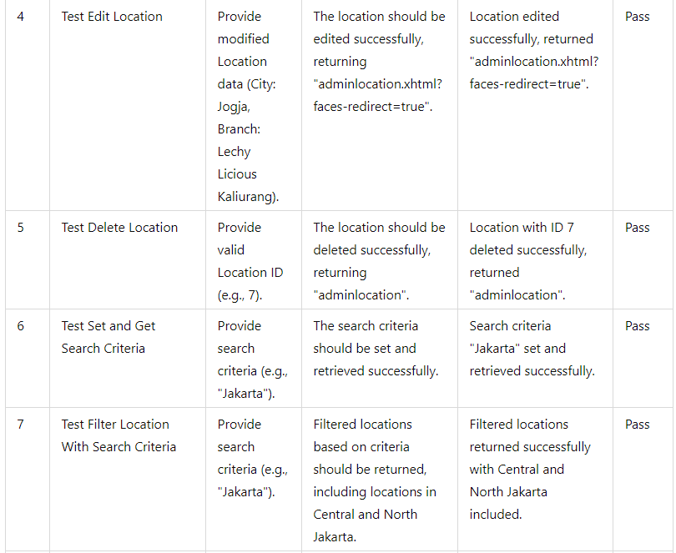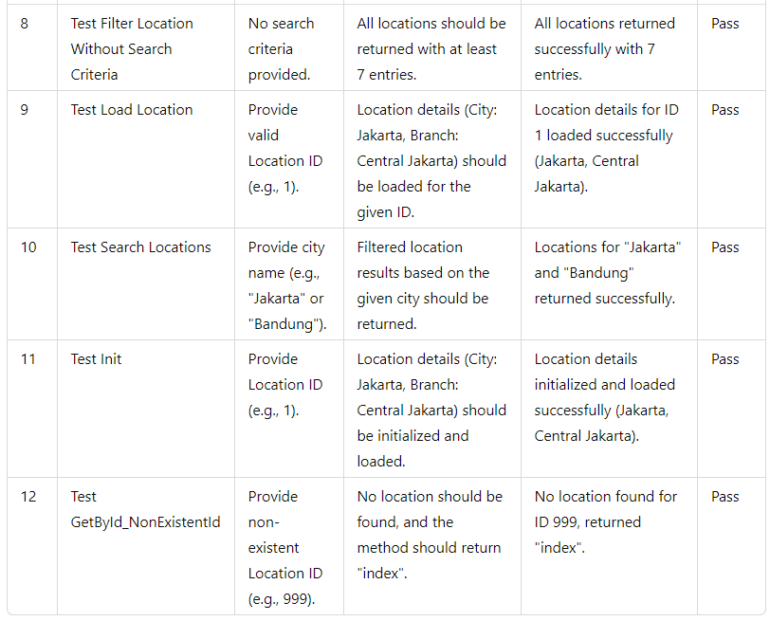

**TESTING IMPLEMENTATION**



**3. LoginTest.java**

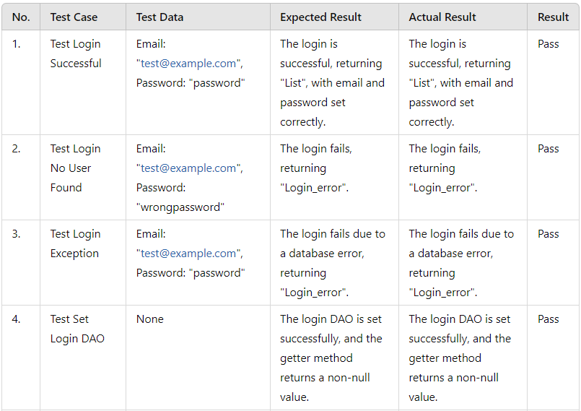

**TESTING IMPLEMENTATION**

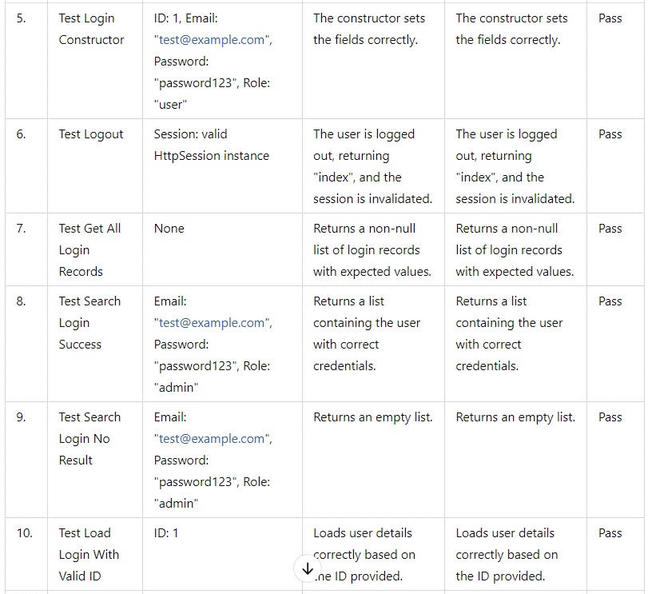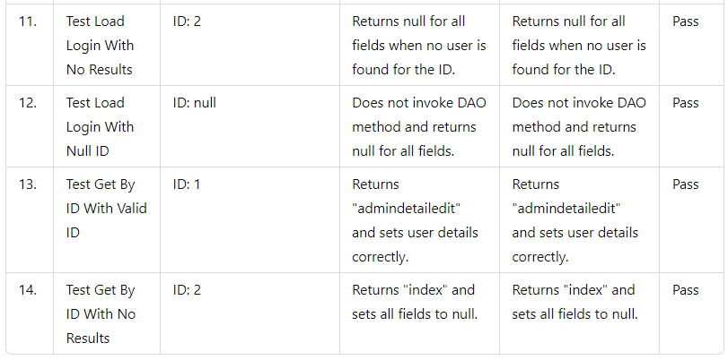

**TESTING IMPLEMENTATION**



**4. NailArtTest.java**

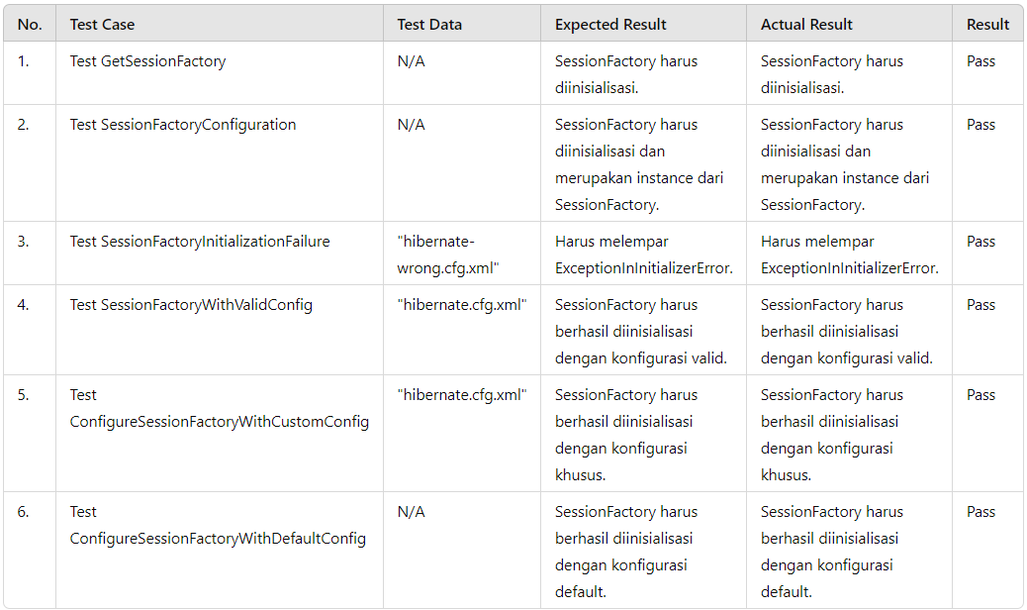

**5. NailArtUtilTest.java**

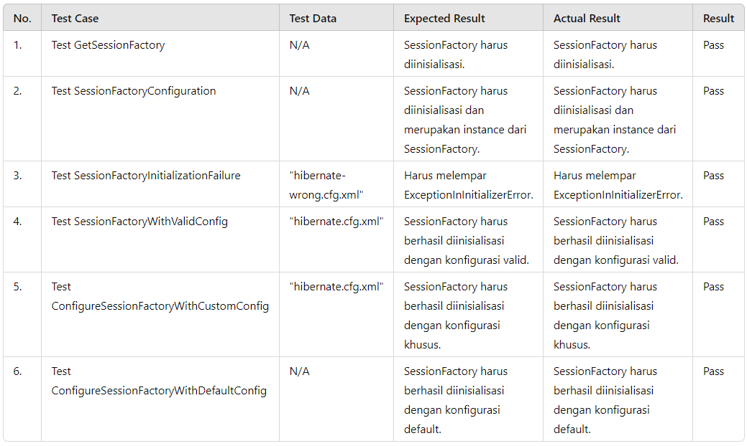

**TESTING IMPLEMENTATION**

**5. NailArtUtilTest.java**



**6. ReservationTest.java**

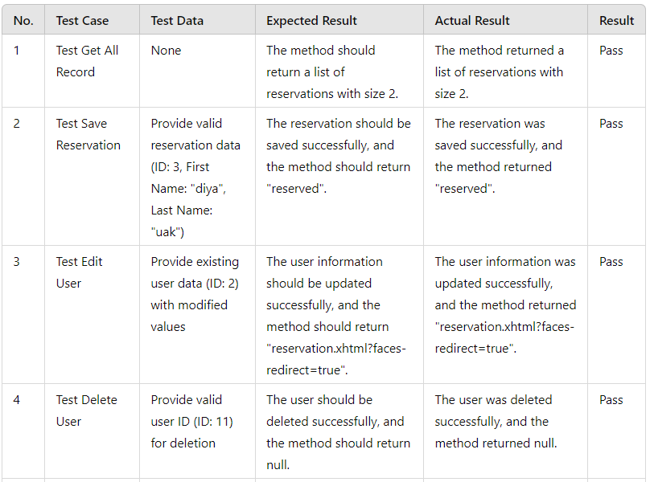

**TESTING IMPLEMENTATION**

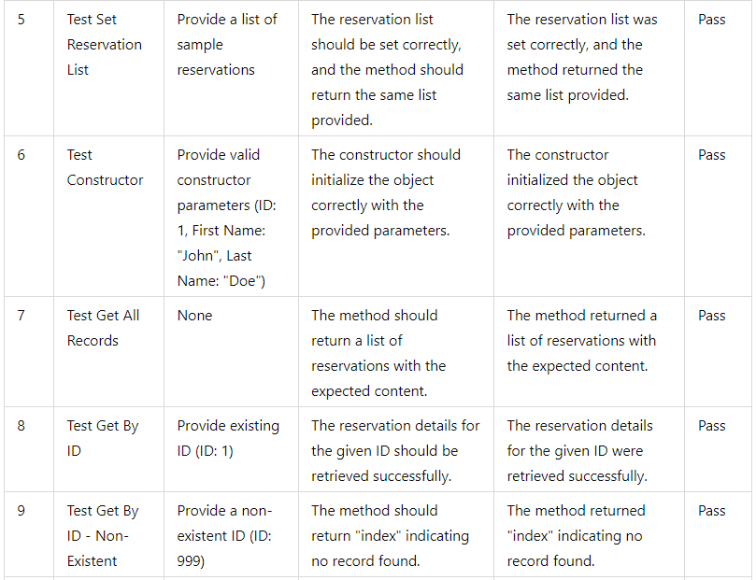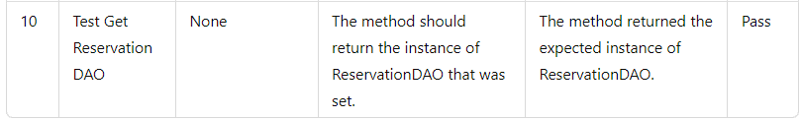

**7. ScheduleTest.java**

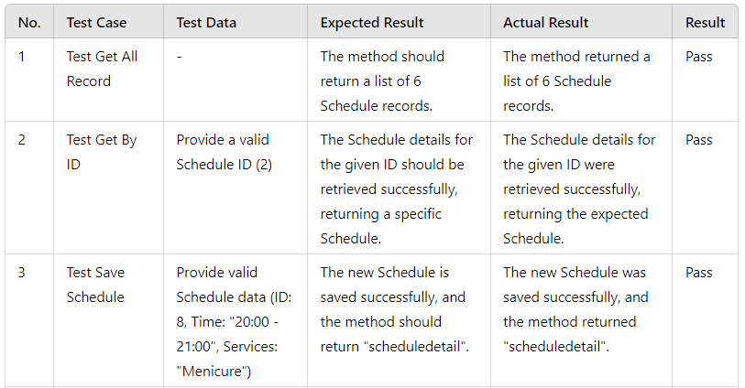

**TESTING IMPLEMENTATION**

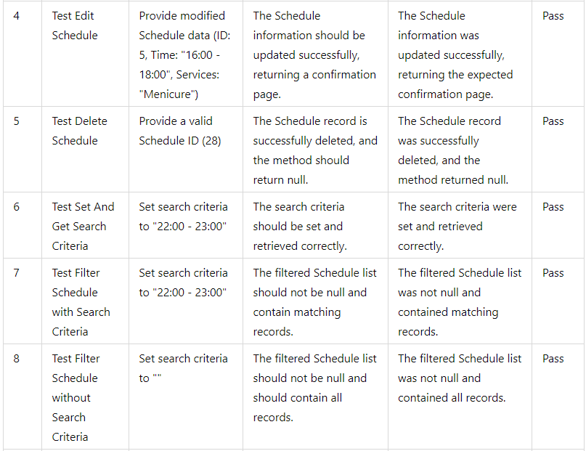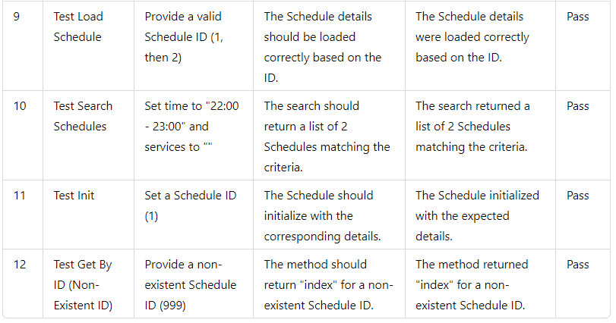

**TESTING IMPLEMENTATION**



**RESULT**

**DAO**

1. **CategoryDAOTest.java**

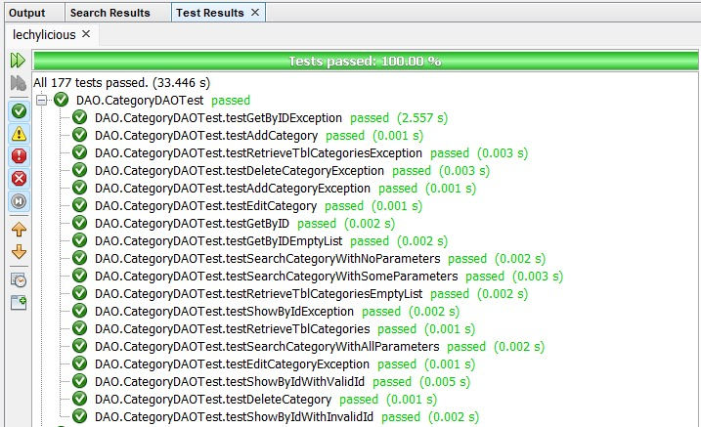

1. **LocationDAOTest.java**

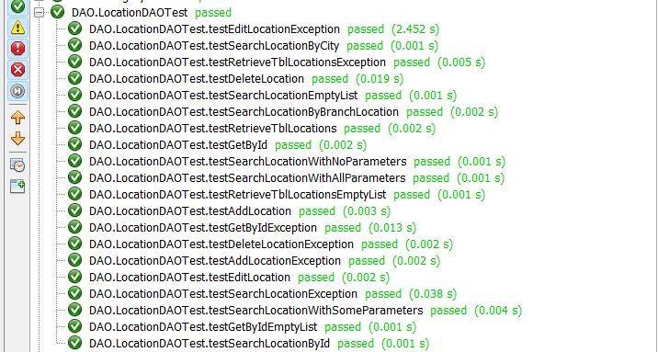

**RESULT**

1. **LoginDAOTest.java**

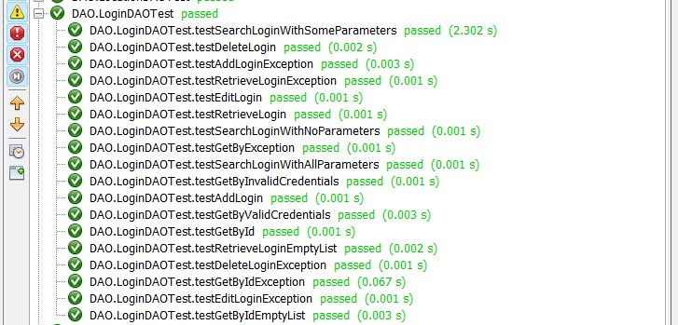

1. **ReservationDAOTest.java**

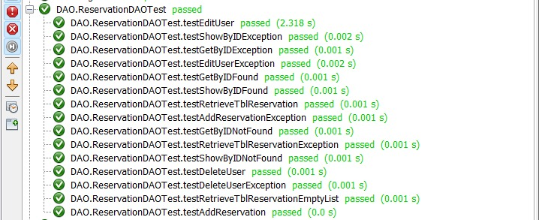

**RESULT**

1. **ScheduleDAOTest.java**

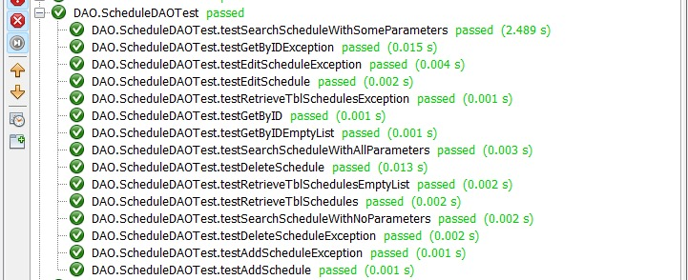

**Pojo**

1. **CategoryTest.java**

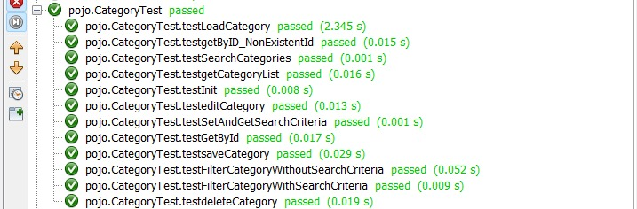

1. **LocationTest.java**

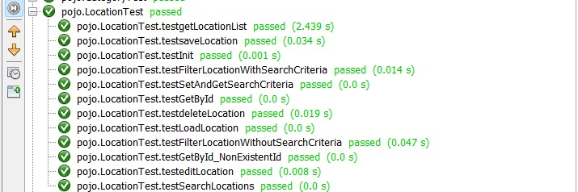

**RESULT**

1. **LoginTest.java**

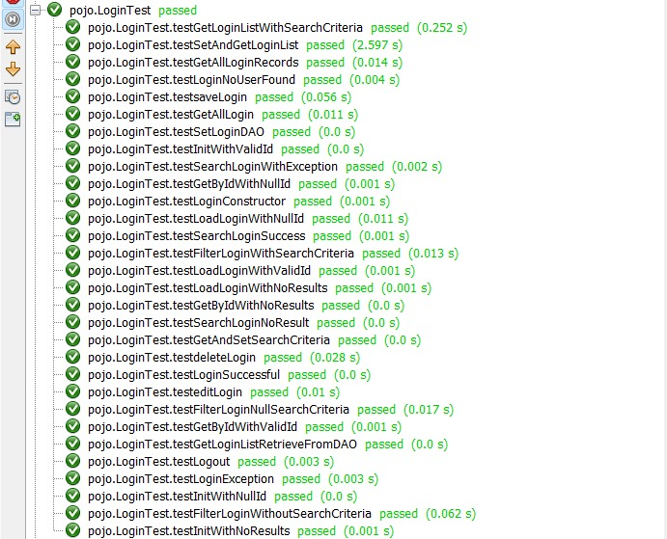

1. **NailArtTest.java**

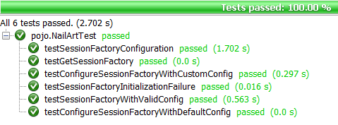

**RESULT**

**Pojo**

1. **NailartUtilTest.java**

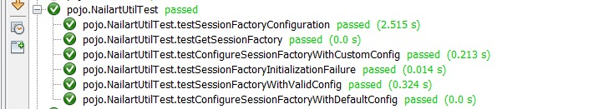

1. **ReservationTest.java**

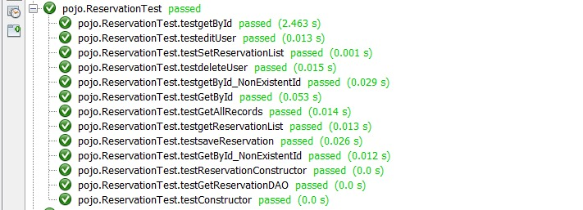

1. **ScheduleTest.java**

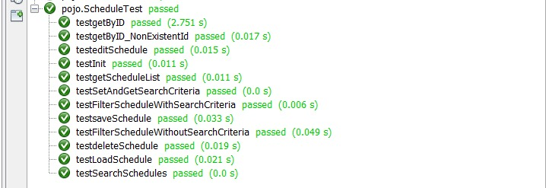

**RESULT JACOCO**

**1. DAO**

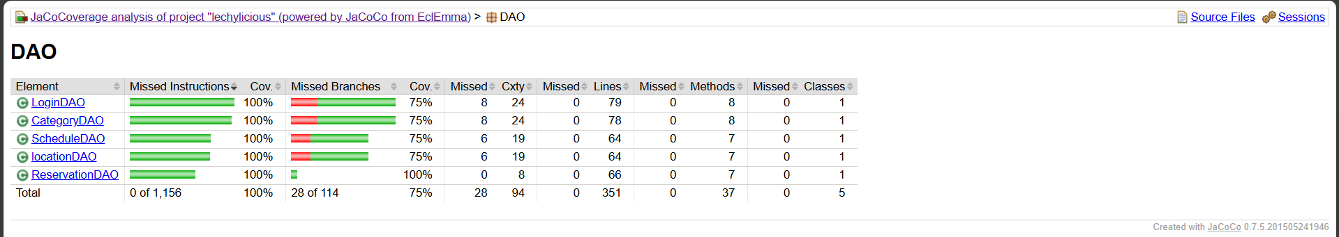

**2. pojo**

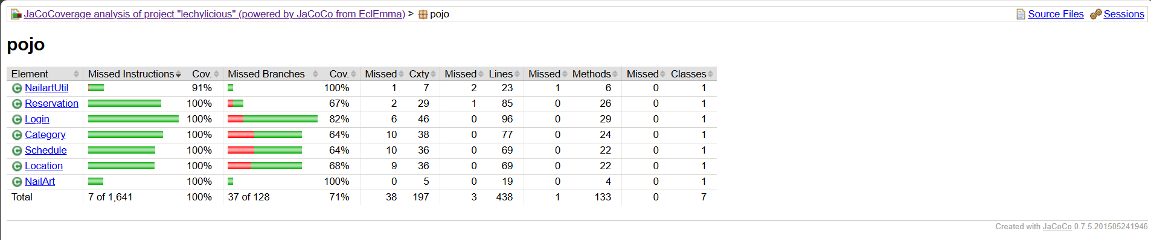

**RESULT JMETER**

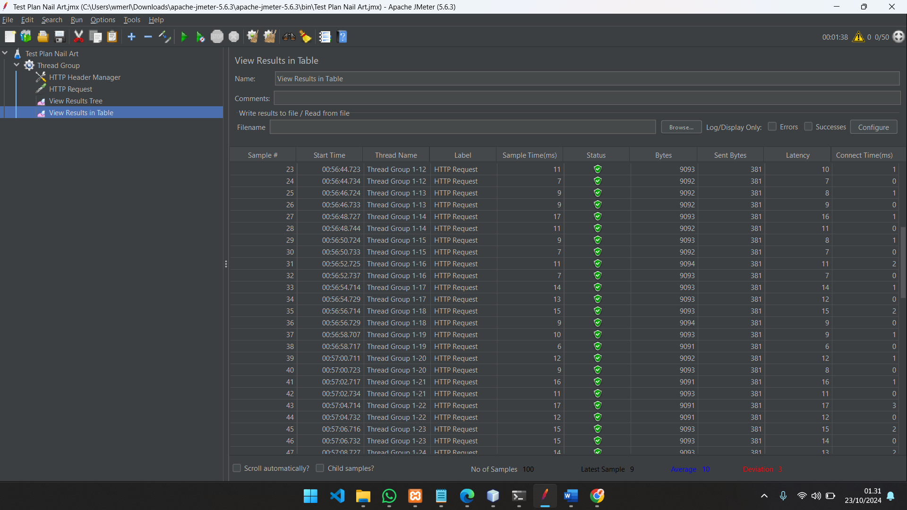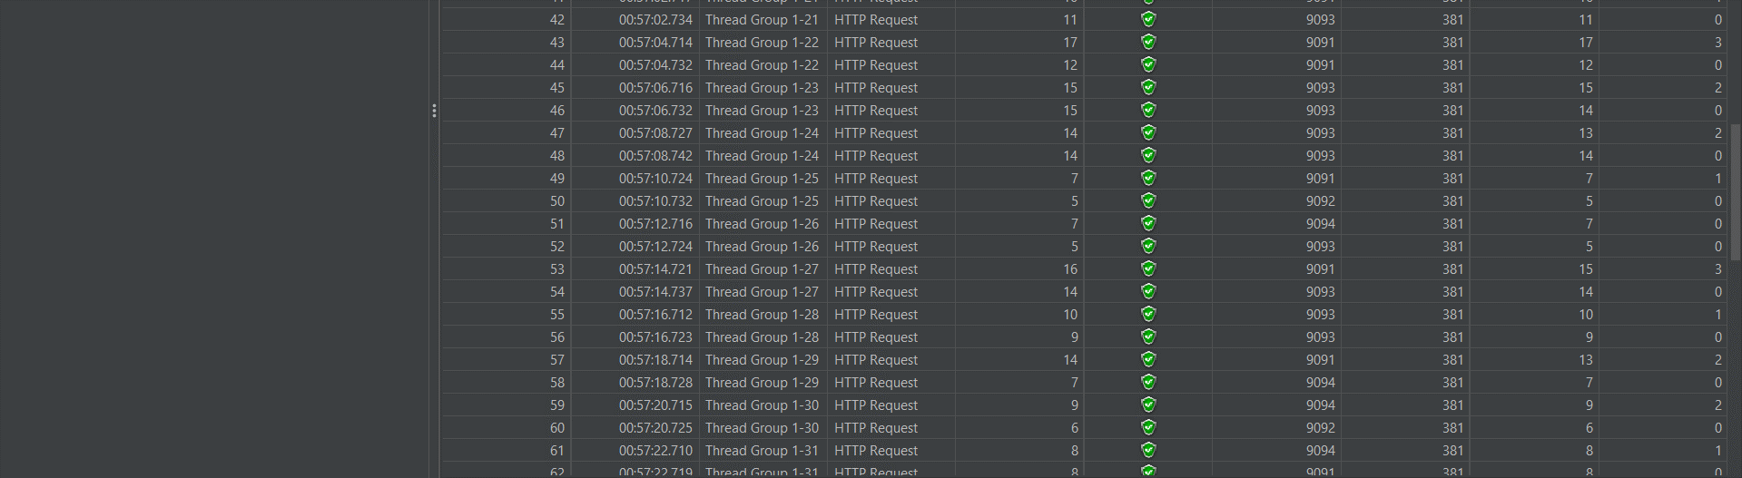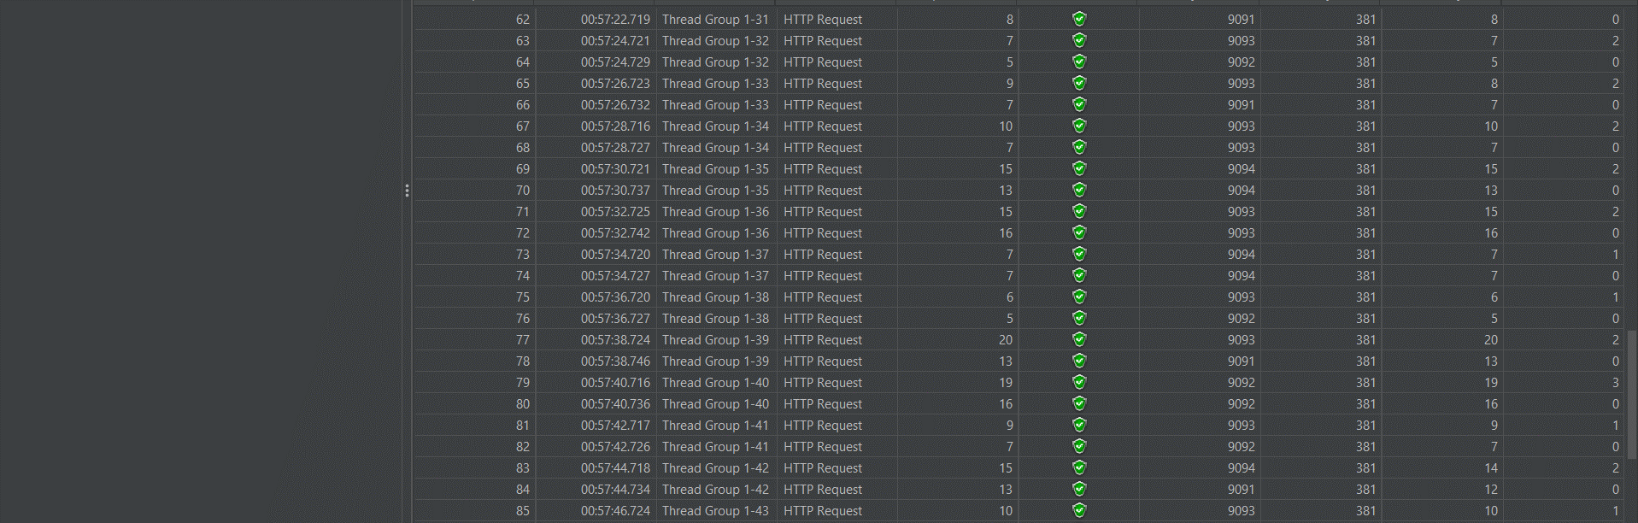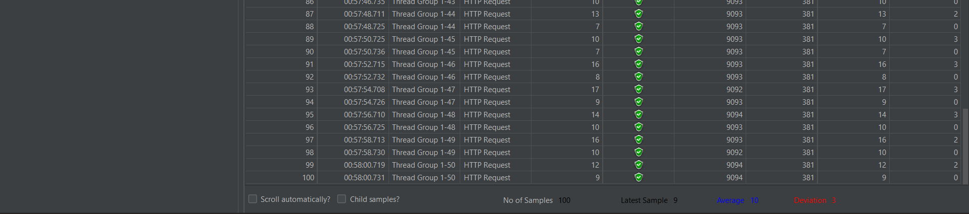

**RESULT JaCoCo**